DEFENCE SPACE ADMINISTRATION
OBASANJO SPACE CENTRE, ABUJA

PAYROLL SYSTEM
Complete User Manual

A full walkthrough of every screen, for day-to-day users,
administrators, and staff in training
Version 1.0 · October 2026
System supplied by Hicad Systems Limited

Document Control
Item | Detail
Title | Defence Space Administration Payroll System: Complete User Manual
Version | 1.0
Date | October 2026
Covers | The DSA Payroll System: all ten menu groups, 65 chapters and 6 appendices.
Audience | Day-to-day users; administrators and IT staff; trainers and new-staff onboarding.
Screenshots | 69 figures captured from working installations on 26 October 2026 (Chapter 1.4).
Related material | The Navy Payroll System Complete User Manual, on which the layout of this manual is based. The two systems share a platform; where they differ, this manual describes DSA.
Classification | Restricted. Contains personnel and financial data. Not for distribution outside the Administration.

How to use this document
The contents list on the following pages is generated by Word. If it appears blank or out of date, click anywhere inside it and press F9, then choose Update entire table.
Chapter and figure cross-references throughout the text are given as chapter numbers, for example “see Chapter 22”, so that they remain accurate however the document is printed or paginated.
Read Chapter 1 first. Readers new to the system should then read Chapters 2 to 5 in order; Chapter 5 in particular is the spine of everything that follows.

Contents

1. About This Manual
Read this chapter first. It explains who the manual is for, how it is arranged, and the small set of conventions used throughout.

1.1 Who this manual is for
This manual covers the Defence Space Administration Payroll System: the application used to hold personnel records, capture payments and deductions, calculate salaries, and produce payslips, bank schedules and statutory returns for the staff of the Defence Space Administration (DSA). It is written for three groups of readers, and each of them can use it differently:
Reader | How to use this manual
Day-to-day users: clerks and operators who enter data, run reports and answer queries. | Work through Part I to learn the screen layout, then read only the chapters covering the menus you are given access to. Every screen is described from a standing start; no prior knowledge is assumed.
Administrators and IT staff: the people who create users, configure reference tables, run month-end and hold the system together. | Read Part I and Part II in full before anything else. Part II describes the settings that everything else depends on. Appendix C lists the errors that come back to you as support calls.
Trainers and new-staff onboarding. | The manual is written in running order: a reader who starts at Chapter 1 and works to the end has covered the full monthly cycle once. Appendix E contains practice exercises keyed to the chapters.

No previous experience of payroll software is assumed. Where a term is specific to this system or to Service pay, it is explained the first time it appears and again in the Glossary (Appendix D).

1.2 How the manual is arranged
The chapters follow the left-hand menu of the application, and the menu itself follows the order of work in a normal month. That is deliberate: if you read the manual front to back you will also have walked through one complete payroll run.
Part | Chapters | Contents
Part I: Getting Started | 1 – 5 | The manual itself; what the system does; signing in; the dashboard and navigation; payroll classes; and the monthly processing cycle that ties every other chapter together.
Part II: Administration | 6 – 13 | Roles and permissions, user accounts, payroll class setup and migration, registration number changes, one-off payments, the company profile, and month-end and year-end processing.
Part III: Personnel Profile | 14 – 16 | Adding personnel one at a time or in bulk, maintaining current records, and handling personnel who have left.
Part IV: Data Input | 17 – 21 | Everything that feeds figures into a pay run: payments and deductions, variations, cumulatives, input documentation and arrears.
Part V: File Update | 22 – 26 | The fixed sequence that closes data entry and carries the input into the master file.
Part VI: Payroll Calculations | 27 – 28 | Running the calculation and reading the calculation reports.
Part VII: Reference Tables | 29 – 41 | The standing tables the calculation and the reports read: overtime, commands, the overpayment alarm, tax, salary scales, pay elements, PFAs, banks, departments, states, local governments and titles.
Part VIII: Utilities | 42 – 45 | Emolument and IPPIS menu items, class backup and restore, and consolidated payslips.
Part IX: Reports | 46 – 59 | Every report on the Reports menu, with the options each one offers.
Part X: Audit Trail | 60 – 65 | The six control reports on the Audit Trail menu: variance, personal-detail changes, variation listings, overpayment, duplicate accounts and out-of-range payments.
Appendices | A – F | Payroll class reference, pay element codes, troubleshooting, glossary, training exercises, and the figure index.

1.3 Conventions used
The manual uses a small number of consistent devices. They are worth two minutes now because they appear on almost every page.
Convention | Meaning
Bold | The exact wording of something on screen: a button, a menu item, a field label, a tab, or a status. If the manual says press Generate Report, there is a button with precisely that text.
Monospace | Something you type, a file name, a code, or a screen address such as dashboard.html#role-management.
Menu > Item | A path through the left-hand menu. Reference Tables > Bank Details means open the Reference Tables group, then click Bank Details.
Numbered steps | A procedure to be followed in order. Do not skip a step; several screens in this system refuse to open until the step before them has been completed.
Figure 4.2 | A screenshot. The first number is the chapter, the second is the position within it. Every figure has a caption saying what you are looking at.

Three coloured boxes appear throughout:
NOTE
A note adds context: something true about the screen that is not obvious from looking at it.

CAUTION
A caution marks an action that is difficult or impossible to reverse, or that affects live pay. Read these before pressing the button, not after.

GOOD PRACTICE
Good practice is advice drawn from how the system behaves in service. It is not compulsory, but following it will save you work.

1.4 About the screenshots
Every screenshot in this manual was captured from a working installation on 26 October 2026, in two sessions:
- The main set (Parts II, V to X) was captured on the live server at dsafinoffice.com, signed in as the administrator account hicad001. At the time the September 2026 calculation for the MILITARY class had completed, which is why those screens show a balanced calculation and why the left-hand menu in them has no Personnel Profile or Data Input group: the system hides both once payroll files are saved (Chapter 5.3).
- The data-entry set (Parts III and IV) was captured that evening on a local copy of the system (localhost:7070), signed in as IT.SYSTEM A., with data entry open. Those screens therefore show the full ten-group menu and empty input tables.
Your own installation will show its own address in the browser and its own signed-in user; nothing else differs. All figures show the MILITARY payroll class, which is why the top right of every screen reads Currently Active In: MILITARY. When you are working in the CIVILIAN class, that indicator, and the data below it, will change accordingly. See Chapter 4.
CAUTION
Personnel names, service numbers, account numbers and amounts appearing in the figures are drawn from a working data set and must be treated as restricted. Do not reproduce individual screenshots from this manual outside the Administration, and do not use live records when training new staff.

2. The System at a Glance
What the application is, who works in it, and what it produces. Read this before you sign in for the first time.

2.1 What the system does
The DSA Payroll System holds one record for every member of staff on the payroll, together with everything needed to work out what that person should be paid this month. Each month the system takes four kinds of information and turns it into pay:
- Standing information about the person: rank, salary group and grade, location, bank account, pension fund administrator, tax state. This changes rarely and lives on the personnel record (Part III).
- Reference information that applies to everybody: the salary scales, the tax table, the definitions of each allowance and deduction, and the rules about which allowances cannot be paid together. This is set up once and reviewed when policy changes (Part VII).
- Variable information for this month only: allowances earned, deductions to be taken, arrears, one-off payments. This is captured every cycle (Part IV).
- Cumulative information carried forward: tax to date, gross to date, outstanding loan balances. The system maintains this itself as each month is closed.
From these it calculates the pay run, and from the pay run it produces payslips, bank payment schedules, statutory returns (tax, National Housing Fund, pension), management summaries and reconciliation reports. The complete sequence is set out in Chapter 5, and it is the single most important thing in this manual.

2.2 Who uses it
Access is controlled by role. A role is a named bundle of menu permissions; every user account is given exactly one. The roles supplied with the system are:
Role | Description shown on screen | Typical holder
HICAD | Full system access | System administrator. Can reach every menu including Administration and Audit Trail.
MANAGER | Processor tasks + manage users & payment types | Pay office supervisor. Everything a Processor can do, plus user administration and pay element maintenance.
PROCESSOR | Operator tasks + process payroll + reports | Senior payroll staff. Runs the file update, the calculation and the reports.
OPERATOR | Data entry + input reports + utilities | Payroll clerk. Captures input and prints input-stage reports.
DATA_ENTRY | Handles data input and view all data inputs | Data capture staff. Entry and viewing only.

The roles are cumulative in practice (each one includes roughly what the one below it can do), but they are not hard-coded. An administrator can create additional roles and set their menu access individually (Chapters 6 and 7).

2.3 What you need before you start
- A User ID and password issued by your system administrator, a role appropriate to your duties, and the payroll class you are to work in.
- A modern web browser. The screenshots in this manual were taken in Microsoft Edge; Google Chrome and Mozilla Firefox behave the same way.
- A screen of at least 1366 × 768. The application is responsive and will work on a smaller display, but tables with many columns become awkward to read.
- The address of the payroll server, given to you by your administrator.

2.4 A word about care
This system produces actual pay for serving staff. Almost every screen in it is capable of being corrected afterwards; a small number are not. Month-end processing cannot be undone. A payroll class migration applied to all personnel cannot be reversed by pressing anything. A restore overwrites live data.
Those screens are marked with a caution box in the chapters that follow. Where you have a choice between checking now and correcting later, check now.

3. Signing In and Finding Your Way Around
The sign-in page, the header, the menu, the dashboard, and the handful of controls that appear on every single screen.

3.1 Signing in
The address of the payroll server opens a welcome page with two routes: User Login, which is the staff self-service portal described in 3.7, and Payroll admin login, which is the route for everybody who works in the payroll itself.
- Open your browser and enter the address of the payroll server given to you by your administrator.
- Click Payroll admin login.
- Enter your User_Id and your Password.
- Choose your payroll class in Class. This is the class the system will open in for you; you can change it later from the Administration menu (Chapter 9).
- Press Login. The system checks your credentials, reads your role, and builds a menu containing only the sections that role is permitted to reach.

Forgotten password
Press Forgot Password? on the sign-in form. The system asks you to verify your identity with your User ID, your Full Name exactly as registered, and your Payroll Class (an email address is optional). Press Verify Identity. If the details match, you are asked for a New Password of at least six characters and to confirm it. Press Reset Password, then sign in with the new password.
NOTE
If a menu described in this manual does not appear on your screen, there are two possible explanations. Either your role has not been given access to it, which is a permissions question for your administrator (Chapter 7) and not a fault, or it is Personnel Profile or Data Input, which the system hides on purpose while a pay run is in progress (Chapter 5.3).

3.2 The dashboard
A successful sign-in lands you on the dashboard. This is the home screen of the system and the place the Dashboard menu item always returns you to.
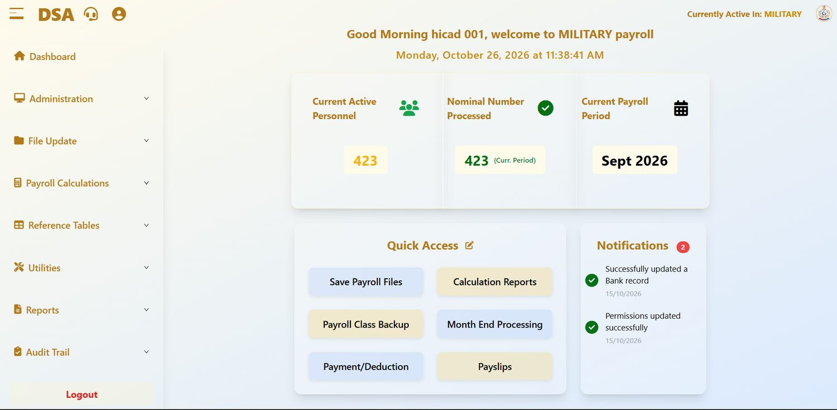
Figure 3.1 The dashboard, showing the greeting, the three headline figures, Quick Access and Notifications. The left-hand menu runs down the side of every screen in the system.

Reading the dashboard
The dashboard is arranged in three bands. The greeting at the top confirms who the system thinks you are and which payroll class you are working in: in the figure, Good Morning hicad 001, welcome to MILITARY payroll. Beneath it sits the current date and a live clock.
The middle band carries three headline figures:
Field / control | What it is for
Current Active Personnel | How many people are on the payroll in the active class right now. In the figure, 423.
Nominal Number Processed | How many records were processed, with a label saying which period the figure refers to: (Curr. Period) or (Prev. Period). In the figure, 423 for the current period. A gap between this number and the one on its left is normal, because it represents joiners, leavers and suspended records, but a large or growing gap is worth investigating.
Current Payroll Period | The month and year the system is currently processing. Everything you enter today is attributed to this period. In the figure, Sept 2026.

The lower band is split between Quick Access, a set of shortcut buttons to the six most-used screens (Save Payroll Files, Calculation Reports, Payroll Class Backup, Month End Processing, Payment/Deduction and Payslips), and Notifications, a list of recent system events with a count badge. The pencil icon beside Quick Access lets you change which shortcuts appear.
GOOD PRACTICE
Check Current Payroll Period every time you sign in. Entering a month of data into the wrong period is one of the few mistakes in this system that is tedious to unwind.

3.3 The header bar
The strip across the top of the window is present on every screen. From left to right it carries:
Field / control | What it is for
Hamburger icon (☰) | Collapses and expands the left-hand menu. Collapsing it gives a wider working area on tables with many columns.
DSA wordmark | Returns you to the dashboard from anywhere.
Headset icon | Opens support. Use this to raise an issue with the system administrator.
Person icon | Your own account: profile and password.
Currently Active In: <CLASS> | The payroll class every screen is currently reading and writing. This is the single most important indicator in the header. See Chapter 4.
DSA crest | Decorative.

3.4 The page header and footer
Below the top strip, each screen shows its own title on the left (Role Management, Payslips, Bank Details and so on) and, on the right, a green status dot, the signed-in user name, and the current time. The green dot means the browser has a live connection to the server. If it is absent or the time stops advancing, your session has dropped; sign in again before entering anything further.
At the foot of every screen sits a yellow Return button on the left, which takes you back to the previous screen, and the copyright line © 2026 Hicad Systems Limited on the right.

3.5 The left-hand menu
The menu is the spine of the system. It has ten groups below Dashboard; clicking a group opens it to show the screens inside. Only the groups your role permits are shown.
Menu group | What it holds | Covered in
Dashboard | The home screen described above. | Chapter 3
Administration | Roles, users, payroll classes, registration numbers, irregular one-off payments, company profile, month-end and year-end. | Part II
Personnel Profile | Adding and maintaining personnel records; old personnel. Hidden while a pay run is in progress. | Part III
Data Input | Payments and deductions, batch upload, variations, cumulatives, documentation, arrears. Hidden while a pay run is in progress. | Part IV
File Update | Save payroll files, personnel changes, input variable report, master file update, recall. | Part V
Payroll Calculations | The calculation itself, and calculation reports. | Part VI
Reference Tables | Overtime, command, overpayment alarm, tax, salary scales, pay elements, fixed amounts, mutual exclusions, PFAs, banks, department, states, LGAs, titles. | Part VII
Utilities | Emolument form processing, IPPIS payments, class backup and restore, consolidated payslips. | Part VIII
Reports | The reporting suite, including personnel reports and Enquiry. | Part IX
Audit Trail | Six control reports for finding and explaining exceptions. | Part X

Below the groups sits Logout. Use it whenever you leave your desk. The system holds a live session, and anything done from an unattended machine is recorded against your name.

3.6 Controls that behave the same everywhere
The system is consistent, which means a handful of controls are worth learning once:
Control | Behaviour
+ Add New / + Create New / + Add Command (blue) | Opens a blank form, usually directly above the list you are looking at. Fill it in and press Save.
Generate Report (gold) | Produces a printable version of whatever the screen holds. Most report screens let you choose PDF or Excel first.
Edit (green text or button) | Opens the selected row for amendment.
Delete (red) | Removes the record. Where a record is referenced elsewhere the system will refuse rather than orphan the reference.
View (blue) | Opens the record read-only. Use this when you only need to check something: it leaves no edit footprint.
Search… | Filters the list below as you type. Most searches accept either a service number or part of a name.
Records per page / 10 per page | Controls page length on long lists, with Previous / Next beneath. The record count, for example Showing 1 to 10 of 94 records, is always shown.
Clear / Reset Form (grey) | Empties the form without saving. It does not undo anything already saved.
Return (yellow) | Goes back one screen.

3.7 The staff self-service portal
Members of staff do not use the payroll screens. They reach their own payslips through User Login on the welcome page, signing in with their User ID, Password and Class. Two routes help them in:
- First Time?: a member of staff who has never signed in enters their User ID and the Account Number their salary is paid into. If both match the payroll record they are taken to a page to set their password.
- Forgot Password?: the member of staff enters their User ID and the email address held for them. If both match, a reset link is sent to that address.
Both routes depend on the personnel record being right: the account number on Step 2 and the email address on Step 1 (Chapter 14). When a member of staff cannot get in, check those two fields before anything else.

4. Payroll Classes
The single concept that most often catches out new users. Five minutes here will save a great deal of confusion later.

4.1 What a payroll class is
Staff are not held in one undifferentiated list. They are divided into payroll classes: groups that are paid on different scales and processed as separate runs. The classes configured in the system are:
Code | Description | Who it covers
1 | MILITARY | Service personnel on the DSA payroll. The primary class.
2 | CIVILIAN | Civilian staff of the Administration.

A class is more than a label. Each class carries its own processing month and year, its own payment and deduction records, its own calculation run and its own backup. Two classes can legitimately be in different months at the same time; in the installation shown in this manual both are processing September 2026 (Figure 9.1).

4.2 Only one class is active at a time
This is the rule that matters. Every screen in the system reads and writes the active payroll class only, and the active class is shown at the top right of every page as Currently Active In: <CLASS>.
CAUTION
If you enter a deduction while MILITARY is active, that deduction is attached to the military pay run. It will not appear in the civilian run, and it will not be found by anyone searching the civilian data. Before entering anything, look at the top right of the screen.

You choose a class when you sign in (Chapter 3.1). To change it afterwards, use Administration > Switch Active Payroll Class (Chapter 9). Switching is quick and has no side effects: it simply changes which set of data every screen is pointed at.

4.3 The class statistics
The Change Personnel Payroll Class screen shows a Payroll Class Statistics panel giving the population of each class: in Figure 9.3, 423 MILITARY and 768 CIVILIAN. It is the fastest way to sanity-check a migration or an upload.

4.4 Class and role are different things
Two independent controls decide what you can do:
- Your role decides which menus you can open: see Chapters 6 and 7.
- The active payroll class decides which population those menus act on: see Chapter 9.
A user with the HICAD role can reach every screen in the system, but if the active class is CIVILIAN they will still see only civilian staff. Conversely, switching class does not grant any additional permission.

5. The Monthly Payroll Cycle
The order of work. Everything else in this manual is a detail inside this chapter.

5.1 Why the order matters
The system enforces a sequence. Several screens will not open until the screen before them has been completed, and they say so plainly: Personnel Details Report Not Available Yet: this section will become available once the payroll files are saved. These locks are not an obstacle to work around; they are the system making sure that what you are about to calculate is based on data that has been checked and frozen.
If a screen you need is locked, the answer is always the same: go back and finish the step before it. Each locked screen provides a button that takes you straight there.

5.2 The ten steps
A complete cycle for one payroll class runs as follows.
# | Step | Where | Chapter
1 | Confirm the active class and the processing period | Header · Administration > Switch Active Payroll Class | 4, 9
2 | Bring personnel records up to date: joiners, leavers, transfers, bank changes | Personnel Profile | 14 – 16
3 | Capture this month's payments and deductions | Data Input > Payments/Deductions (and Batch Upload) | 17
4 | Capture variations, arrears and one-off payments | Data Input · Administration | 11, 18 – 21
5 | Save the payroll files: this closes data entry | File Update > Save Payroll Files | 22
6 | Print the changes in personnel data | File Update > Changes in Personnel Data | 23
7 | Print the input variable report | File Update > Input Variable Report | 24
8 | Run the master file update | File Update > Master File Update | 25
9 | Calculate the payroll and read the calculation reports | Payroll Calculations | 27 – 28
10 | Produce the reports, run the control reports, then close the month | Reports · Audit Trail · Administration > Month End Processing | 13, 46 – 65

5.3 The payroll status, and why two menus disappear
Behind the sequence, each payroll class carries a single status that moves forward one step at a time as you work down the File Update menu. Month End Processing shows it as Current Status (Figure 13.1). Knowing the ladder makes every lock in the system predictable:
Status shown | Reached by | What it releases
Data Entry Open | Month-end of the previous period, or Recall Payment Files | Personnel Profile and Data Input are on the menu. Save Payroll Files is available.
Data Entry Closed | Save Payroll Files (Chapter 22) | Personnel Profile and Data Input disappear from the menu. Changes in Personnel Data opens.
First Report Generated | Printing Changes in Personnel Data (Chapter 23) | Input Variable Report opens.
Two Reports Generated | Printing the Input Variable Report (Chapter 24) | Master File Update opens.
Update Completed | Master File Update (Chapter 25) | Payroll Calculations opens.
Calculation Completed – Ready for Month-End | Payroll Calculations (Chapter 27) | Calculation Reports, and Month End Processing.

Month End Processing returns the class to Data Entry Open for the next month, and the two hidden menus come back. This is what you see in the figures: the main set was captured with September calculated, so the menu runs straight from Administration to File Update; the data-entry set was captured with entry open, so the full menu is shown.
NOTE
This replaces a validation screen. There is no separate “lock” button in this system: Save Payroll Files is the lock. Once it is pressed the system says so (after saving, you can not make changes to the payroll data) and the only way back is Recall Payment Files (Chapter 26), which reopens data entry and sends you back to step 5.

NOTE
For IT staff: the status is held per class on the BT05 record of py_stdrate, in the sun column: 0, 666, 775, 777, 888 and 999 for the six rows above. It should only ever be moved by the screens; see Appendix C.

5.4 Step by step

1 · Confirm class and period
Look at Currently Active In in the header and at Current Payroll Period on the dashboard. If either is wrong, correct it before you touch anything else. A month of input captured against the wrong class has to be re-keyed.

2 · Update personnel records
Add anyone who has joined, mark anyone who has left, and correct ranks, salary grades, bank accounts and pension details. This is the point at which standing data should be right; once the payroll files are saved the Personnel Profile menu is withdrawn until month-end.

3 · Capture payments and deductions
Enter the variable amounts for the month. Small numbers of records are keyed directly; larger volumes go in through Batch Upload from a spreadsheet. Every record carries a service number, a payment or deduction type, an amount payable, an amount to date and a pay indicator.

4 · Capture variations, arrears and one-offs
Anything that is not a straightforward recurring payment is handled here: a change to a running deduction, back-pay owed on a promotion, or a one-off payment such as a grant.

5 · Save the payroll files
This is the gate between capture and processing. Save Payroll Files commits the input for the period, closes data entry and withdraws the Personnel Profile and Data Input menus. Nothing downstream will run until this is done.
CAUTION
Once the files are saved, further entry for the period is closed. Make sure every source document has been captured before you save.

6 · Print the changes in personnel data
This report lists every change made to personnel records in the period. Its purpose is control: somebody other than the person who keyed the changes should read it. It is refused until the payroll files are saved.

7 · Print the input variable report
The companion report to step 6, listing the variable input captured for the period. It is refused until the personnel changes have been printed.

8 · Run the master file update
The master file update writes the input into the master records. It is refused until the input variable report has been printed. After this step, the data the calculation will use is fixed.

9 · Calculate
Payroll Calculations works out gross pay, deductions, tax and net pay for every active record in the class, for the current processing month and year, and checks that the totals balance. When it finishes, Calculation Reports unlocks. Read them before going any further: a problem found here costs an hour, the same problem found after month-end costs a great deal more.

10 · Report and close
Produce payslips, bank payment schedules, the payroll register, statutory returns and management summaries. Run the control reports. Reconcile. Then run Month End Processing to finalise the period and roll the system forward.
CAUTION
Month-end processing finalises all payroll data for the selected period and cannot be undone. Do not run it until the reports have been read and agreed.

5.5 The exception reports
Between calculation and month-end there is a group of reports whose only purpose is to find mistakes. They take minutes to run and they are the cheapest insurance in the system:
Report | What it finds | Chapter
Salary Reconciliation (filter: Errors Only) | Records where this month's figures do not reconcile against last month's. | 57
Salary Variance Analysis | Staff whose pay has moved unexpectedly between periods. | 60
Overpayment | Payments that breach the overpayment percentage alarm. | 63
Out-of-Range Payments | Net amounts outside a minimum and maximum you specify. | 65
Duplicate Account Number | Two or more personnel sharing a bank account number. | 64

GOOD PRACTICE
Run all five every month, in that order, before month-end. Duplicate account numbers in particular are worth scanning even in a quiet month: they are the classic signature of a keying error in bank details.

6. Role Management
Administration > Role Management · dashboard.html#role-management
Roles are the bundles of access the system hands out. This screen creates and maintains them; Chapter 7 decides what each one can reach.

6.1 Opening the screen
Open Administration in the left menu and click Role Management. The screen lists the roles that exist under Current Roles, each with the description that will be shown to users and to whoever assigns accounts.
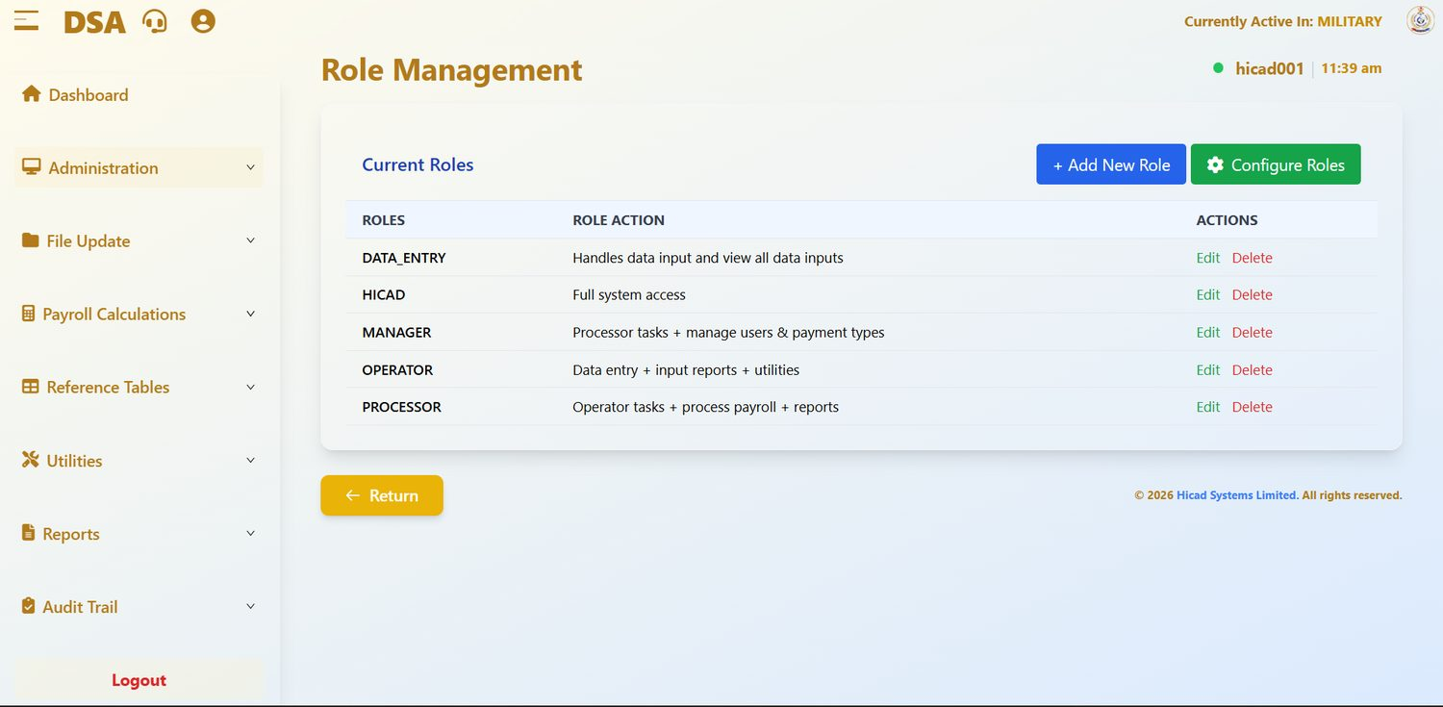
Figure 6.1 Role Management with the five roles supplied as standard. Each row can be edited or deleted; the buttons at the top right add a new role or jump to permissions.

6.2 Reading the list
Field / control | What it is for
ROLES | The role name. Displayed in upper case with underscores, for example DATA_ENTRY. This is the value that appears in the User Role list when an account is created.
ROLE ACTION | A plain-language description of what the role is for. Users see this text, so write it for them: “Data entry + input reports + utilities” is more useful than “Level 2”.
ACTIONS | Edit opens the role for amendment; Delete removes it.

The two buttons at the top right are + Add New Role, which opens the creation form, and Configure Roles, which takes you to the Role Permissions screen described in Chapter 7.

6.3 Creating a role
- Press + Add New Role. A short form opens above the list.
- Enter the Role Name*. Use upper case with underscores in place of spaces, matching the convention of the existing roles.
- Enter the Role Description*. Describe the duties the role covers, not the person who happens to hold it.
- Press Save. The role appears in the list below. Press Cancel to abandon the form.
NOTE
Creating a role gives it no access at all. A new role can sign in and see nothing until you grant it menu access on the Role Permissions screen. Always do the two together.

6.4 Editing and deleting roles
Edit reopens the name and description for amendment. Changing a description is safe at any time. Changing a name affects every account currently holding the role, so check who they are on Control Payroll Users (Chapter 8) first.
CAUTION
Delete removes the role. Do not delete a role while accounts are still assigned to it: move those accounts to another role first, or you will leave users unable to work. The HICAD role should never be deleted; it is the only role with full system access, and removing the last account that can reach Administration locks everybody out of the system's own controls.

6.5 Designing a set of roles
The five supplied roles form a ladder, each including roughly what the one below it can do. If you add roles of your own, keep to the same principle: grant the narrowest access that lets the person do their job, and separate the duties that ought to check one another.
GOOD PRACTICE
Keep data capture and payroll processing in different roles wherever staffing allows. The person who keys a deduction should not also be the person who saves the payroll files and runs month-end: that separation is what makes the control reports in steps 6 and 7 of the cycle meaningful.

7. Role Permissions
Administration > Role Management > Configure Roles
Deciding, menu by menu, what each role is allowed to open.

7.1 Opening the screen
Press Configure Roles on the Role Management screen. The permissions screen opens with a single instruction (Configure menu access for each role), an empty Select Role: list, and a Configure Permissions button that stays greyed until a role is chosen.

7.2 Selecting a role
- Open the Select Role: list. It contains every role defined on the Role Management screen.
- Choose the role you want to work on. The screen confirms the role and its description, with the reminder Click “Configure Permissions” to manage menu access.
- Press Configure Permissions, which is now enabled, to open Configure Menu Permissions.
NOTE
No screen capture of this screen was taken for this edition. The controls named here are those the screen displays; if your version differs, the release note for that version takes precedence.

7.3 Granting access
Configure Menu Permissions shows the role at the top and the menu items below, spread over one or more sections. Move between sections with Previous and Next; the position is shown between them as Section 1 of …. Switch on the items the role should be able to open and switch off the rest, then press Save Permissions. The confirmation reads Permissions saved successfully, and the change takes effect the next time a holder of that role signs in.
A menu group appears for a user only if at least one item inside it is switched on for their role. Switching off every item in a group removes the group from the menu altogether.
NOTE
Permissions are granted at menu level, not at button level. A role that can open Payments/Deductions can also add, edit and delete within it. Where you need someone to look without touching, give them a role that reaches the report equivalent rather than the maintenance screen.

CAUTION
Never remove Administration access from the last remaining HICAD account. If you do, nobody can reach Role Management to put it back, and the system will have to be corrected at database level.

7.4 Good practice
- Change permissions for one role at a time, and have the holder sign in and confirm before you move to the next.
- Record why a permission was changed, and on whose authority. The system holds the new setting, not the reason for it.
- Review the whole set once a year, and always after a reorganisation of the pay office.

8. User Accounts
Administration > Create Payroll User · dashboard.html#create-user; Administration > Control Payroll Users · dashboard.html#control-user
Creating accounts, and maintaining the ones that exist.

8.1 Creating a payroll user
Open Administration > Create Payroll User. The form creates one account at a time.
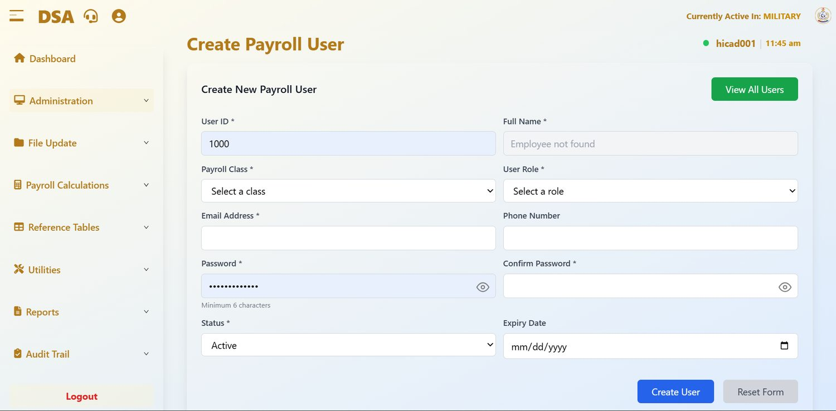
Figure 8.1 Create Payroll User. Fields marked with an asterisk are required. The Full Name field fills itself from the personnel record once a recognised User ID is entered.
Field / control | What it is for
User ID * | The identifier the user will sign in with. Where the user is on the payroll, enter their service number exactly as it stands on the personnel record.
Full Name * | Filled in by the system from the personnel record matching the User ID. Employee not found, as in the figure, means no personnel record carries that number: check the number before going further.
Payroll Class * | The class the account is associated with. Choose from the classes configured in Chapter 9.
User Role * | The role, and therefore the menu access, this account will carry. The list is drawn from Role Management (Chapter 6).
Email Address * | Used for system correspondence and password recovery. Enter a working address; an account with a wrong address is difficult to recover.
Phone Number | Optional contact number.
Password * / Confirm Password * | The initial password, at least six characters, entered twice. The eye icon shows what you have typed.
Status * | Set to Active for an account that is to be used now. An account can be created in advance and activated later.
Expiry Date | Optional. After this date the account can no longer sign in. Use it for temporary attachments, audit teams and contractors: it is far more reliable than remembering to revoke access by hand.

To create an account
- Enter the User ID and check that Full Name fills in with the person you expect.
- Complete the remaining required fields.
- Choose the User Role carefully. Give the narrowest role that covers the person's duties; it can be raised later if needed.
- Set an Expiry Date if the posting is temporary.
- Press Create User. To empty the form and start again, press Reset Form.
- Confirm the new account appears on Control Payroll Users, and ask the holder to sign in, and change the password, while you are still available to help.
NOTE
View All Users at the top right is a shortcut to the Control Payroll Users screen described below.

8.2 Controlling existing users
Open Administration > Control Payroll Users to see every account in the system.
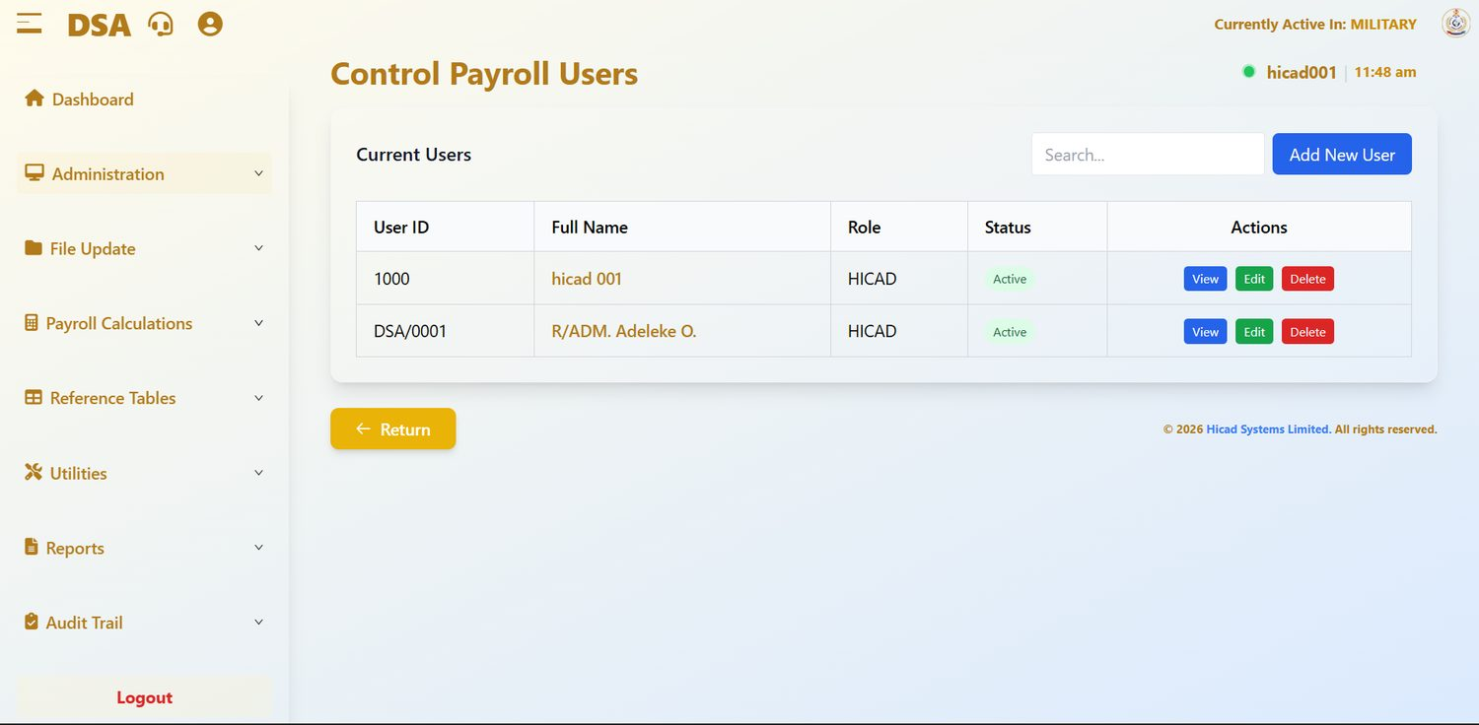
Figure 8.2 Control Payroll Users. Each account shows its User ID, name, role and status, with View, Edit and Delete against it.
Field / control | What it is for
Search… | Filters the list by User ID or name.
Add New User | Opens the Create Payroll User form described above.
User ID / Full Name | Identify the account. The name is a link that opens the account.
Role | The role currently assigned. To change it, press Edit.
Status | Active accounts can sign in; inactive ones cannot.
Actions | View opens the account read-only, Edit opens it for amendment, Delete removes it.

Routine account maintenance
- A user changes appointment. Press Edit and change the role to match the new duties. Do not leave the old role in place “just in case”.
- A user leaves the pay office. Set the status so the account can no longer sign in, or delete it. Do not leave a live account behind a departed holder.
- A user has forgotten their password. They can reset it themselves from the sign-in page (Chapter 3.1). If they cannot, confirm their identity by a means other than the system, then reset it from the account.
- A user reports a missing menu. Check the role on this screen against the permissions in Chapter 7, and check the payroll status (Chapter 5.3), before assuming a fault.
CAUTION
Deleting an account does not delete what that account did. Records created by the user remain. That is deliberate, but it also means a deleted account cannot be used to hide activity, and should never be deleted for that purpose.

GOOD PRACTICE
Review the user list every quarter against the current staff of the pay office. The figure shows two accounts, both HICAD; full-access accounts in particular should be few and named. Accounts belonging to people who have moved on are the most common finding in an access audit.

9. Payroll Class Setup and Migration
Administration > Payroll Class Setup · Switch Active Payroll Class · Change Personnel Payroll Class
Defining the classes, choosing which one you are working in, and moving personnel between them.

9.1 Payroll Class Setup
Open Administration > Payroll Class Setup to see the classes the system knows about and to add new ones.
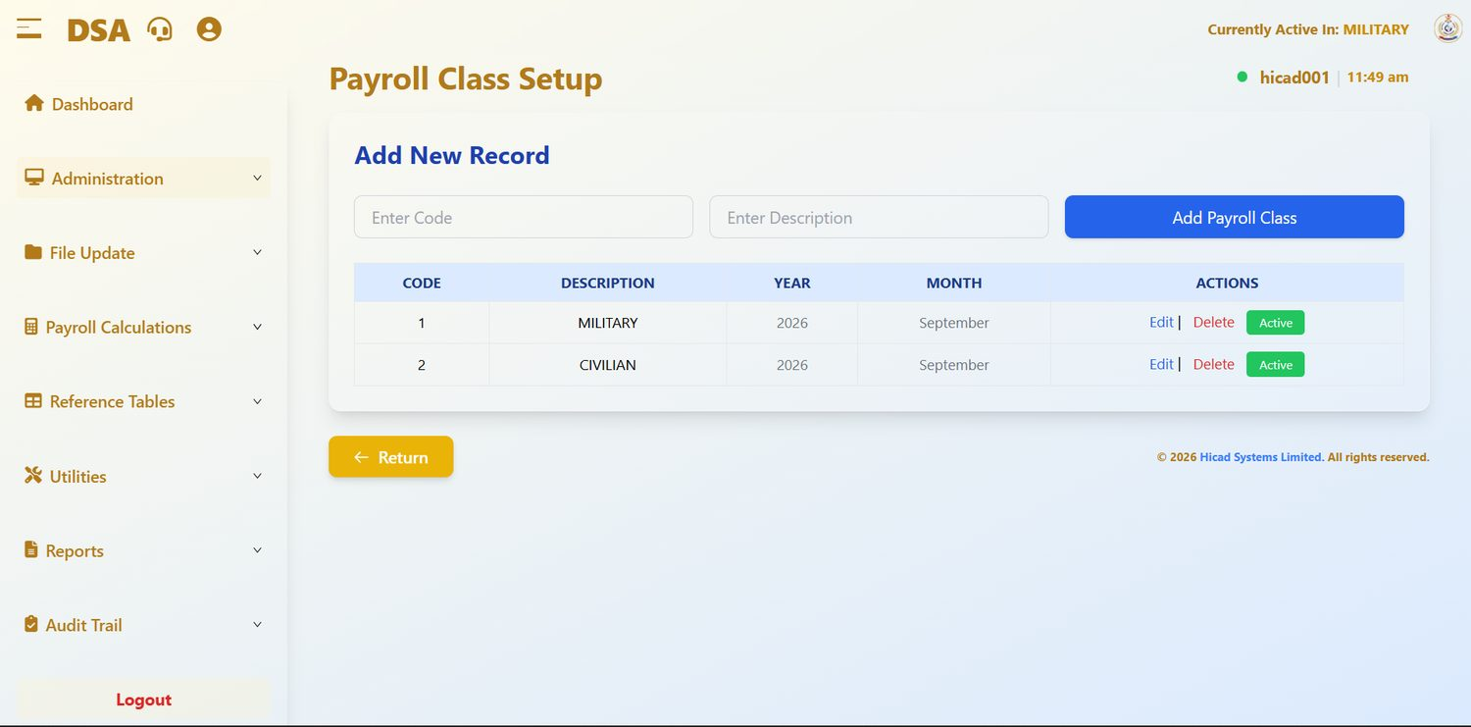
Figure 9.1 Payroll Class Setup. The Add New Record strip creates a class; the table below lists those that exist, with the period each is currently processing.
Field / control | What it is for
Enter Code | A short numeric code for the class. Codes must be unique.
Enter Description | The name users will see: MILITARY, CIVILIAN. Use upper case, consistent with the existing entries.
Add Payroll Class | Creates the class from the two fields to its left.
CODE / DESCRIPTION | As entered above.
YEAR / MONTH | The period this class is currently processing: 2026 and September for both classes in the figure. A newly created class shows no period until its first cycle runs.
ACTIONS | Edit amends the class; Delete removes it. The green Active badge shows the class is available for processing.

CAUTION
Do not delete a payroll class that has personnel or historical pay data attached to it. Move the personnel to another class first (see below), and keep the class itself for the sake of the history.

9.2 Switching the active class
Open Administration > Switch Active Payroll Class. The screen states the rule at the top: Only one payroll class can be active at a time. Focus on a class to make it active.
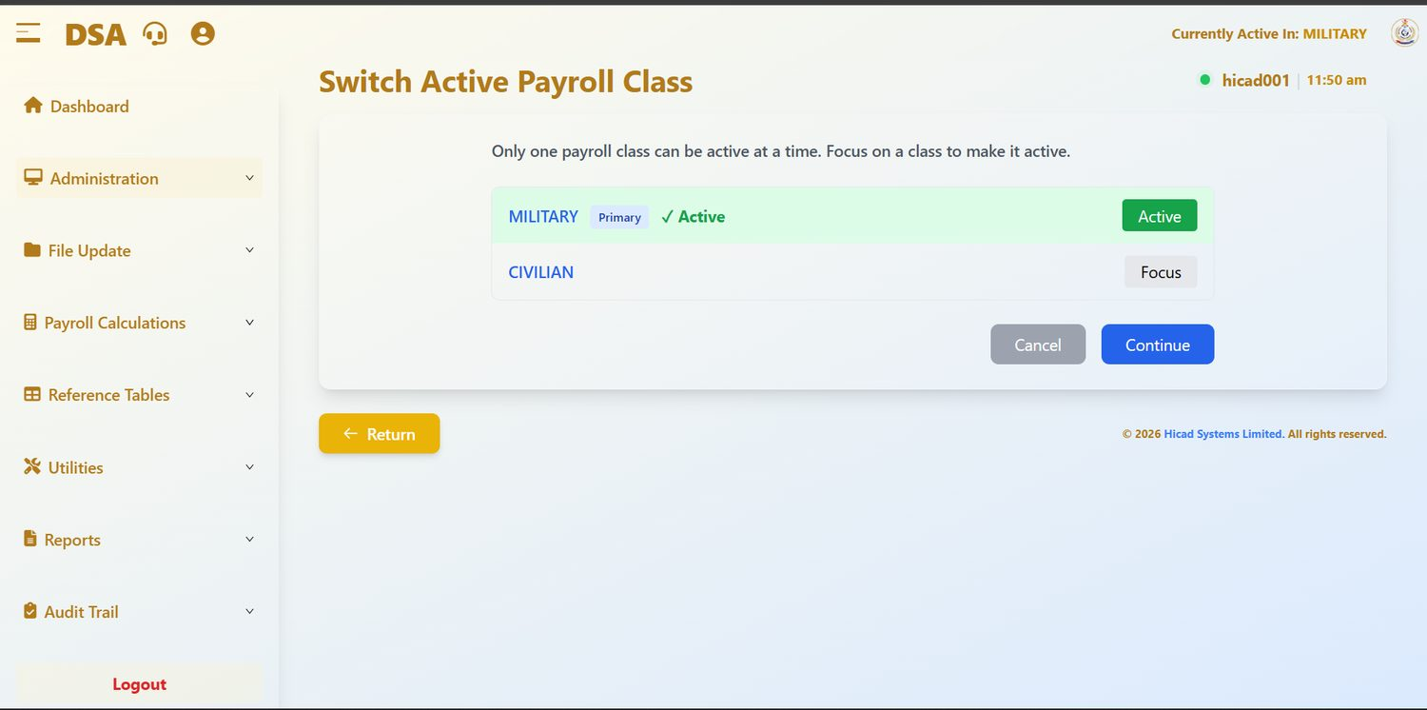
Figure 9.2 Switch Active Payroll Class. MILITARY is active (shown by the green highlight, the tick and the Active badge) and is marked Primary. CIVILIAN offers a Focus button.
- Find the class you want to work in.
- Press Focus on its row.
- Press Continue to confirm, or Cancel to stay where you are.
- Check the header. Currently Active In must now read the class you chose.
GOOD PRACTICE
Make this the first thing you do at the start of any piece of work and the last thing you check before entering data. It takes five seconds and it prevents the most common data-entry error in the system.

9.3 Changing a person's payroll class
Open Administration > Change Personnel Payroll Class. This screen moves personnel from one class to another: when a person is reclassified from military to civilian service, for example. The screen offers three Migration Type options.
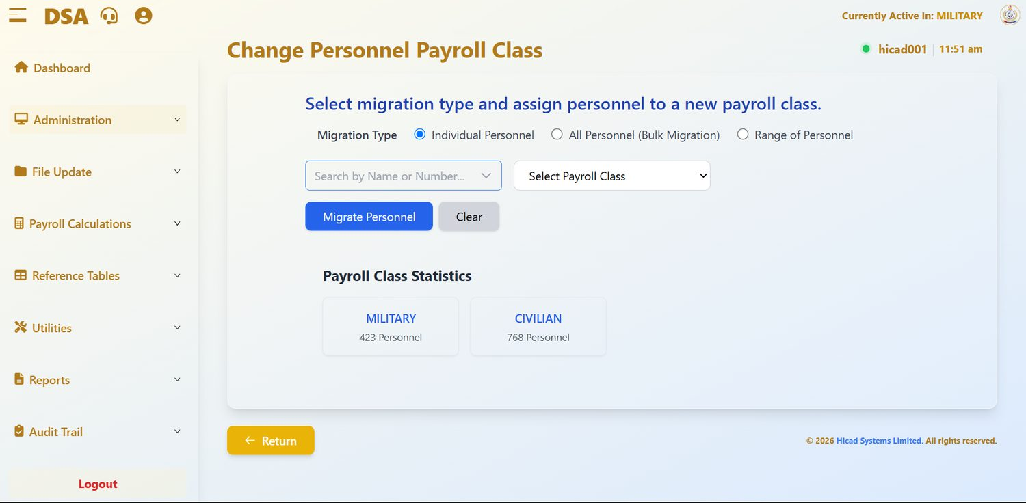
Figure 9.3 Change Personnel Payroll Class with Individual Personnel selected. The Payroll Class Statistics panel below shows the population of each class: 423 MILITARY and 768 CIVILIAN.

Individual Personnel
Moves one named person. This is the option to use for routine reclassifications.
- Select Individual Personnel.
- Type a name or service number into Search by Name or Number… and pick the person from the results.
- Choose the destination in Select Payroll Class.
- Press Migrate Personnel. Clear empties the form without doing anything.
- Confirm the move by checking the population figures in Payroll Class Statistics below.

All Personnel (Bulk Migration)
Moves every member of the currently active class into a target class in one action. Only the target class need be chosen.
CAUTION
Bulk migration affects every person in the active class and there is no undo button. Before pressing Migrate Personnel, note the current figures in Payroll Class Statistics, and take a class backup (Chapter 43). If the migration is wrong, the backup is your route back.

Range of Personnel
Moves a contiguous block: useful when a whole group changes class together. Set the first record in From and the last in To, choose the destination class and press Migrate Personnel.
NOTE
A range is worked out on the system's internal ordering of records, which follows service number. Before running a range migration, satisfy yourself that everybody between the two end points really should move: the range will include anyone whose service number falls between them.

9.4 Reading the class statistics
The Payroll Class Statistics panel gives a live count for every class. Note the figures before a migration and check them again afterwards: the number leaving one class should equal the number arriving in the other.

10. Change Registration Number
Administration > Change Registration Number · dashboard.html#change-registration-number
A small screen with large consequences. The registration (service) number is the key that ties a person to everything else in the system.

10.1 Why this screen is separate
A registration number (shown on most screens as Service No) is not an ordinary field. It links the personnel record to its payments and deductions, its cumulative figures, its salary history, its payslips and, where the person is also a system user, their User ID. Because of that, it cannot be amended on the personnel record itself. It is changed here, deliberately, on a screen of its own.
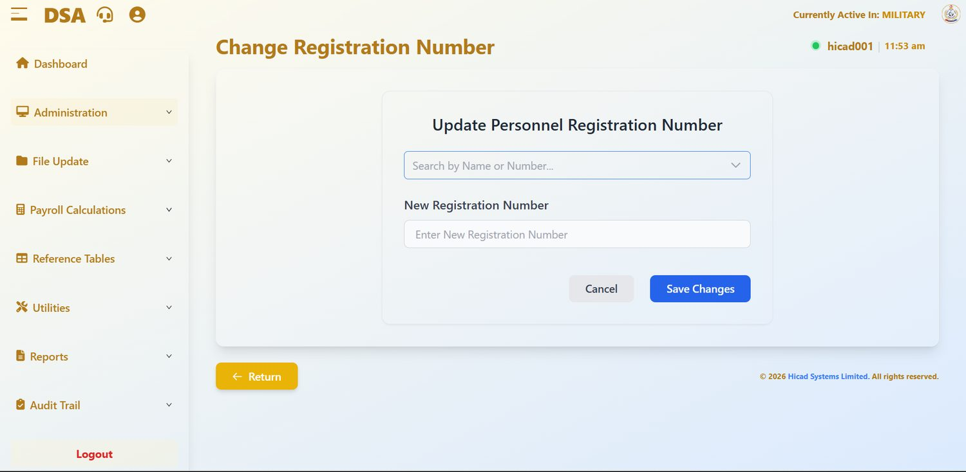
Figure 10.1 Change Registration Number. Find the person, enter the new number, save.

10.2 Making a change
- Open Administration > Change Registration Number.
- Use Search by Name or Number… to find the person. Confirm from the result that you have the right individual: check the name in full, not just the number.
- Enter the replacement in New Registration Number. Type it, read it back against the source document, and type it again if you are not certain.
- Press Save Changes, or Cancel to abandon.

10.3 Before you change a registration number
- Have written authority. A number change should be traceable to a document, not to a telephone call.
- Check the new number is not already in use. Two personnel sharing a number will produce misdirected pay.
- Do it between cycles where possible: after month-end and before the next month's input. Changing the key part-way through a live cycle is the point at which things go wrong.
- Tell the person. They sign in to the staff portal with this number.
CAUTION
The change propagates through the system. Historical records follow the person to the new number, which is what you want, but it also means that a number entered in error will move somebody else's pay history onto the wrong record. Check twice before saving.

NOTE
The installation shown in this manual mixes number formats: DSA/0001 beside NN/1868 on the Current Personnel list (Figure 15.1). Both are valid; what matters is that each number is unique and matches the person's own documents.

11. One-Off Payments
Administration > Irregular One-Off Payments > One-Off Requirement Setup · One-Off Fixed Amount By Rank · Individual One-Off Payment Input · One-Off Calculations · One-Off Reports
Payments made outside the normal recurring cycle: grants, subsidies, arrears settlements and special allowances.

11.1 How one-off processing works
One-off payments run as a small cycle of their own, sitting alongside the main monthly run. The five screens sit in a sub-menu, Irregular One-Off Payments ▸, inside Administration, and must be taken in order:
Stage | Screen | What happens
1 · Define | One-Off Requirement Setup | Declare which payment types are to be treated as one-off this cycle, and how each is to be worked out.
2 · Rate | One-Off Fixed Amount By Rank | For payments calculated by rank, set the amount for each rank.
3 · Capture | Individual One-Off Payment Input | Record the payment against individual personnel where it is not calculated automatically.
4 · Calculate & report | One-Off Calculations, One-Off Reports | Run the calculation, then produce bank reports, remittance advice, payment analysis or a summary.

NOTE
In the installation shown, no one-off payment had been set up: every list in Figures 11.1 to 11.3 is empty. That is the normal state between one-off exercises.

11.2 One-Off Requirement Setup
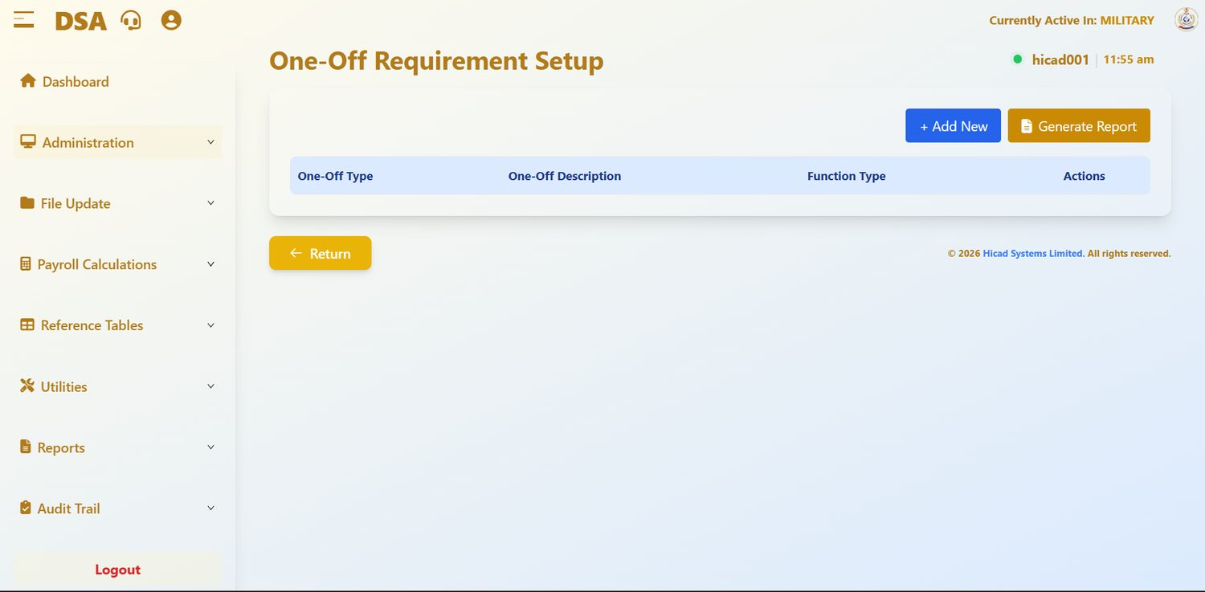
Figure 11.1 One-Off Requirement Setup, before any one-off type has been defined.
Field / control | What it is for
One-Off Type | The payment type code. These codes are defined on Pay Element Description (Chapter 34).
One-Off Description | The plain-language name of the payment.
Function Type | How the amount is arrived at, for example FIXED AMOUNT BY RANK, which takes the amount from the rank table in 11.3.
Actions | View, Edit and Delete against each row.
+ Add New | Adds a payment type to the one-off list.
Generate Report | Prints the setup for the record.

CAUTION
Check the whole list for repeated payment types before running a calculation. A duplicated entry can produce a duplicated payment.

11.3 One-Off Fixed Amount By Rank
This screen holds the amount payable at each rank for every one-off payment type whose function is fixed amount by rank.
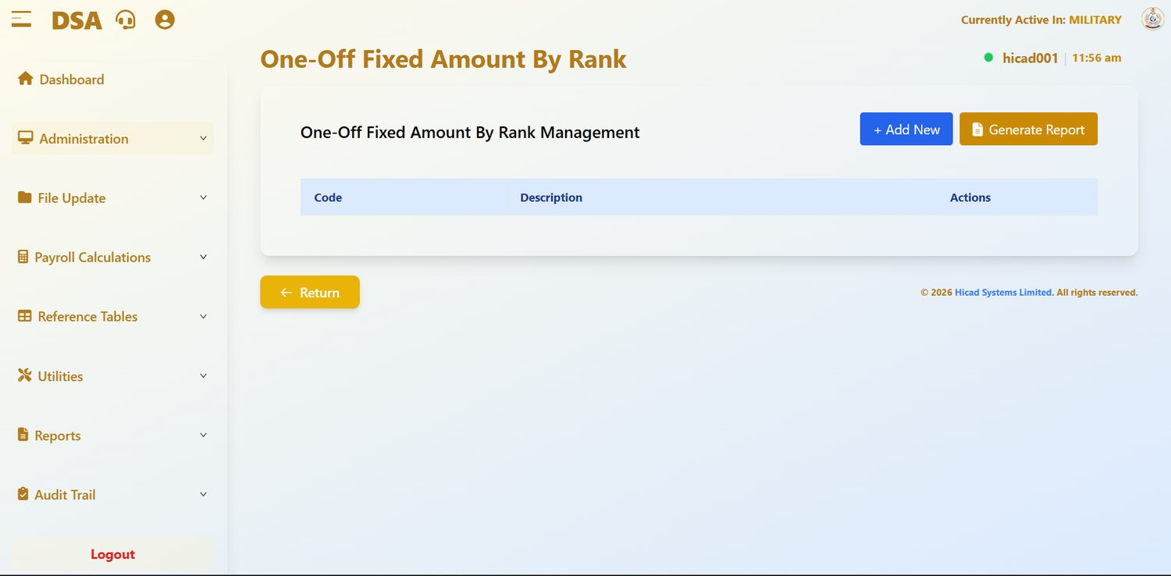
Figure 11.2 One-Off Fixed Amount By Rank Management. Each code is opened with View or Edit to reach the rank-by-rank amounts.
- Find the payment type in the list, or press + Add New to add one.
- Press Edit to open the rank schedule.
- Enter the amount payable at each rank. Where a rank is not entitled, leave it at zero rather than deleting the row.
- Save, then press Generate Report and check the printed schedule against the authority for the payment.
GOOD PRACTICE
Print the schedule and have it signed off before the calculation runs. The rank table is the point at which a single mistyped figure multiplies across every holder of that rank.

11.4 Individual One-Off Payment Input
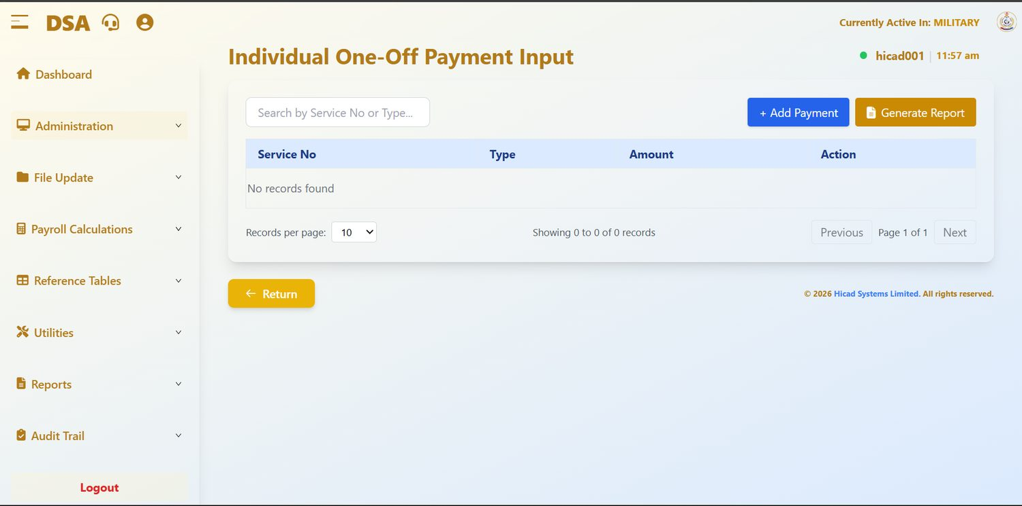
Figure 11.3 Individual One-Off Payment Input with no records. The search box, Add Payment and the paging controls are the same as on every list screen.
Field / control | What it is for
Search by Service No or Type… | Filters the list. Search by service number to see everything held against one person, or by type to see everyone receiving a given payment.
Service No | The person the payment belongs to.
Type | The payment, with its code.
Amount | The figure payable, in naira. A zero here means the payment is defined for that person but no amount has yet been set.
Action | Edit amends the entry; Delete removes it.
+ Add Payment | Records a new one-off payment against a person.
Generate Report | Prints the input for checking.

11.5 One-Off Calculations
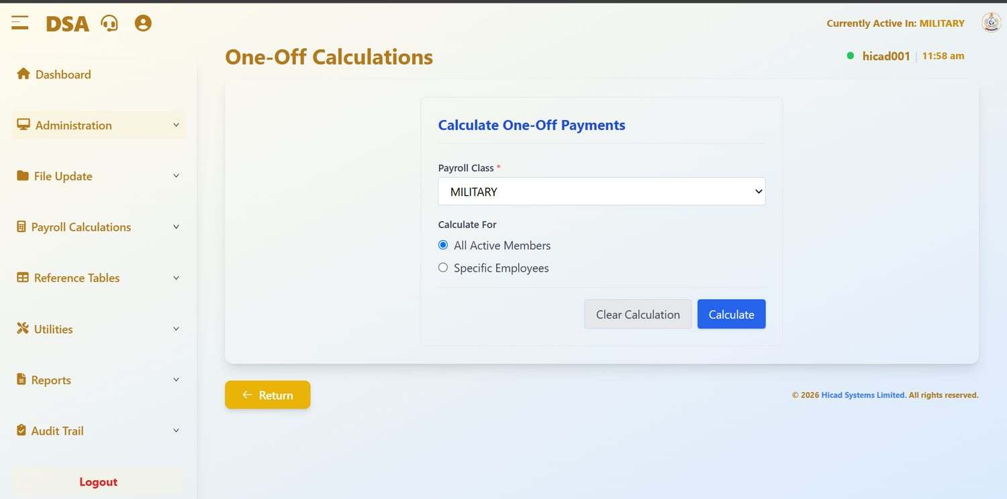
Figure 11.4 One-Off Calculations. Choose the payroll class, decide whether to calculate for everybody or for named employees, and press Calculate.
- Confirm the Payroll Class*. It defaults to the active class.
- Under Calculate For, choose All Active Members to process the whole class, or Specific Employees to name individuals.
- Press Calculate.
- If you need to start again, Clear Calculation removes the results so that the calculation can be re-run.
NOTE
Clear Calculation discards calculated one-off results; it does not remove the underlying input from Individual One-Off Payment Input. That is what makes it safe to re-run after correcting a rate.

11.6 One-Off Reports
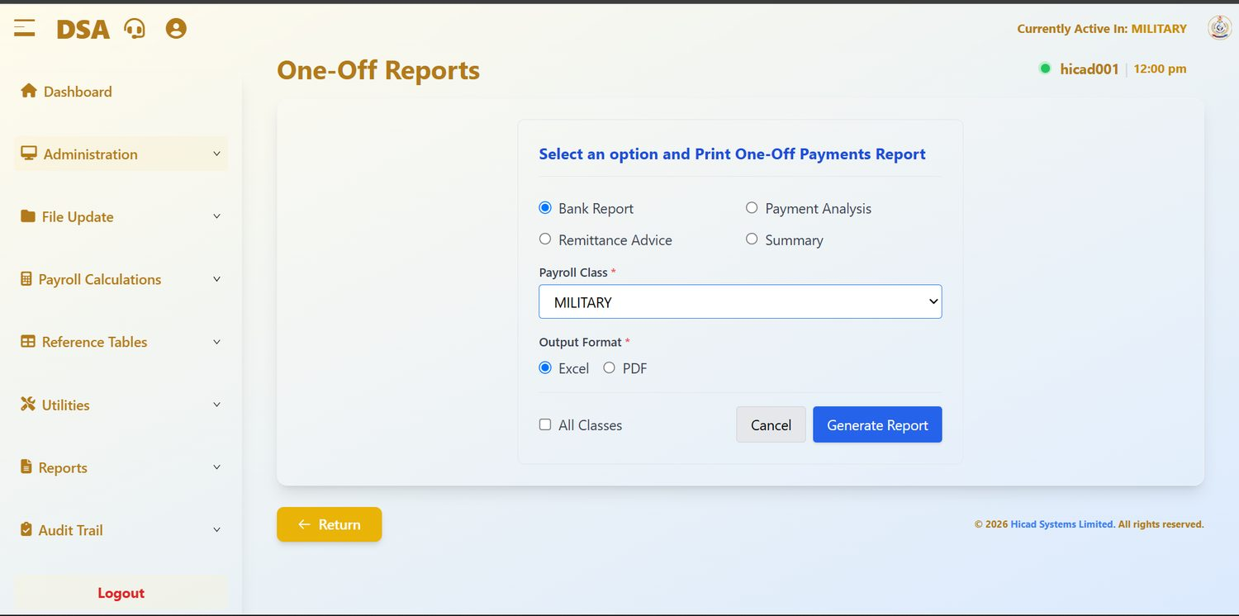
Figure 11.5 One-Off Reports. Four report types, a payroll class, an output format, and an option to cover all classes at once.
Field / control | What it is for
Bank Report | The schedule of payments by bank, for transmission to the banks.
Payment Analysis | An analysis of what was paid and to whom.
Remittance Advice | Advice notes for the payments made.
Summary | A one-page total by payment type.
Payroll Class * | The class to report on.
Output Format * | Excel for further analysis, PDF for a fixed record or for signature.
All Classes | Covers every class in one report instead of the single class chosen above.
Generate Report | Produces the report. Cancel abandons.

GOOD PRACTICE
Produce the Summary first and check the totals against your authority. Only when those agree should you produce the Bank Report: that is the one that moves money.

12. Company Profile
Administration > Company Profile · dashboard.html#company-profile
The organisation's own details, and a small number of settings that change how the payroll behaves.

12.1 What is held here
This screen holds the identity of the paying organisation (DEFENCE SPACE ADMINISTRATION) together with the addresses and switches that the rest of the system reads. It is set up at installation and changed rarely.
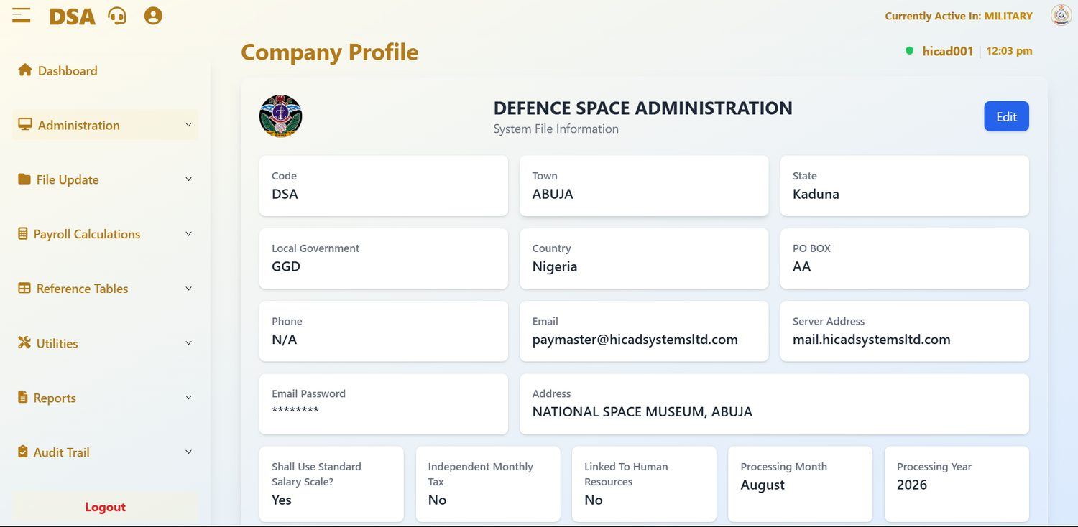
Figure 12.1 Company Profile. The Edit button at the top right opens every field for amendment.

Identity and address
Field / control | What it is for
Code | The short identifier for the organisation: DSA.
Town, State, Local Government, Country, PO BOX, Address | The postal identity of the pay office. The address appears on documents the system produces, so keep it accurate. The figure shows NATIONAL SPACE MUSEUM, ABUJA.
Phone, Email | Contact details. The email address is the account the system sends from.
Server Address, Email Password | The mail server the system uses to send documents. The password is masked. Changing these stops or starts outbound email: do not change them without your administrator.

Processing settings
Field / control | What it is for
Shall Use Standard Salary Scale? | When Yes, the calculation reads salaries from the salary scale table (Chapter 33) rather than from amounts held on individual records. Shown as Yes.
Independent Monthly Tax | When Yes, tax is worked out month by month rather than cumulatively across the year. Shown as No.
Linked To Human Resources | Whether the payroll is fed from a separate HR system. No here means personnel data is maintained in this system, as described in Part III.
Processing Month / Processing Year | The period the system considers current at organisation level.

NOTE
Several values in the figure look like set-up placeholders rather than final data: State reads Kaduna against a town of ABUJA, Local Government reads GGD, PO BOX reads AA and Phone reads N/A. Processing Month reads August 2026 while both classes are processing September (Figure 9.1). Confirm the correct values and update the profile; the address block is printed on documents the system produces.

CAUTION
The processing settings change the arithmetic of the payroll. Altering Shall Use Standard Salary Scale? or Independent Monthly Tax part-way through a year will produce a discontinuity between one month and the next that is difficult to explain to an auditor. Change them only between years, and only with written authority.

12.2 Editing the profile
- Press Edit at the top right.
- Amend the fields you need to change.
- Save.
- Confirm by opening the screen again and reading the values back.
NOTE
Because this screen affects every payroll class, restrict access to it. In a normal configuration only the HICAD role should be able to reach Company Profile.

13. Month-End and Year-End Processing
Administration > Month End Processing · dashboard.html#monthly-yearly-processing; Administration > Year End Processing · dashboard.html#yearly-processing
Closing the period. These are the two screens in the system that most reward a slow, careful reading before the button is pressed.

13.1 Month-End Processing
Month-end finalises the payroll for the period and rolls the system forward. Open Administration > Month End Processing.
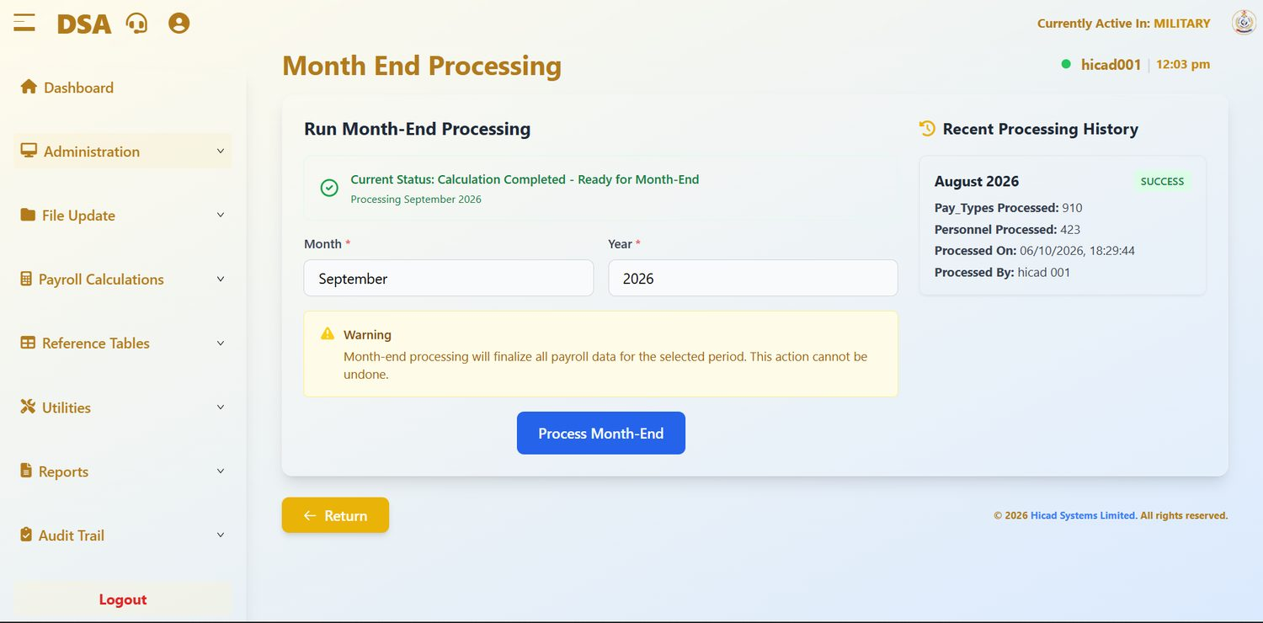
Figure 13.1 Month End Processing. The current status, the period to be processed, an explicit warning, and, on the right, the history of previous runs.

Reading the screen
Field / control | What it is for
Current Status | Where the period stands, from the ladder in Chapter 5.3. Calculation Completed - Ready for Month-End with Processing September 2026 beneath it means September has been calculated and may now be closed.
Month *, Year * | The period to be closed. These are pre-filled from the current processing period; check them.
Warning | “Month-end processing will finalize all payroll data for the selected period. This action cannot be undone.” The system means it.
Process Month-End | Runs the close. It is refused unless the status reads Calculation Completed, and refused for a period that has already been closed.
Recent Processing History | The last close, with the number of pay types processed, the number of personnel processed, when it ran and who ran it. In the figure: August 2026, SUCCESS, 910 pay types, 423 personnel, run by hicad 001 on 06/10/2026.

Before you press the button
Work through this list. Every item on it is cheaper to check now than to correct afterwards.
- The payroll calculation has completed for the period and shows BALANCED (Chapter 27).
- The calculation reports have been read and agreed (Chapter 28).
- The five exception reports listed in Chapter 5.5 have been run and any findings resolved.
- The payroll register and bank payment schedules have been produced and reconciled.
- Payslips have been generated.
- A payroll class backup has been taken (Chapter 43).
- The Month and Year on this screen are the period you actually intend to close.
CAUTION
There is no reversal. If a period is closed in error, the only route back is a restore from the backup taken before the run, which is why the backup is on the checklist above and not merely recommended.

Running the close
- Confirm Month and Year.
- Press Process Month-End.
- Wait for the run to finish; do not navigate away.
- Read the new entry in Recent Processing History and check the personnel count against what you expected.
- Confirm on the dashboard that Current Payroll Period has moved to the next month, and that Personnel Profile and Data Input have returned to the menu.
NOTE
Month-end is run for each payroll class in turn. Closing MILITARY does not close CIVILIAN. Switch class (Chapter 9) and repeat.

13.2 Year-End Processing
Year-end closes the payroll year, resets the annual cumulative figures and prepares the system for the new one. Open Administration > Year End Processing.
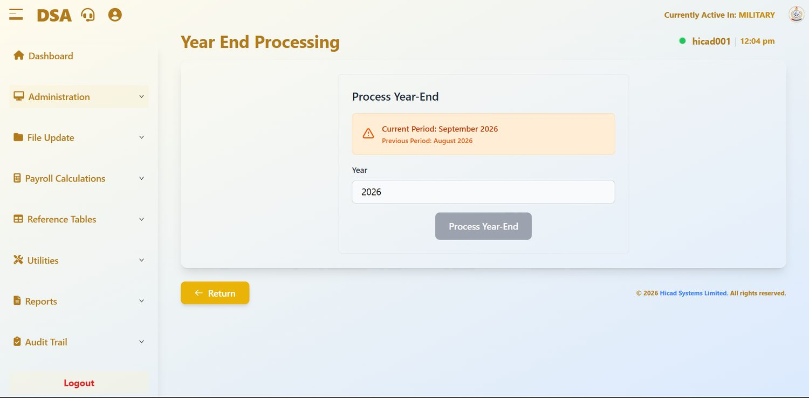
Figure 13.2 Year End Processing. The panel confirms the current and previous periods; Process Year-End is greyed because September is not the last month of the year.
Field / control | What it is for
Current Period / Previous Period | Confirmation of where the system stands. In the figure, September 2026 current and August 2026 previous.
Year | The year being closed.
Process Year-End | Runs the close. Greyed until the year's final month-end has been completed.

- Confirm that the final month of the year has been closed by month-end processing for every payroll class.
- Produce and file the annual statutory returns: tax by state (Chapter 51), National Housing Fund (Chapter 53) and pension (Chapter 54).
- Take a backup of every payroll class.
- Confirm the Year.
- Press Process Year-End.
CAUTION
Year-end resets annual cumulative figures: tax to date, gross to date and the rest. Any statutory return not produced before the year is closed becomes materially harder to produce afterwards. Print first, close second.

14. Adding New Personnel
Personnel Profile > Add New Personnel · dashboard.html#add-personnel
The longest form in the system, taken three steps at a time, plus next of kin, children, and bulk upload.
NOTE
The whole Personnel Profile menu is available only while data entry is open. Once payroll files are saved for the period it is withdrawn until month-end (Chapter 5.3). Plan joiners and amendments for the start of the cycle.

14.1 How the form is organised
A personnel record is built in pieces. Three step buttons run across the top of the form for the person's own details, and tabs at the top right switch between the person, their next of kin and their children.
Control | Holds
Step 1: Basic Details | Identity, origin, contact details and photograph.
Step 2: Official Info | Service dates, tax, pension, salary and bank details.
Step 3: Additional Info | Seniority, location, branch, command, specialisation and entitlements.
Personnel / NOK / Children tabs | Switch between the person's own record, their next of kin, and their children.
Batch Upload | Loads many personnel at once from a spreadsheet instead of keying them.
Current Personnel | Leaves the form and opens the list of existing personnel.

NOTE
The step buttons are navigation, not a wizard. You can move between them freely, and Submit at the foot of the form saves the record as a whole.

14.2 Step 1: Basic Details
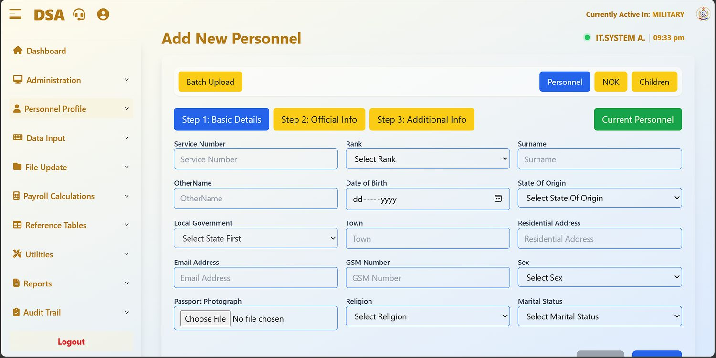
Figure 14.1 Add New Personnel, Step 1. The three step buttons run across the top; the record tabs and Batch Upload sit above them.
Field / control | What it is for
Service Number | The person's service (registration) number. This is the key to the whole record (see Chapter 10), so enter it from the source document and read it back.
Rank | Chosen from the list, which is maintained on the Title table (Chapter 41). Rank drives entitlement to fixed-amount-by-rank elements.
Surname, OtherName | The person's name. Enter it as it appears on their official documents; this is what will be printed on the payslip and sent to the bank.
Date of Birth | Entered as dd/mm/yyyy.
State Of Origin | Chosen from the list maintained in Chapter 39.
Local Government | Populates only after a state has been chosen: the field reads Select State First until then. Maintained in Chapter 40.
Town, Residential Address | Home address.
Email Address, GSM Number | Contact details. The email address is also the one the staff portal sends password resets to (Chapter 3.7).
Sex, Religion, Marital Status | Chosen from lists.
Passport Photograph | Press Choose File and select a recent photograph on a plain background.

14.3 Step 2: Official Info
The second step holds the service and financial data on which pay depends. This is the step to take slowly.
Field / control | What it is for
Date Joined | Date of entry. Used for seniority and long-service entitlements.
Date Commissioned | For officers. Leave blank where it does not apply.
Entry Mode | How the person entered service.
Date Left, Exit Mode | Completed only when the person leaves. See Chapter 16.
Taxed ? | YES or NO: whether the person is subject to PAYE. Only change this from the normal setting where there is a specific authority.
TaxID No(TIN) | Tax identification number.
Tax State | The state to which tax is remitted. This drives the Tax Payments By State return in Chapter 51: a wrong entry here sends money to the wrong state internal revenue service.
RSA(Pension) Code | The Retirement Savings Account number.
Pension Fund Administrator | The PFA holding that account, from the list in Chapter 36.
Salary Group | The salary scale the person is paid on, from Chapter 33, for example CONSSDSA.
Salary Grade | The grade and step within that group.
Bank Code, Bank Branch | The bank and branch the salary is paid to, from the list in Chapter 37.
Account Number | The salary account. It is also what a member of staff uses to set their portal password the first time (Chapter 3.7).

CAUTION
Account Number is the field most likely to cause a personal hardship if it is wrong. Enter it, read it back digit by digit against the source document, and, where the person is present, have them confirm it. After the record is saved, run Duplicate Account Number (Chapter 64) to make sure the account has not been keyed against somebody else as well.

14.4 Step 3: Additional Info
Field / control | What it is for
Seniority Date | Date of seniority in current rank.
Ship/Establishment | Where the person is placed, from the location list in Chapter 38.
Branch | Their branch, from Chapter 38.
Command | The command they fall under, from Chapter 30.
Specialisation | Trade or specialisation.
Present Appointment | Current appointment, entered as free text.
Award/Decoration | Awards held.
NHF Code | National Housing Fund number. Feeds the return in Chapter 53.
Country | Country of posting.
Accommodation Type, Rent Subsidy | Accommodation status and whether rent subsidy is payable (YES / NO).
Emolument Form Received?, IPPIS NO | Carried over from the platform the system shares with other payrolls. Neither feeds the DSA pay run (see Chapter 42); leave them as they are unless your administrator instructs otherwise.

When all three steps are complete, press Submit. Cancel abandons the record.
NOTE
Steps 2 and 3, and the NOK and Children tabs, were not captured for this edition. The fields listed are those the form displays.

14.5 Next of kin
Switch to the NOK tab to record next of kin.
- Press + Add.
- Enter the First Name*, Last Name*, Full Address*, Relationship*, Mobile Number* and Email Address*, and where known the date of birth, home number and place of work.
- Set Next Of Kin Type to Main or Alternate.
- Press Save. The entry appears in the table, with actions to amend or remove it.
- Repeat for any additional next of kin.
GOOD PRACTICE
Next of kin details are the ones nobody checks until they are needed urgently. Review them whenever a person's own contact details are updated.

14.6 Children
Switch to the Children tab and press + Add. Record the child's Full Name* and, where known, sex, date of birth, school and contact details, then press Save. The entries appear in the table with actions against them.

14.7 Batch Upload
Where a whole group is being enrolled, keying each record is not practical. Batch Upload loads them from a spreadsheet.
- Press Batch Upload.
- Press Download Sample Template and use it. The template carries the column headings the system expects; a file built from scratch will be rejected or, worse, loaded into the wrong columns.
- Complete the template. Only .xlsx and .csv files are accepted.
- Choose the file under Upload File.
- Press Upload. Cancel abandons.
- Open Current Personnel and confirm the record count has risen by the number of rows you loaded.
NOTE
The on-screen notes are worth taking literally: ensure the file is properly formatted before uploading, and duplicate Service Number will not be uploaded. A row silently missing after an upload is almost always a service number that already exists.

CAUTION
A batch upload writes many records in one action. Load a small test file of two or three rows first, check the result, and only then load the full file.

15. Current Personnel
Personnel Profile > Current Personnel · dashboard.html#current-personnel
The working list of everybody on the payroll in the active class.

15.1 The list
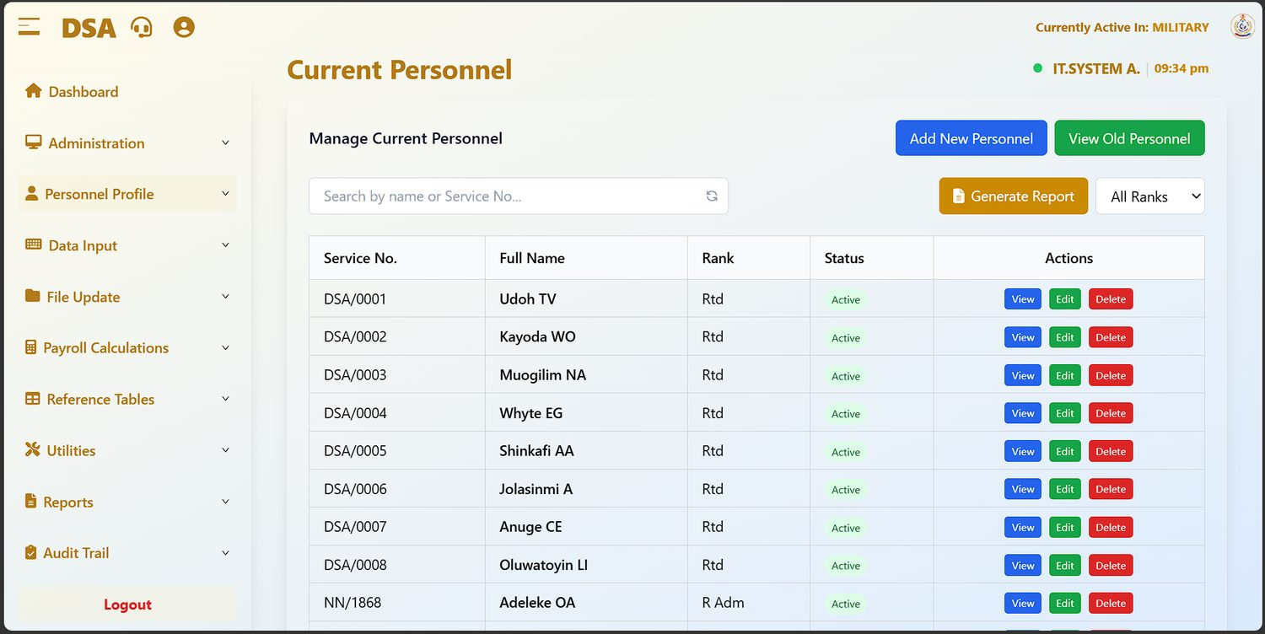
Figure 15.1 Current Personnel. The list is filtered to the active payroll class; each row carries View, Edit and Delete.
Field / control | What it is for
Search by name or Service No… | Filters the list as you type. The circular arrow beside it clears the search.
Generate Report | Opens the Current Personnel Reports screen described below.
All Ranks | Filters the list to a single rank.
Add New Personnel | Opens the form described in Chapter 14.
View Old Personnel | Switches to the list of personnel who have left (Chapter 16).
Service No., Full Name, Rank, Status | The record. Active in the status column means the person is on the live payroll.
Actions | View opens the record read-only, Edit opens it for amendment, Delete removes it.

NOTE
The rank column reflects exactly what is on each record. In the figure most rows read Rtd while one reads R Adm. Where a rank has been keyed inconsistently, correct it to the standard title list (Chapter 41): inconsistent ranks break the By Rank scope on every personnel report.

15.2 Maintaining a record
- Find the person using the search box.
- Press View first and read the record. If nothing needs to change, close it: a view leaves no edit footprint.
- If a change is needed, press Edit.
- Amend only the fields covered by your source document.
- Save, then re-open the record and read the changed values back.
CAUTION
Delete removes the personnel record. Where somebody has left, do not delete them: record the Date Left and Exit Mode on Step 2 of their record instead, so that they move to Old Personnel and their history is preserved (Chapter 16).

15.3 Current Personnel Reports
Generate Report opens a screen offering eight views of the personnel population. The same screen is on the Reports menu as Reports > Current Personnel Reports.
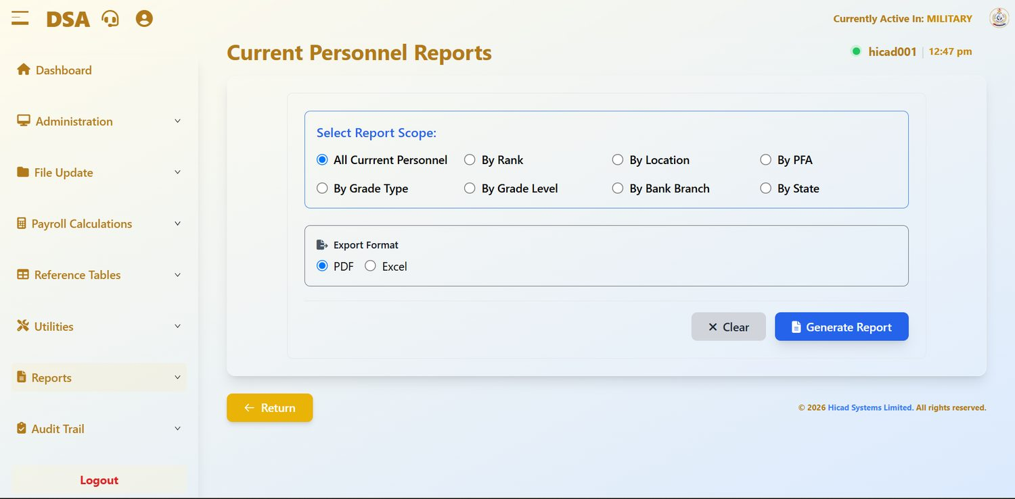
Figure 15.2 Current Personnel Reports. Choose a scope, choose PDF or Excel, and generate.
Scope | Produces
All Current Personnel | Everybody in the active class.
By Rank | Grouped by rank: the standard establishment return.
By Location | Grouped by location (Chapter 38).
By PFA | Grouped by pension fund administrator. Use this when reconciling with a PFA.
By Grade Type / By Grade Level | Grouped by salary grade type or level.
By Bank Branch | Grouped by paying branch. Useful before a bank reconciliation.
By State | Grouped by state of origin.

Choose PDF for a fixed record or a document for signature, or Excel where the figures are to be analysed further. Press Generate Report, or Clear to reset the choices.

16. Old and Exited Personnel
Personnel Profile > Old Personnel · dashboard.html#old-personnel; Reports > List Of Exited Members · dashboard.html#listof-exited-members
Where personnel go when they leave, and how to report on them.

16.1 Old Personnel
When a Date Left and Exit Mode are recorded on a personnel record, the person moves out of Current Personnel and into Old Personnel. They stop being paid; their history remains.
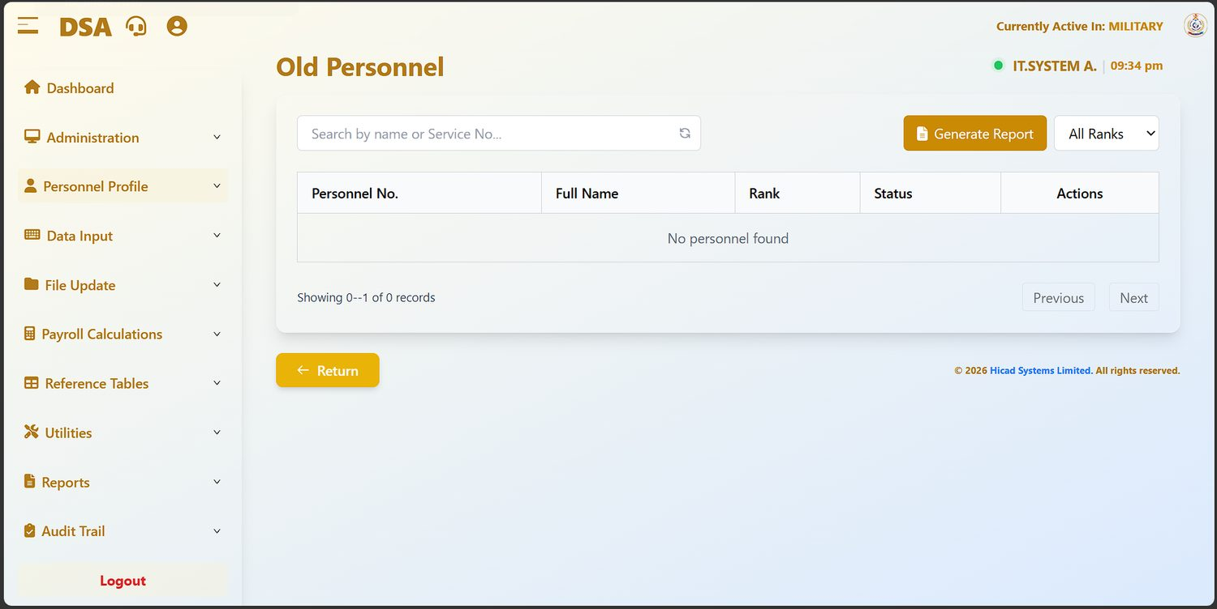
Figure 16.1 Old Personnel, empty in the installation shown: nobody had yet been recorded as having left.
Field / control | What it is for
Search by name or Service No… | Filters the list.
All Ranks | Filters to a single rank.
Generate Report | Opens the exited members report described below.
Personnel No., Full Name, Rank | The record.
Status | Inactive for everybody on this screen.
Actions | View, Edit and Delete.

NOTE
With no records the footer reads Showing 0--1 of 0 records. That is a display quirk of the empty list, not an error.

CAUTION
Resist the temptation to delete old records. They are the evidence behind any later query on a pension, a gratuity or a historical payment, and they cost nothing to keep.

16.2 List Of Exited Members
Generate Report, or Reports > List Of Exited Members, opens a report screen with eight scopes.
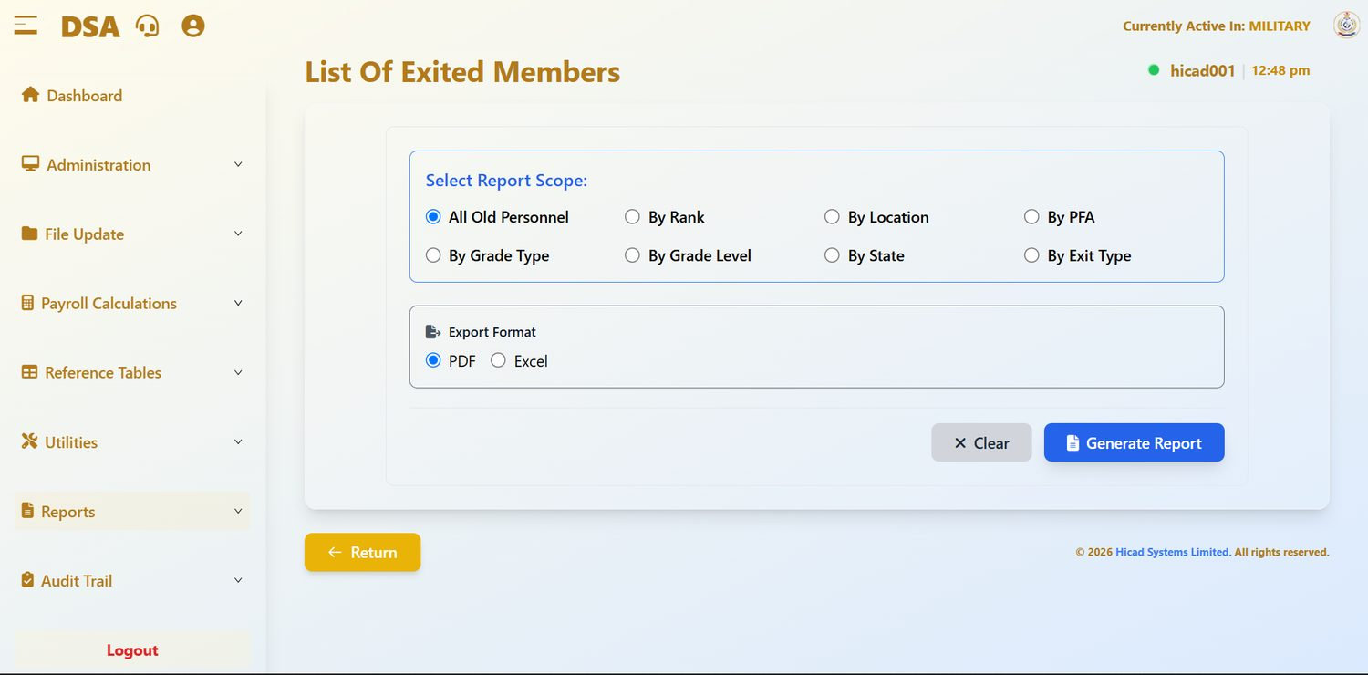
Figure 16.2 List Of Exited Members. The scopes mirror the current personnel report, with By Exit Type added.
Scope | Produces
All Old Personnel | Everybody who has left.
By Rank | Grouped by rank held on departure.
By Location | Grouped by last location.
By PFA | Grouped by pension fund administrator: the list to send a PFA when reconciling leavers.
By Grade Type / By Grade Level | Grouped by salary grade.
By State | Grouped by state of origin.
By Exit Type | Grouped by how the person left: retirement, resignation, discharge and so on. This is the most useful scope for wastage analysis.

Choose PDF or Excel and press Generate Report.
GOOD PRACTICE
Run By Exit Type at the end of each year alongside the year-end returns. It is the quickest evidence that leavers have been correctly recorded and removed from the live payroll.

17. Payments and Deductions
Data Input > Payments/Deductions · dashboard.html#payments-deductions; Data Input > Payments/Deductions(Batch Upload) · dashboard.html#payments-deductions-upload
The heart of monthly data capture. Everything variable that a person is to be paid, or is to have taken from them, is entered here.
NOTE
Like Personnel Profile, the Data Input menu is available only while data entry is open, and is withdrawn when payroll files are saved (Chapter 5.3).

17.1 The screen
Open Data Input > Payments/Deductions. The screen lists the payment and deduction records held for the current period in the active class.
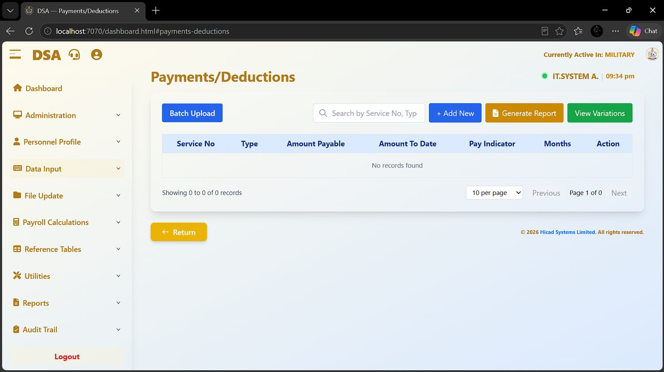
Figure 17.1 Payments/Deductions at the start of a period, before any records have been captured. This capture includes the browser address bar, showing the screen address.
Field / control | What it is for
Batch Upload | Switches to the bulk upload screen described in 17.3.
Search by Service No, Type… | Filters the list by person or by payment type.
+ Add New | Opens the form to capture one record.
Generate Report | Prints the captured input for checking.
View Variations | Opens the Variation to Payments/Deductions screen (Chapter 18).
Service No | The person the record belongs to.
Type | The payment or deduction, from the pay elements defined in Chapter 34.
Amount Payable | The amount for this period.
Amount To Date | The cumulative amount paid or deducted so far. For a loan or a recovery this is what makes it possible to see how much remains.
Pay Indicator | Governs how the record behaves: whether it recurs, and how it is treated by the calculation.
Months | How many months the record runs for. Used for instalment deductions.
Action | Edit or delete the record.

17.2 Capturing a record
- Confirm the active payroll class in the header and the processing period on the dashboard.
- Press + Add New.
- Enter the Service No. Confirm the name the system returns is the person you intend.
- Choose the Type.
- Enter the Amount Payable.
- Where the record is an instalment arrangement, set Months and check Amount To Date.
- Set the Pay Indicator according to the nature of the payment.
- Save, and confirm the record appears in the list.
NOTE
Showing 0 to 0 of 0 records at the start of a period is normal: the table is empty until capture begins. It is also a useful check: if it is not empty when you expect it to be, you may be looking at the wrong period or the wrong class.

17.3 Batch upload
For volume, use Data Input > Payments/Deductions(Batch Upload).
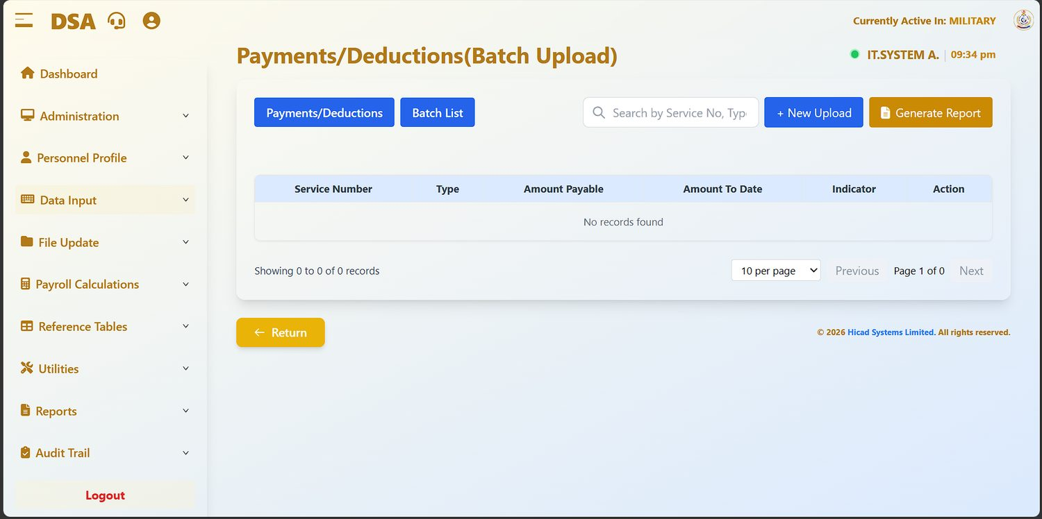
Figure 17.2 Payments/Deductions (Batch Upload). The Batch List button keeps a record of previous uploads.
Field / control | What it is for
Payments/Deductions | Returns to the single-record screen.
Batch List | Shows previous uploads, so you can see what was loaded and when.
+ New Upload | Starts an upload.
Generate Report | Prints what has been uploaded.
Search by Service No, Type… | Filters the uploaded records.

- Press + New Upload.
- Download and use the template offered.
- Complete one row per payment or deduction, with the service number, type, amount payable, amount to date and indicator.
- Upload the file.
- Check the record count, then use Generate Report and reconcile the total against your source document.
GOOD PRACTICE
Reconcile the uploaded total against the authority for the payment before you save the payroll files. A batch that is out by one row is easy to correct now and hard to explain after month-end.

18. Variation to Payments and Deductions
Data Input > Variation to Payments/Deductions · dashboard.html#variation-payments
Changing a payment or deduction that is already running, without disturbing its history.
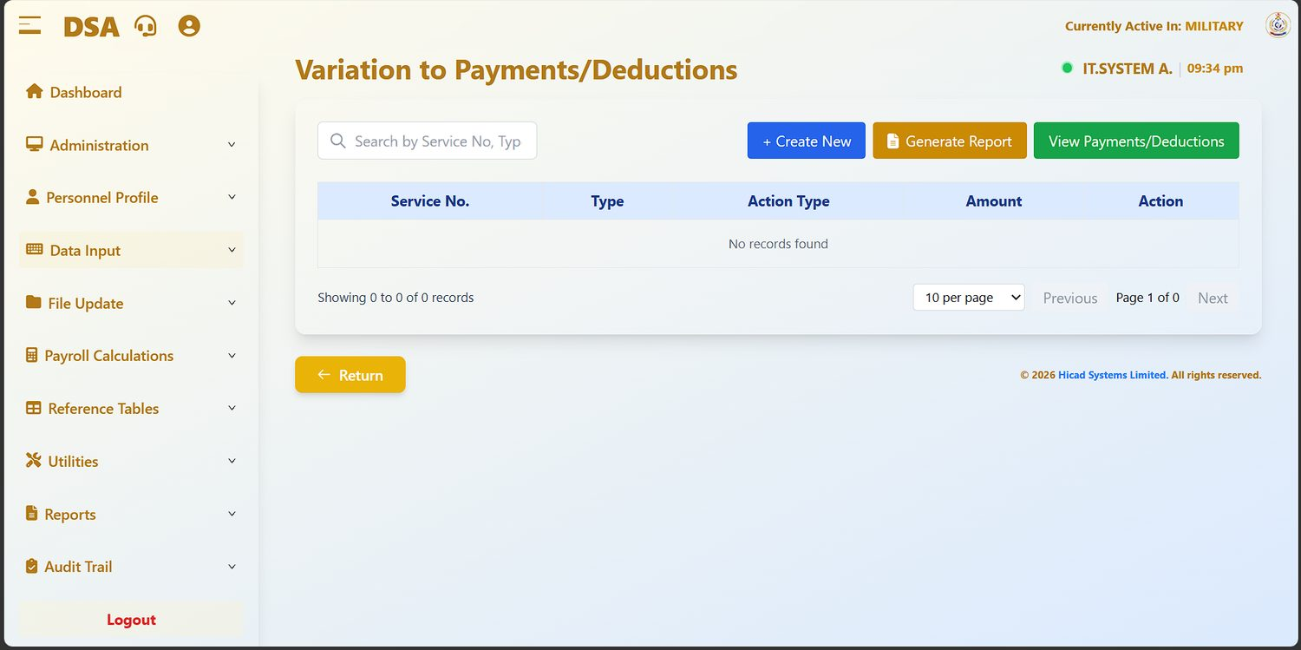
Figure 18.1 Variation to Payments/Deductions, before any variation has been recorded.
A variation records a change to an existing arrangement: increasing a deduction, suspending an allowance, altering an instalment. It is kept separate from the original record so that both the original and the change remain visible.
Field / control | What it is for
Search by Service No, Type… | Finds existing variations.
+ Create New | Records a variation.
Generate Report | Prints the variations captured for the period.
View Payments/Deductions | Returns to the main capture screen (Chapter 17).
Service No. | The person affected.
Type | The payment or deduction being varied.
Action Type | What is being done to it: the nature of the variation.
Amount | The revised figure.

- Press + Create New.
- Identify the person and the payment or deduction being varied.
- Choose the Action Type.
- Enter the revised Amount.
- Save, then press Generate Report and check the variation reads as you intended.
NOTE
Variations are listed separately on the Variation Input Listings report (Chapter 62), which can be produced by pay element, by employee or by operator. That report is the natural control document for this screen.

19. Cumulative Payroll Transfer
Data Input > Cumulative Payroll Transfer · dashboard.html#cumulative-payroll
Carrying year-to-date figures into the system: normally only when a payroll is first brought on, or when somebody transfers in mid-year.
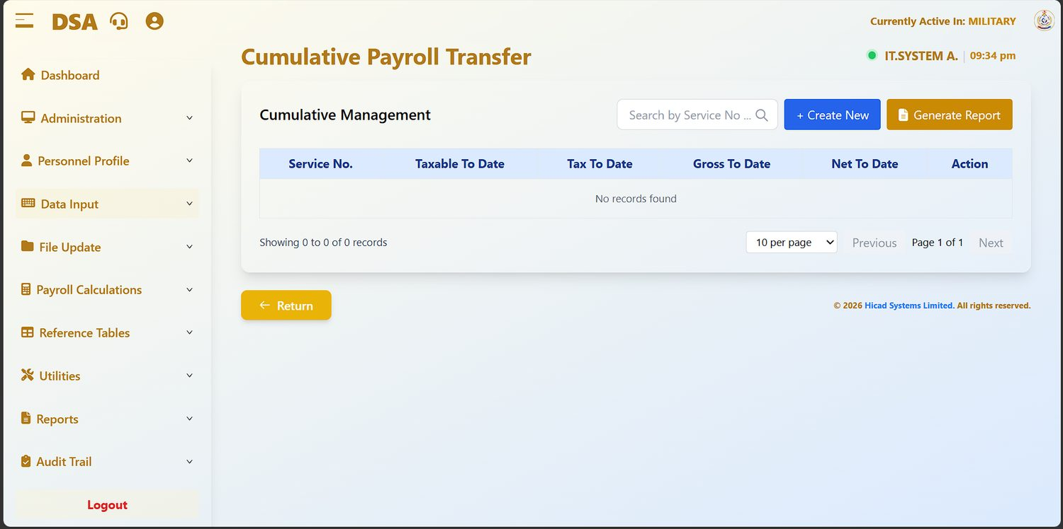
Figure 19.1 Cumulative Payroll Transfer, showing the four year-to-date figures the system holds.
Field / control | What it is for
Service No. | The person the cumulative figures belong to.
Taxable To Date | Taxable pay for the year so far.
Tax To Date | Tax deducted for the year so far.
Gross To Date | Gross pay for the year so far.
Net To Date | Net pay for the year so far.
+ Create New | Records cumulative figures for a person.
Generate Report | Prints the cumulatives held.

In normal running the system maintains these figures itself as each month-end is processed. You will only need this screen in two situations: when the payroll is first loaded part-way through a year, and when a person transfers in from another payroll carrying year-to-date figures with them.
CAUTION
Cumulative figures drive the tax calculation. An incorrect Taxable To Date or Tax To Date will produce a wrong tax deduction for every remaining month of the year. Enter these only from a formal statement of pay, and have them checked by a second person.

20. Input Documentation
Data Input > Input Documentation · dashboard.html#input-documentation
The per-person input form: what has been captured against one individual this period.
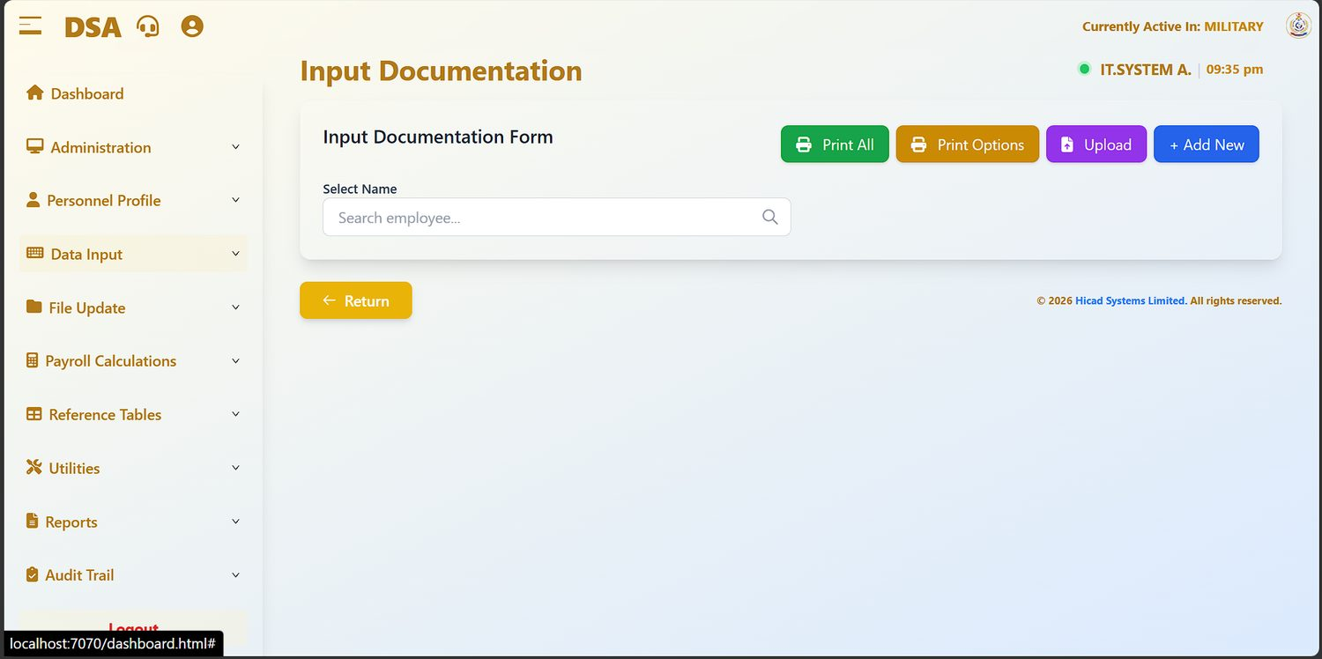
Figure 20.1 Input Documentation. Search for a person to see and print their input form.
Field / control | What it is for
Select Name / Search employee… | Find the person whose input you want to see.
Print All | Prints input documentation for everybody.
Print Options | Sets what the printed form contains.
Upload | Loads input documentation from a file.
+ Add New | Adds an input documentation record.

This screen is the natural answer to the question “what have we actually put through for this person this month?”. It is worth using whenever a query arrives, before opening any of the maintenance screens.
GOOD PRACTICE
Print the input documentation for anybody whose pay is queried, and file it with the query. It is a single sheet that shows exactly what was captured, and it usually settles the matter.

21. Arrears Calculations
Data Input > Arrears Calculations · dashboard.html#arrears-calculations
Working out back pay owed when a change of grade or of rate is applied retrospectively.
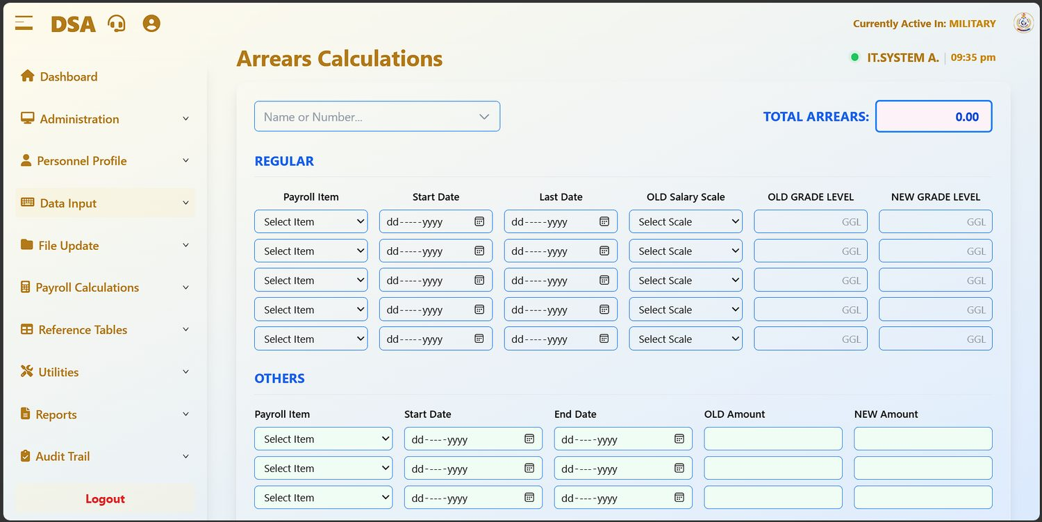
Figure 21.1 Arrears Calculations. The REGULAR block handles grade changes; the OTHERS block handles any other retrospective difference. The running total sits at the top right.

21.1 The two blocks

REGULAR: arrears arising from a grade change
Field / control | What it is for
Payroll Item | The element the arrears relate to.
Start Date / Last Date | The period the arrears cover.
OLD Salary Scale | The scale in force before the change.
OLD GRADE LEVEL / NEW GRADE LEVEL | The grade before and after, entered in the grade-level form the boxes prompt for (GGL).

OTHERS: any other retrospective difference
Field / control | What it is for
Payroll Item | The element concerned.
Start Date / End Date | The period covered.
OLD Amount / NEW Amount | The figures before and after. The system works out the difference across the period.

21.2 Producing an arrears calculation
- Find the person in Name or Number….
- Complete a line in REGULAR for each grade change, or in OTHERS for each rate change.
- Set the dates carefully. The period boundaries are what determine the number of months in the calculation, and a date out by one day can be a month out in the answer.
- Press Calculate. TOTAL ARREARS at the top right updates.
- Press Print and check the calculation line by line against the authority. Cancel abandons the calculation.
- Enter the agreed total as a payment on Payments/Deductions (Chapter 17), or through the one-off route in Chapter 11 where it is being paid as a one-off.
CAUTION
Arrears are paid retrospectively and are frequently large. Have the printed calculation checked and signed by somebody other than the person who prepared it before the figure is entered for payment.

22. Save Payroll Files
File Update > Save Payroll Files · dashboard.html#save-payroll-files
Step 5 of the cycle: commit the input for the period and close data entry.
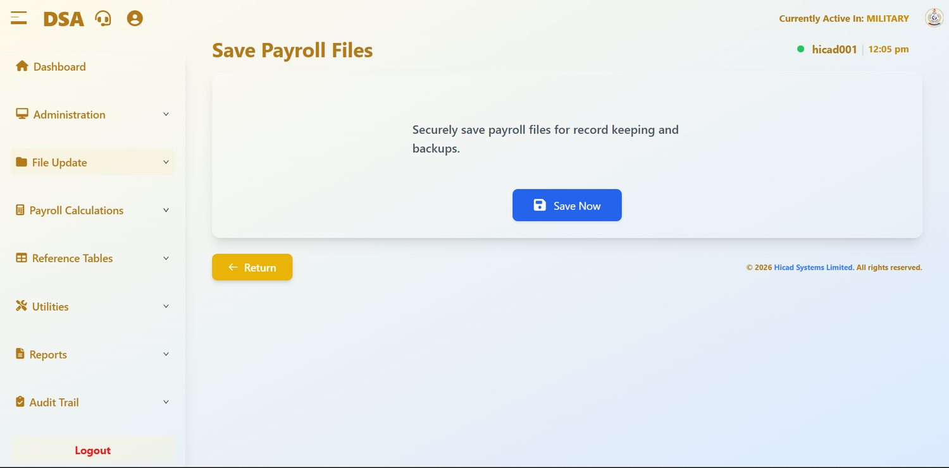
Figure 22.1 Save Payroll Files. A single action, with its purpose stated on the screen.
The purpose of this screen is stated on it: securely save payroll files for record keeping and backups. It is the point at which the input for the period is committed to the record, and it is the lock that closes data entry (Chapter 5.3).

22.1 Saving
- Confirm that every source document for the period has been captured or uploaded.
- Press Save Now.
- Read the confirmation. It names the period and warns: After Saving, you can not make changes to the payroll data.
- Press Yes, Save, or Cancel to go back.
- Wait for Payroll files saved successfully!, then press Go to Personnel Data to move on to Chapter 23.
CAUTION
Saving closes data entry for the period. The Personnel Profile and Data Input menus disappear until month-end. Anything found afterwards has to be handled by recalling the files (Chapter 26), which sends you back to the start of the File Update sequence.

NOTE
If the files have already been saved for the period, the screen says so (You have already saved Payroll Files for this period. To make new changes, recall Payroll Files.) and offers the way on to the next step.

NOTE
This is the first of four screens that unlock in sequence. Save Payroll Files releases Changes in Personnel Data, which releases the Input Variable Report, which releases the Master File Update. Work down the File Update menu in order and each screen will open as you reach it.

23. Changes in Personnel Data
File Update > Changes in Personnel Data · dashboard.html#changes-personnel-data
Step 6: the control report listing every change made to personnel records.
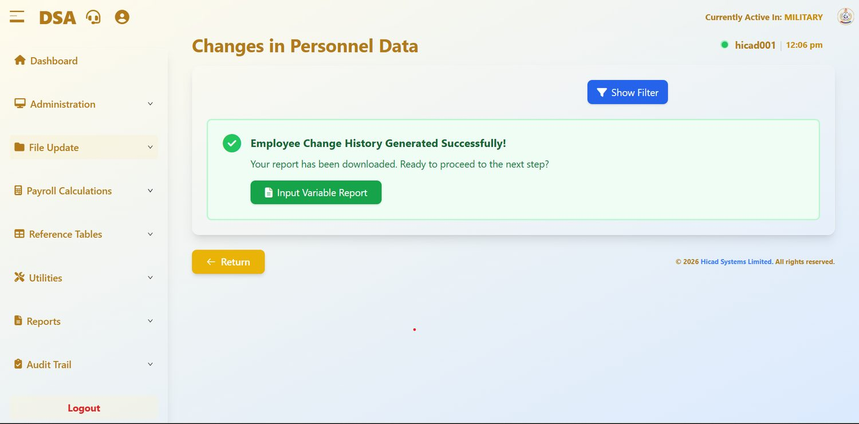
Figure 23.1 Changes in Personnel Data after the report has been produced. The green panel confirms the download and offers the next step.
This report lists the amendments made to personnel records: new records, changed ranks, changed bank details, changed salary grades. It exists so that somebody other than the person who keyed the changes can read them before they affect pay.

23.1 The lock
Until the payroll files are saved the screen shows Personnel Details Report Not Available Yet: this section will become available once the payroll files are saved, with the instruction first ensure you have saved payroll files and a Save Payroll Files button.

23.2 Using the report
- Complete Save Payroll Files (Chapter 22).
- Return here and press Show Filter. Choose All Personnel or Specific Personnel, set the Period Range (Required) (From and To, year and month) and choose PDF or Excel.
- Press Generate Report. The report downloads, and the screen shows Employee Change History Generated Successfully!
- Read it against the source documents for the period. Every change should be traceable to an authority, and the report should be checked and signed by a supervisor.
- Press Input Variable Report to move on to Chapter 24.
GOOD PRACTICE
Pay particular attention to changed bank account numbers and changed salary grades. Those two categories account for most of the corrections that arise after a pay run.

24. Input Variable Report
File Update > Input Variable Report · dashboard.html#input-variable-report
Step 7: the control report listing the variable input captured for the period.
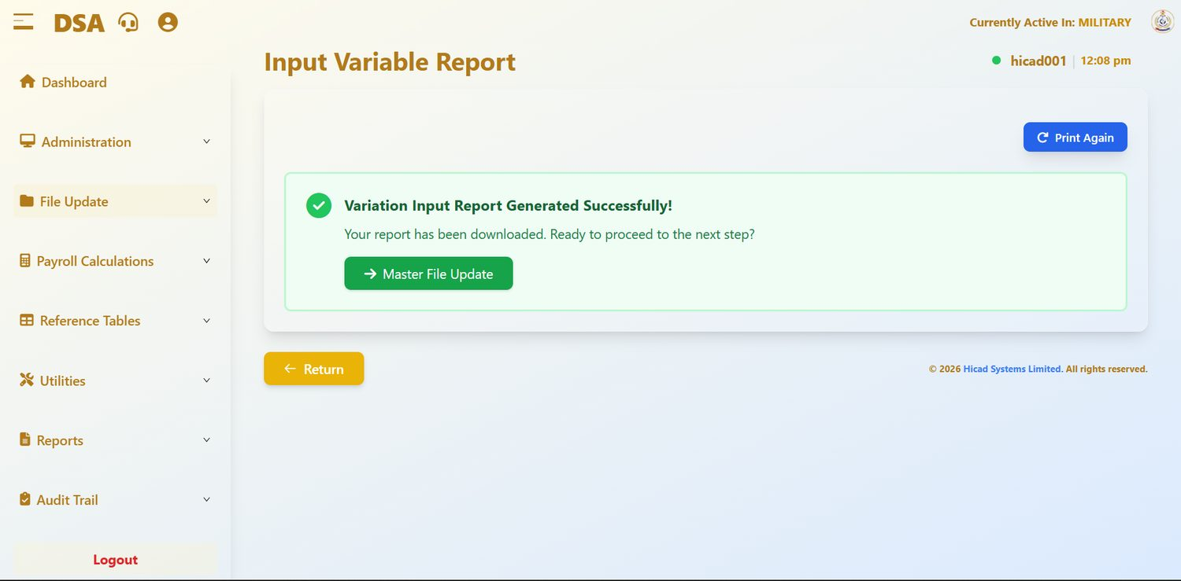
Figure 24.1 Input Variable Report after the report has been produced. Print Again reproduces it; Master File Update moves on.
Where Chapter 23 covers changes to standing data, this report covers the variable input for the period: the payments, deductions and variations captured in Part IV. Together, the two reports account for everything that can move a person's pay this month.

24.1 The lock
Until the personnel changes have been printed, the screen shows Input Variable Report Not Available Yet (this section will become available once the personnel data changes are printed) with a button to go back and do it.

24.2 Using the report
- Complete Changes in Personnel Data (Chapter 23).
- Return here and produce the report. On success the screen reads Variation Input Report Generated Successfully!; Print Again reproduces it at any time.
- Reconcile the totals against the source documents and the batch upload totals from Chapter 17.
- Investigate anything that does not reconcile before running the master file update. After that point the figures are committed.
- Have the report checked and signed, file it with the personnel changes report, and press Master File Update.

25. Master File Update
File Update > Master File Update · dashboard.html#master-file-update
Step 8: writing the input into the master records.
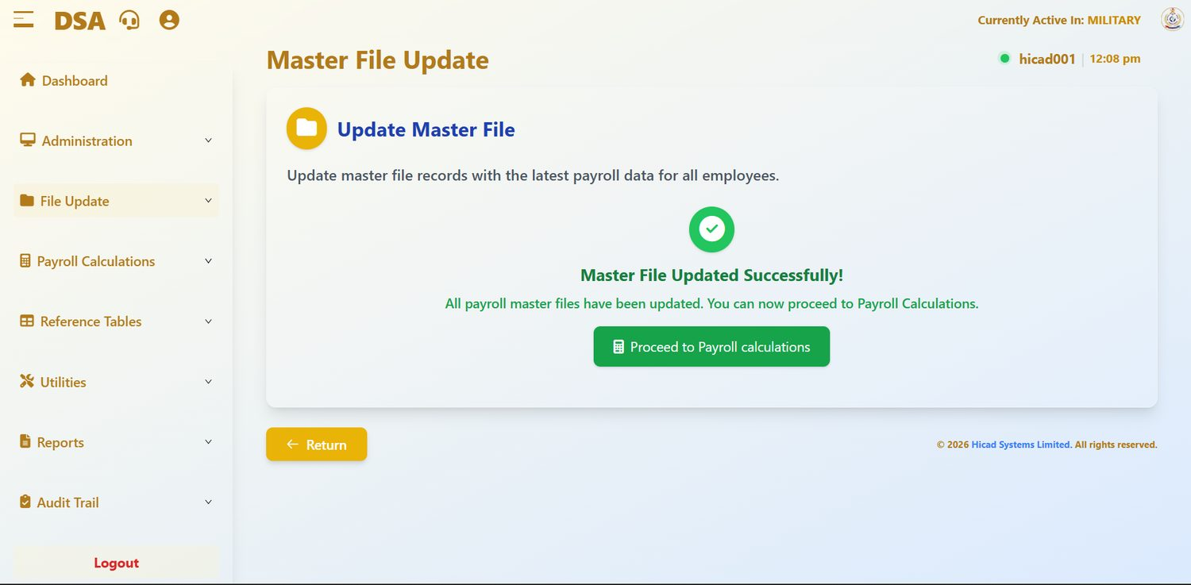
Figure 25.1 Master File Update, completed. The confirmation offers the way on to Payroll Calculations.
The master file update takes the reported input and writes it into the master records, ready for the calculation. Its purpose is given on the screen: update master file records with the latest payroll data for all employees.

25.1 The lock
Until the input variable report has been printed, the action button is disabled and labelled Waiting for Input Variable Report. Once the update has run, it cannot be run again for the same period.

25.2 Running the update
- Complete Input Variable Report (Chapter 24).
- Return here. The button becomes available.
- Press it and wait for Master File Updated Successfully!: all payroll master files have been updated.
- Press Proceed to Payroll calculations (Chapter 27).
CAUTION
After the master file update, the data the calculation will use is fixed. Corrections found after this point must be handled in the following period, or by recalling the payment files and working through the sequence again. Read the two control reports properly before you get here: that is what they are for.

26. Recall Payment Files
File Update > Recall Payment Files · dashboard.html#recall-payment-files
Reopening the period when something has to be corrected after the files were saved.
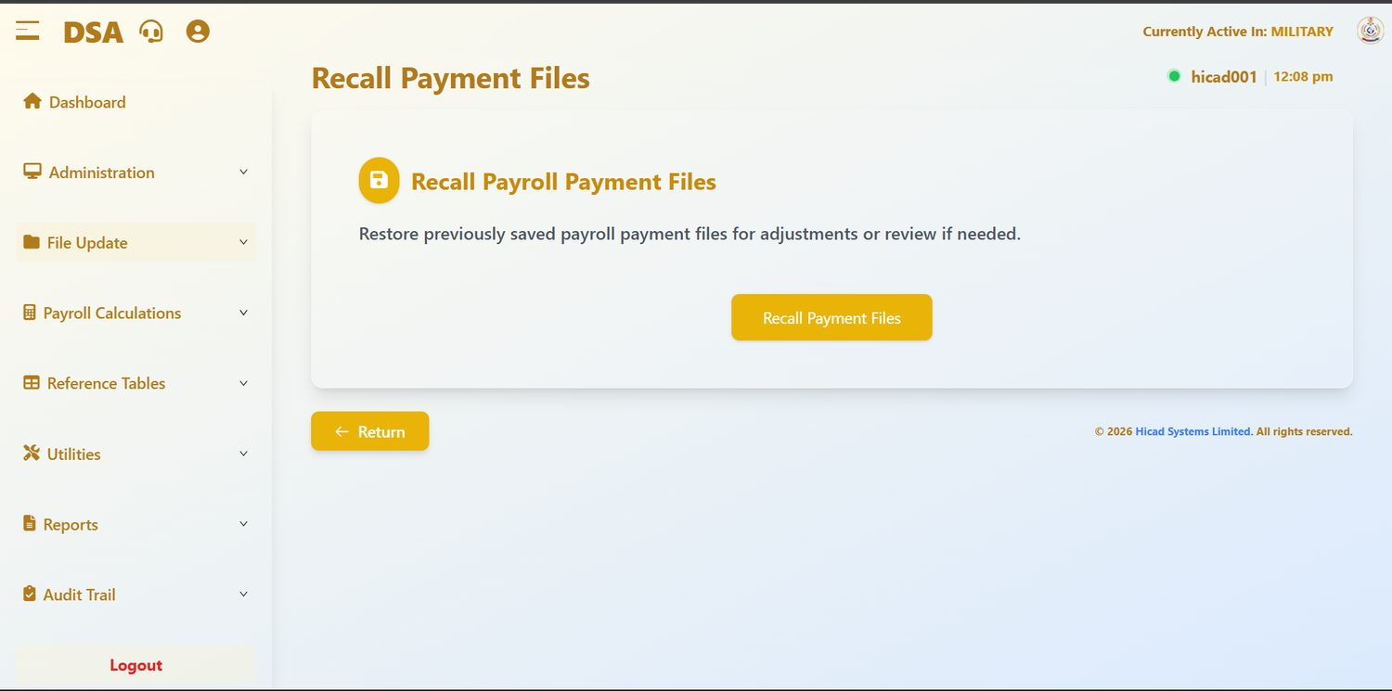
Figure 26.1 Recall Payment Files. A single action, described plainly on the screen.
The screen restores previously saved payroll payment files for adjustments or review if needed. It is the counterpart to Save Payroll Files in Chapter 22: it puts the class back to Data Entry Open, so that the Personnel Profile and Data Input menus return and the input can be corrected.
- Open File Update > Recall Payment Files.
- Press Recall Payment Files.
- Make the correction in Personnel Profile or Data Input.
- Work down the File Update sequence again from Save Payroll Files (Chapters 22 to 25) before calculating.
CAUTION
Recalling takes the class back to the start of the sequence, whatever stage it had reached, including after a calculation. Expect to repeat Chapters 22 to 27, and note on the file why the recall was necessary.

27. Payroll Calculations
Payroll Calculations > Payroll Calculations · dashboard.html#payroll-calculations
Step 9: the calculation itself, and the balance check that comes with it.
This screen calculates pay for every active record in the active payroll class. Its scope is stated on the screen: calculate payroll for all employees.

27.1 Running the calculation
- Confirm the active payroll class in the header.
- Read Processing Month and Processing Year on the screen.
- Press Calculate Payroll. The confirmation lists what will happen: salaries calculated, tax and deductions computed, reconciliation performed. Press Yes, Calculate Payroll.
- Wait for Payroll Calculation Successful! The calculation covers every record in the class; do not navigate away from the screen while it runs.
- Press View Results and read the summary described below.
NOTE
The button is refused until the master file update is complete: the screen says Ensure Master File Update is completed before calculating and offers a Master File Update button. Once a period has been calculated it cannot be calculated again; to recalculate, recall the payment files (Chapter 26).

27.2 Reading the result
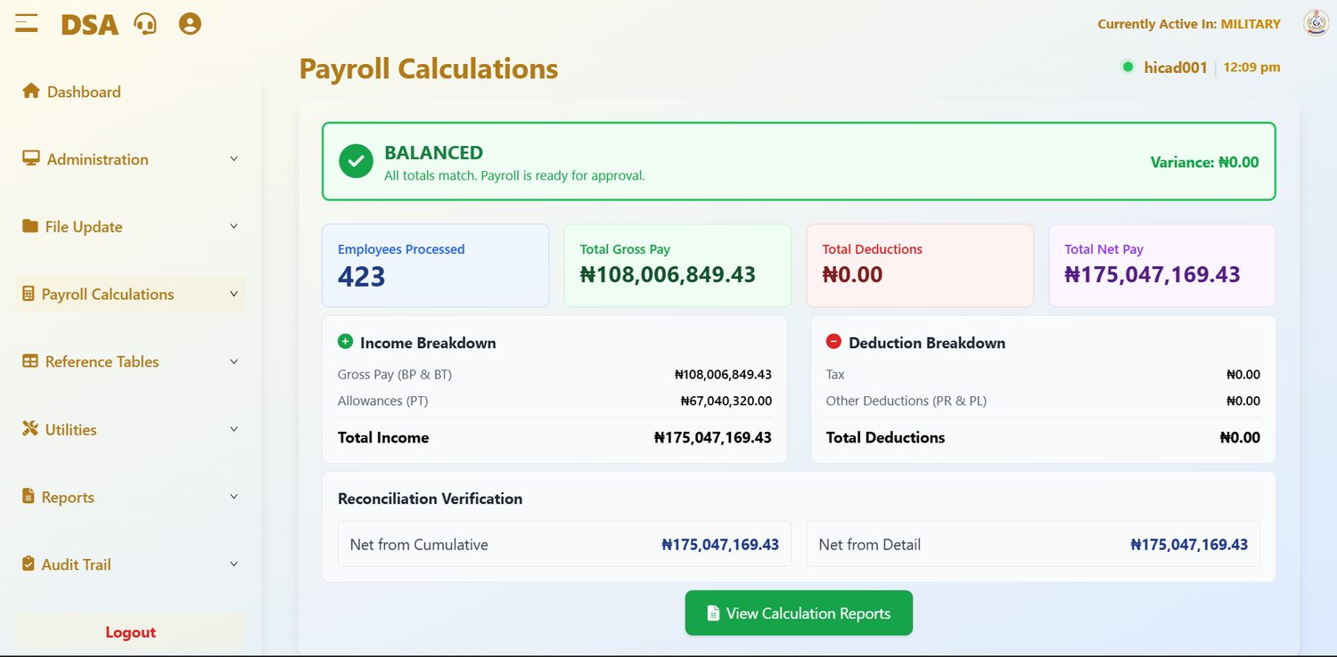
Figure 27.1 Payroll Calculations after a successful run for September 2026. The BALANCED banner confirms that the two independent net-pay totals agree.
Field / control | What it is for
BALANCED / Variance | The headline check. BALANCED: All totals match. Payroll is ready for approval. with Variance: ₦0.00 means the net pay worked out from the cumulative totals equals the net pay worked out line by line.
Employees Processed | The number of records calculated. Compare it with Current Active Personnel on the dashboard: 423 against 423 in this case.
Total Gross Pay | The basic pay elements only: Gross Pay (BP & BT) in the Income Breakdown.
Total Deductions | Tax plus other deductions.
Total Net Pay | What will be paid out.
Income Breakdown | Gross Pay (BP & BT) plus Allowances (PT) gives Total Income.
Deduction Breakdown | Tax plus Other Deductions (PR & PL) gives Total Deductions.
Reconciliation Verification | Net from Cumulative and Net from Detail: the two totals the balance check compares.
View Calculation Reports | Opens Chapter 28.

NOTE
Read the tiles together. In the figure Total Gross Pay is ₦108,006,849.43 while Total Net Pay is ₦175,047,169.43, higher than gross, because the gross tile shows basic pay only and the ₦67,040,320.00 of allowances sit in the Income Breakdown. With deductions at ₦0.00, net equals total income. A month with no tax and no deductions at all is worth confirming against expectation (see Chapter 32).

GOOD PRACTICE
Take a payroll class backup (Chapter 43) immediately before calculating. It is the cheapest possible insurance and takes less than a minute.

NOTE
The calculation is run separately for each payroll class. Complete a class, then switch class (Chapter 9) and repeat.

28. Calculation Reports
Payroll Calculations > Calculation Reports · dashboard.html#calculation-reports
Reading the result before anybody is paid.
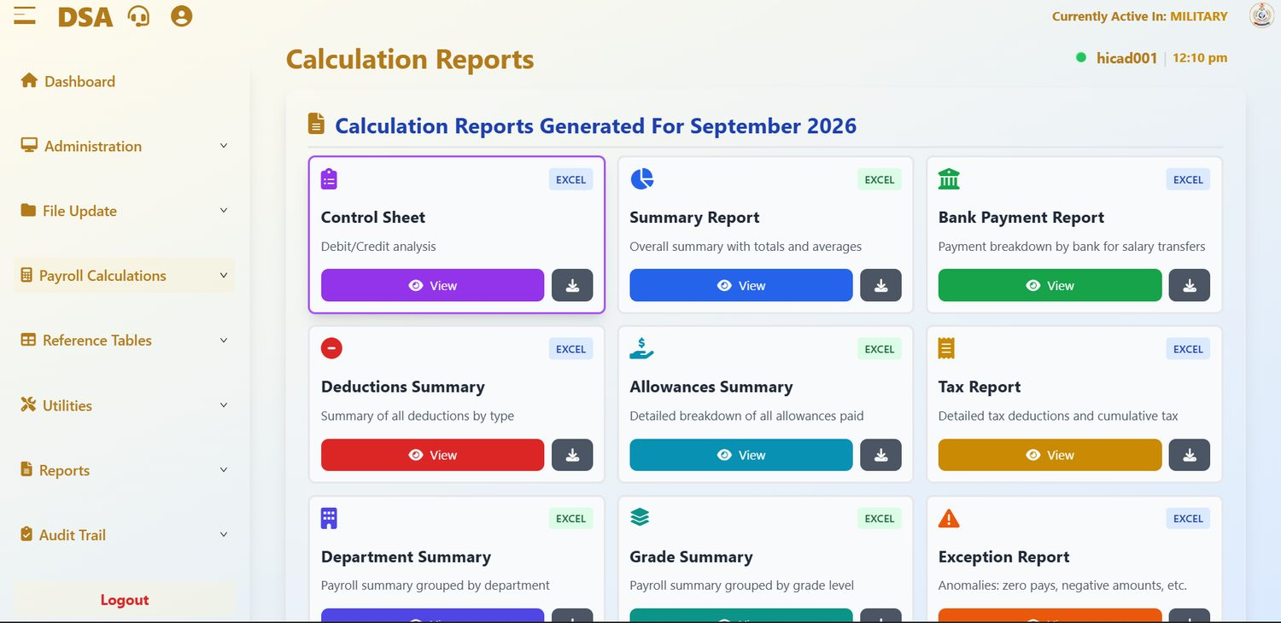
Figure 28.1 Calculation Reports Generated For September 2026. Each card can be viewed on screen or downloaded; all are produced as Excel.
Until the calculation has run, the screen shows Payroll Calculations Not Complete with a button to go to Payroll Calculations. Afterwards it shows a card for each report on the period just calculated. Each card has a View button and a download button.
Report | What it shows
Control Sheet | Debit/credit analysis of the run.
Summary Report | Overall summary with totals and averages.
Bank Payment Report | Payment breakdown by bank for salary transfers.
Deductions Summary | Summary of all deductions by type.
Allowances Summary | Detailed breakdown of all allowances paid.
Tax Report | Detailed tax deductions and cumulative tax.
Department Summary | Payroll summary grouped by department.
Grade Summary | Payroll summary grouped by grade level.
Exception Report | Anomalies: zero pays, negative amounts, etc.

NOTE
The figure shows the first nine cards; scroll down for any further reports your version offers.

28.1 What to check
- The number of records calculated against the number of active personnel in the class.
- The gross, deduction and net totals against the previous period. A movement is normal; a large unexplained movement is not.
- The Exception Report: every zero or negative pay it lists needs an explanation.
- The exception reports listed in Chapter 5.5: reconciliation, variance, overpayment, out-of-range and duplicate accounts.
CAUTION
This is the last comfortable point at which a mistake can be corrected. After the reports have been distributed and month-end has run, a correction becomes an adjustment in a later period, with everything that implies for the person concerned.

29. Overtime Information
Reference Tables > Overtime Information · dashboard.html#overtime-information
The multipliers applied to overtime, and whether overtime is taxed.
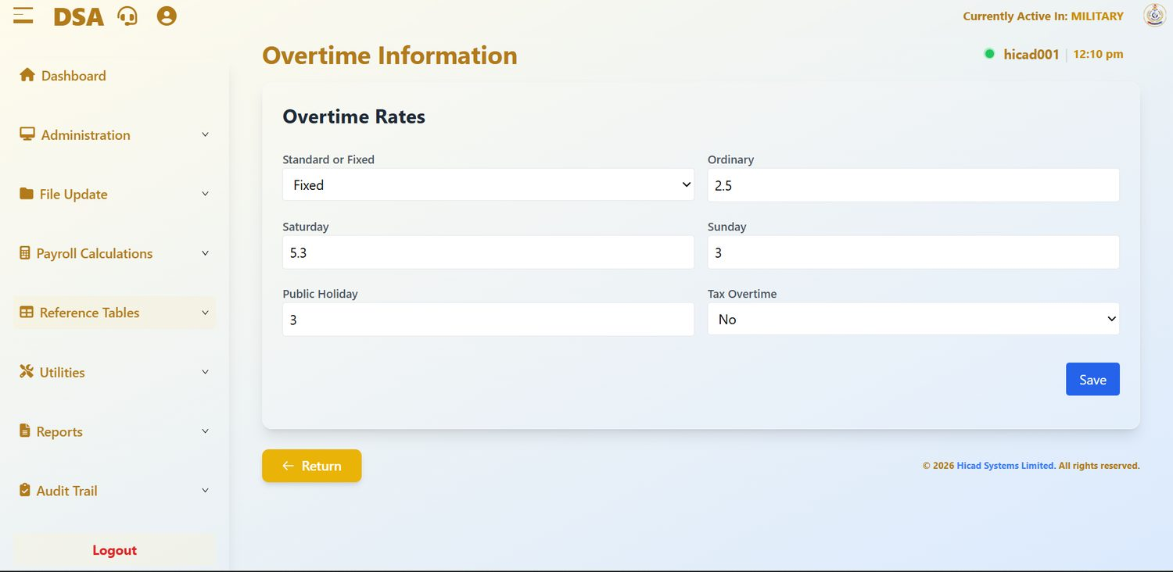
Figure 29.1 Overtime Information. Six settings, one Save button.
Field / control | What it is for
Standard or Fixed | How the overtime rate is derived. Fixed applies the multipliers below to a fixed base; Standard derives them from the salary scale. Shown as Fixed.
Ordinary | The multiplier for ordinary overtime. Shown as 2.5.
Saturday | The multiplier for Saturday working. Shown as 5.3.
Sunday | The multiplier for Sunday working. Shown as 3.
Public Holiday | The multiplier for public holidays. Shown as 3.
Tax Overtime | Whether overtime is subject to tax. Shown as No.

- Amend the values you need to change.
- Press Save.
- Confirm by re-opening the screen and reading the values back.
CAUTION
These multipliers apply to every overtime record calculated afterwards. Change them only on written authority, and only between pay runs: changing them part-way through a period will produce two different rates within the same month.

30. Command
Reference Tables > Command · dashboard.html#command
The commands under which personnel are grouped.
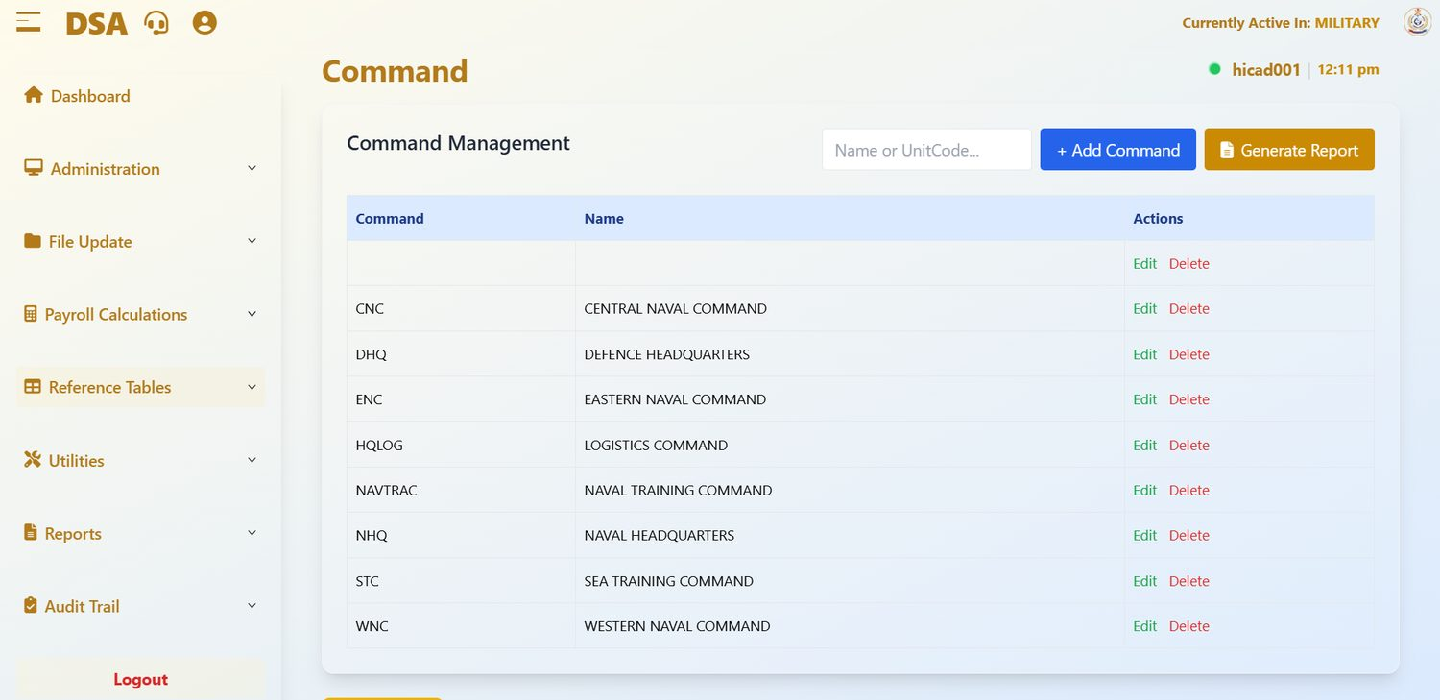
Figure 30.1 Command Management. The first row has neither a code nor a name; the rest carry the commands loaded at installation.
Field / control | What it is for
Name or UnitCode… | Filters the list.
+ Add Command | Adds a command.
Generate Report | Prints the list.
Command | The short code: CNC, DHQ, ENC, HQLOG, NAVTRAC, NHQ, STC, WNC.
Name | The full name: Central Naval Command, Defence Headquarters, Eastern Naval Command, Logistics Command, Naval Training Command, Naval Headquarters, Sea Training Command, Western Naval Command.
Actions | Edit and Delete.

Command appears on Step 3 of the personnel record (Chapter 14.4) and is used to group reports. Keeping this table correct is what makes command-level reporting possible.
CAUTION
Two things in the figure need attention. The first row is blank: a blank command record will collect personnel saved without a command and hide them from command-level reporting; identify any personnel attached to it, reassign them, then delete it. And the remaining entries are naval commands carried over from the platform the system was built on; confirm with the Administration which commands DSA personnel should be grouped under, add those, and retire the ones that do not apply.

NOTE
Deleting a command that personnel records still point to will leave those records without a command and drop them out of command-level reports. Reassign the personnel first.

31. Overpayment Percentage Alarm
Reference Tables > Overpayment Percentage Alarm · dashboard.html#cash-payment
The tolerance that decides what counts as an overpayment.
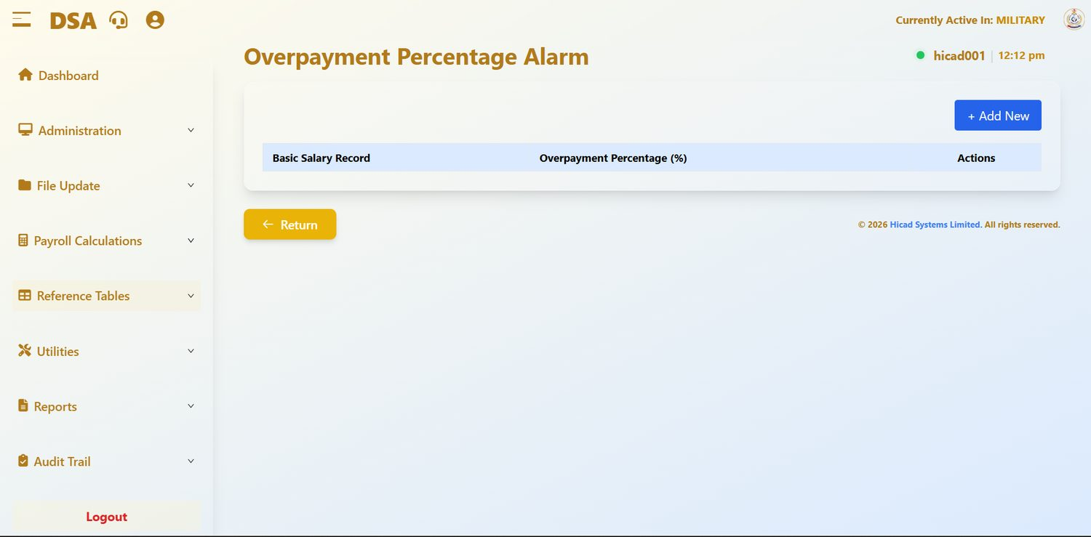
Figure 31.1 Overpayment Percentage Alarm, with no tolerance yet configured.
Field / control | What it is for
Basic Salary Record | The pay element the tolerance applies to.
Overpayment Percentage (%) | How far a payment may exceed the expected figure before it is flagged.
+ Add New | Adds a tolerance for an element.
Actions | Edit and Delete.

This setting drives the Overpayment analysis in Chapter 63. A tolerance of zero means any excess at all is reported, which produces a longer report but misses nothing. A higher tolerance produces a shorter report and relies on the tolerance having been set correctly.
CAUTION
The table is empty in the installation shown. Until a row is added for the basic pay element, the Overpayment analysis has nothing to measure against. Add one before relying on that report.

GOOD PRACTICE
Start at zero and read the report for a month or two before deciding whether a tolerance is justified. It is easier to explain a report that flagged too much than one that flagged too little.

32. Tax Table Information
Reference Tables > Tax Table Information · dashboard.html#tax-table-information
The PAYE bands the calculation applies.
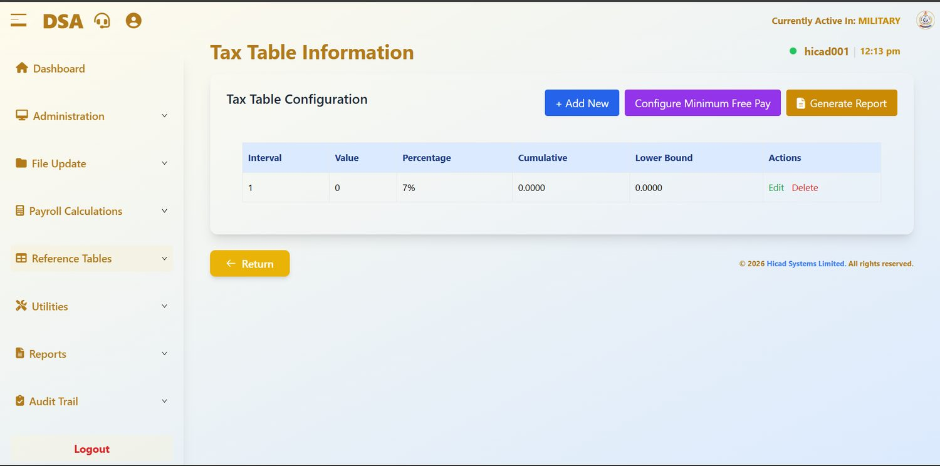
Figure 32.1 Tax Table Configuration. Each row is one band; the buttons above add bands, configure minimum free pay and print the table.
Field / control | What it is for
Interval | The band number, in ascending order.
Value | The width of the band.
Percentage | The rate applied within it: 7% in the figure.
Cumulative | The cumulative amount at the top of the band.
Lower Bound | The income at which the band starts.
+ Add New | Adds a band.
Configure Minimum Free Pay | Sets the tax-free allowance applied before the bands are reached.
Generate Report | Prints the table for checking and for the file.

NOTE
The installation shown holds a single band (interval 1, value 0, 7%) and the September 2026 calculation shows tax of ₦0.00 (Figure 27.1). Whether that is correct depends on the tax position of DSA staff and on the Taxed ? setting on each personnel record (Chapter 14.3). Confirm the intended position and complete the table before relying on the tax figures.

32.1 Maintaining the tax table
- Obtain the authority: a Finance Act, a circular, or a direction from the appropriate authority.
- Press Generate Report and keep a copy of the table as it stands before you change anything.
- Amend or add the bands.
- Check Configure Minimum Free Pay.
- Press Generate Report again and check the new table line by line against the authority.
- File both printouts with the authority.
CAUTION
The tax table applies to every person in every payroll class. An error here is not a single wrong payslip; it is a wrong deduction for the whole payroll, and it will be discovered by the tax authority rather than by you. Have every change checked by a second person before the next calculation runs.

NOTE
Whether tax is calculated month by month or cumulatively is governed by Independent Monthly Tax on the Company Profile (Chapter 12), not on this screen.

33. Salary Scale Information
Reference Tables > Salary Scale Information · dashboard.html#salary-scale-information
The salary scales, and the groups and grades within them.
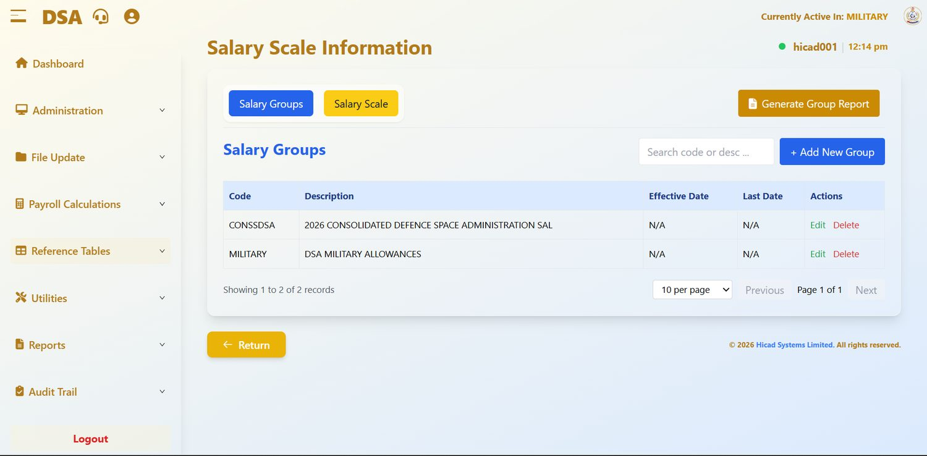
Figure 33.1 Salary Scale Information with the Salary Groups tab selected. The Salary Scale tab beside it holds the amounts.

33.1 Salary Groups
Field / control | What it is for
Code | The group code: CONSSDSA and MILITARY in the installation shown.
Description | What the group is: 2026 CONSOLIDATED DEFENCE SPACE ADMINISTRATION SAL(ARY), and DSA MILITARY ALLOWANCES.
Effective Date / Last Date | The period the group is in force. N/A means it is not time-bounded.
Actions | Edit and Delete.
Search code or desc… | Filters the list.
+ Add New Group | Adds a salary group.
Generate Group Report | Prints the groups.

33.2 Salary Scale
The Salary Scale tab holds the amounts themselves: the figure payable at each grade and step within a group. This is what the calculation reads when Shall Use Standard Salary Scale? is set to Yes on the Company Profile (Chapter 12), as it is in the installation shown.

33.3 Applying a salary review
- Print the existing groups and scale.
- Create a new group with the effective date of the review, rather than overwriting the existing one. The old scale is what makes historical pay explicable.
- Enter the new amounts against the new group.
- Move personnel onto the new Salary Group and Salary Grade on Step 2 of their records (Chapter 14.3).
- Where the review is retrospective, calculate the arrears in Chapter 21.
- Print the new scale and file it with the authority.
GOOD PRACTICE
Never edit a historical salary group in place. Once you do, the pay a person received last year can no longer be reconciled to a scale, and any query about it becomes unanswerable.

34. Pay Element Description
Reference Tables > Pay Element Description · dashboard.html#pay-element-description
The master list of every payment and deduction the system knows about.
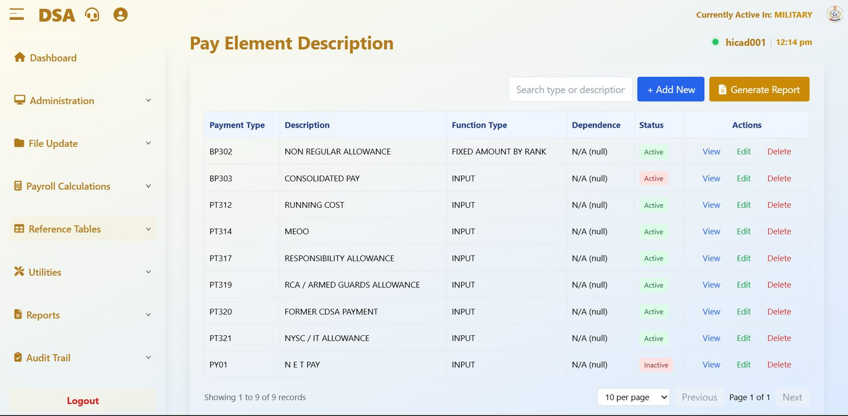
Figure 34.1 Pay Element Description. Nine elements in the installation shown, on a single page.
Field / control | What it is for
Payment Type | The code. The prefix tells you what kind of element it is: see the table below.
Description | The plain-language name, as it will appear on payslips and reports: NON REGULAR ALLOWANCE, CONSOLIDATED PAY, RUNNING COST, RESPONSIBILITY ALLOWANCE.
Function Type | How the element is arrived at. INPUT means the amount is captured; FIXED AMOUNT BY RANK takes it from the rank table in Chapter 35.1.
Dependence | Whether this element depends on another. N/A (null) means it stands alone.
Status | Active elements are available for use; Inactive ones are retained for history but cannot be selected for new input.
Actions | View, Edit, Delete.
Search type or description | Filters the list.
+ Add New | Creates an element.
Generate Report | Prints the list.

34.1 The code prefixes
Prefix | Meaning | Examples in this installation
BP | Basic pay elements | BP302 Non Regular Allowance · BP303 Consolidated Pay
PT | Payments: allowances and other credits | PT312 Running Cost · PT314 MEOO · PT317 Responsibility Allowance · PT319 RCA / Armed Guards Allowance · PT320 Former CDSA Payment · PT321 NYSC / IT Allowance
PR / PL | Deductions and recoveries | None defined yet in the installation shown.
PY | Pay totals | PY01 N E T PAY (Inactive)

The calculation groups elements by prefix, which is why the Payroll Calculations summary shows Gross Pay (BP & BT), Allowances (PT) and Other Deductions (PR & PL) (Chapter 27.2). Give every new element the prefix that matches what it is.

34.2 Retiring an element
When an allowance is withdrawn, set its status to Inactive rather than deleting it. The element then cannot be selected for new input, but every historical record that refers to it still resolves to a description. Deleting it leaves those records pointing at nothing.
NOTE
No deduction elements are defined in the installation shown, which is consistent with the ₦0.00 deductions in Figure 27.1. Deductions such as pension contributions, NHF or loan recoveries need elements here before they can be captured.

35. Pay Element Rules
Reference Tables > Fixed Amount per Rank · dashboard.html#fixed-amount-rank; Reference Tables > Mutually Exclusive Pay Elements · dashboard.html#mutually-exclusive
Two tables that constrain how pay elements behave: what they are worth at each rank, and which of them cannot be paid together.

35.1 Fixed Amount per Rank
Some elements are worth a fixed amount that depends on rank rather than on salary. Those amounts are held here.
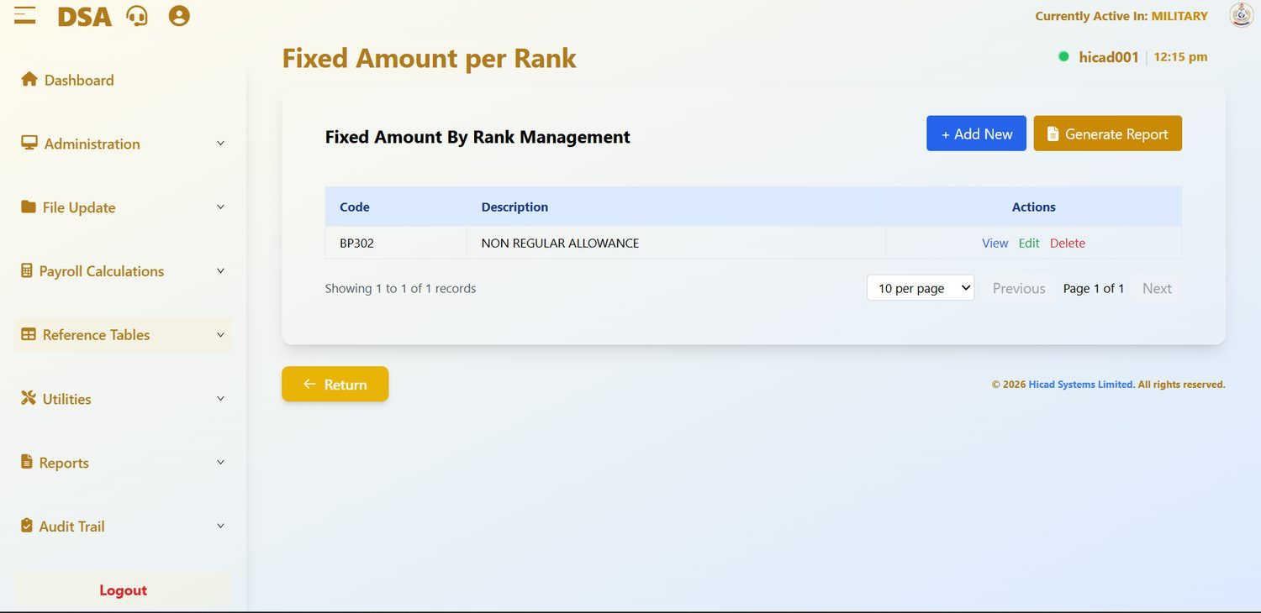
Figure 35.1 Fixed Amount By Rank Management, holding one element: BP302 Non Regular Allowance.
Field / control | What it is for
Code | The element: BP302 in the installation shown, the only element whose function type is FIXED AMOUNT BY RANK.
Description | The element name.
Actions | View opens the rank schedule read-only; Edit opens it for amendment; Delete removes the element from this table.
+ Add New | Brings another element under rank-based amounts.
Generate Report | Prints the schedule.

- Find the element and press Edit.
- Enter the amount payable or deductible at each rank.
- Save.
- Press Generate Report and check the printed schedule against the authority before the next calculation.
NOTE
This table is the reference-data equivalent of One-Off Fixed Amount By Rank in Chapter 11.3. This one governs recurring elements; that one governs a single one-off cycle.

35.2 Mutually Exclusive Pay Elements
Some allowances cannot be paid at the same time as others. This table records those pairs and tells the calculation which one wins.
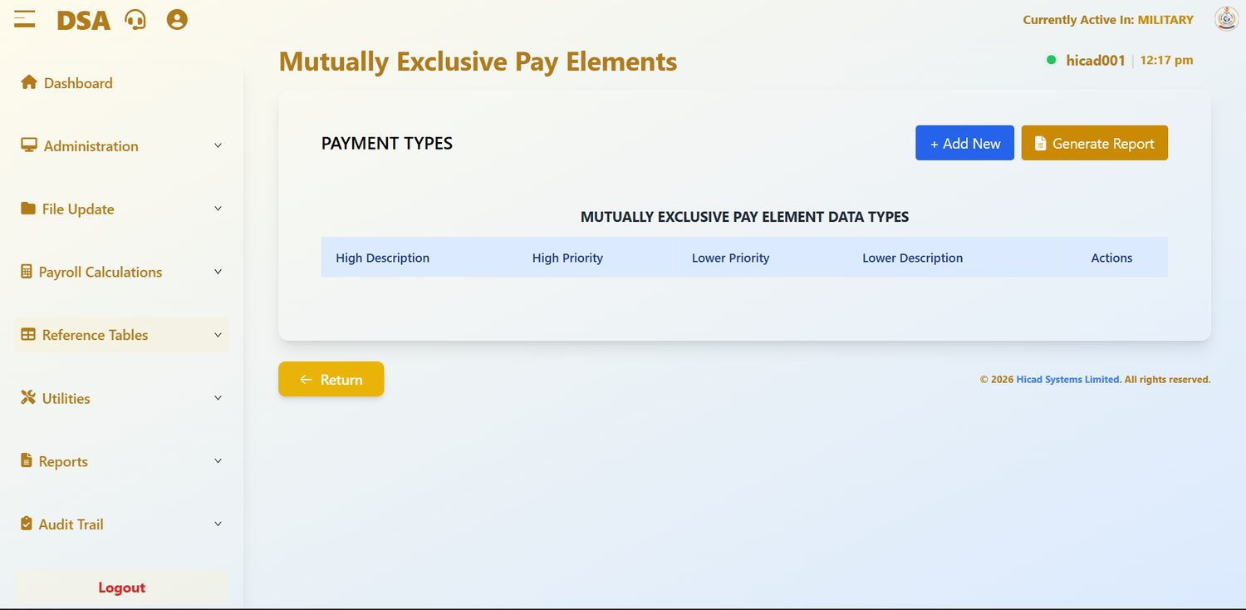
Figure 35.2 Mutually Exclusive Pay Elements, with no pairs configured.
Field / control | What it is for
High Description / High Priority | The element that takes precedence, and its code.
Lower Priority / Lower Description | The element that is suppressed when both would otherwise be paid, and its code.
Actions | Edit and Delete.
+ Add New | Adds a pair.
Generate Report | Prints the table.

GOOD PRACTICE
When somebody queries an allowance that appears on their input but not on their payslip, look here first. A mutual exclusion is the usual explanation, and it is working as intended.

36. Pension Fund Administrators
Reference Tables > Pension Fund Administrator · dashboard.html#pension-fund-administrator
The PFAs staff contribute to, and the custodians behind them.
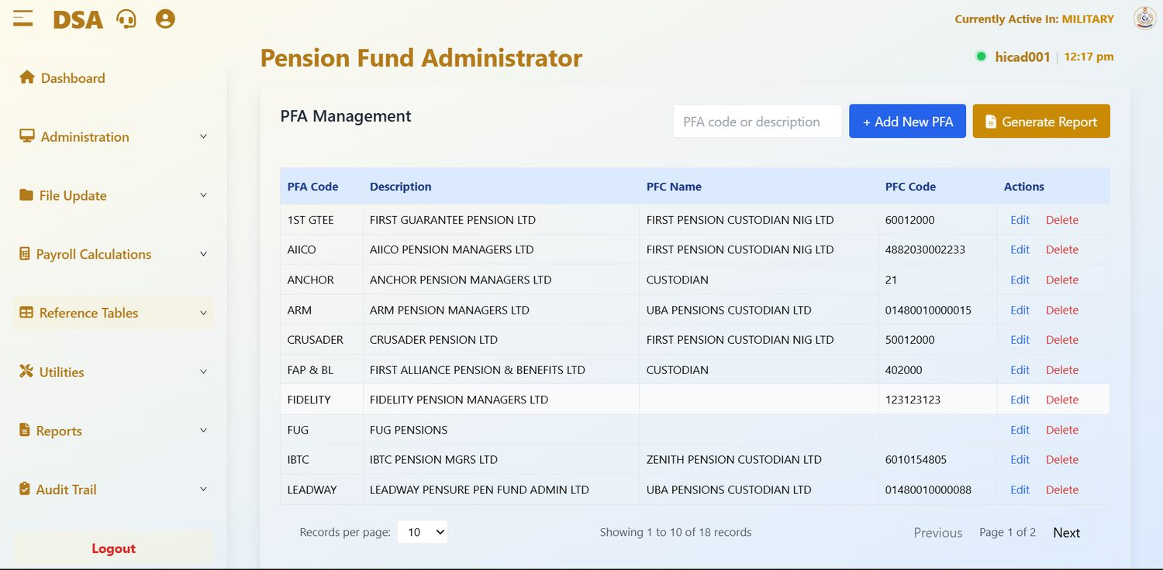
Figure 36.1 PFA Management, first page. Eighteen administrators in the installation shown, each with its pension fund custodian.
Field / control | What it is for
PFA Code | The short code: 1ST GTEE, AIICO, ANCHOR, ARM, CRUSADER, FAP & BL, FIDELITY, FUG, IBTC, LEADWAY and so on.
Description | The administrator's full registered name.
PFC Name | The pension fund custodian holding the assets: First Pension Custodian Nig Ltd, UBA Pensions Custodian Ltd, Zenith Pension Custodian Ltd, or the generic CUSTODIAN.
PFC Code | The custodian's account or identifying code, used on remittance.
Actions | Edit and Delete.
PFA code or description | Filters the list.
+ Add New PFA | Adds an administrator.
Generate Report | Prints the list.

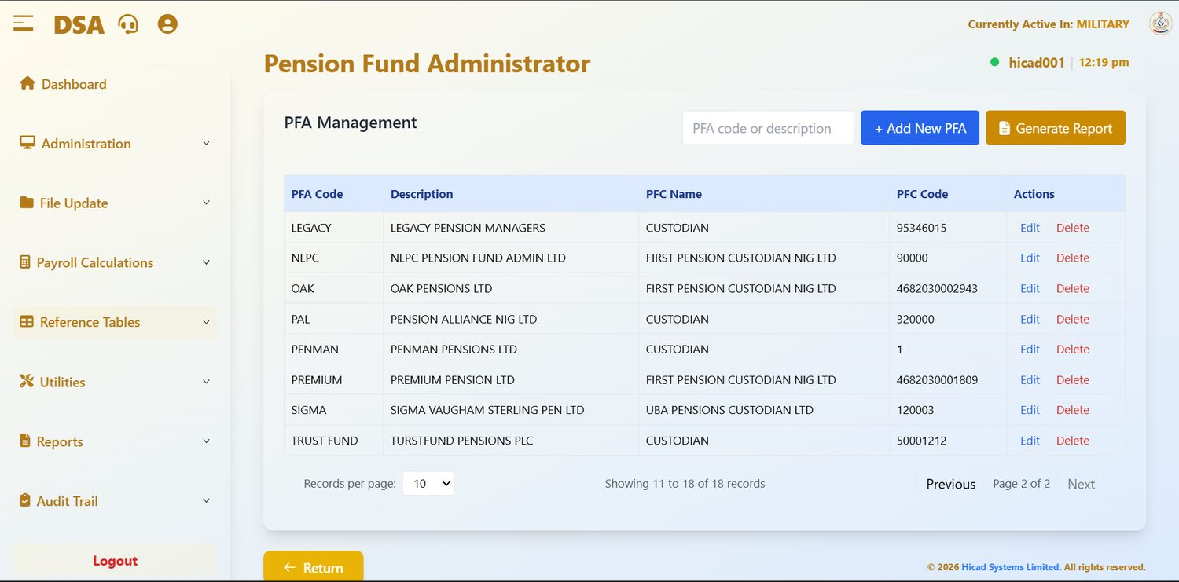
Figure 36.2 PFA Management, second page, reached with Next.
Each person's PFA is recorded on Step 2 of their personnel record (Chapter 14.3), together with their RSA number. The pairing drives the pension return in Chapter 54 and the By PFA personnel reports in Chapters 15.3 and 16.2.
CAUTION
FIDELITY and FUG have no PFC Name recorded, and FUG has no PFC Code either. Several others carry only the generic custodian name CUSTODIAN. A missing or generic custodian produces an incomplete remittance schedule. Complete every entry before the next pension return is produced.

NOTE
TRUST FUND is described as TURSTFUND PENSIONS PLC: a spelling error that will appear on printed returns. Correct it to the registered name.

37. Bank Details
Reference Tables > Bank Details · dashboard.html#bank-details
Every bank and branch that pay can be sent to, including the cash channels.
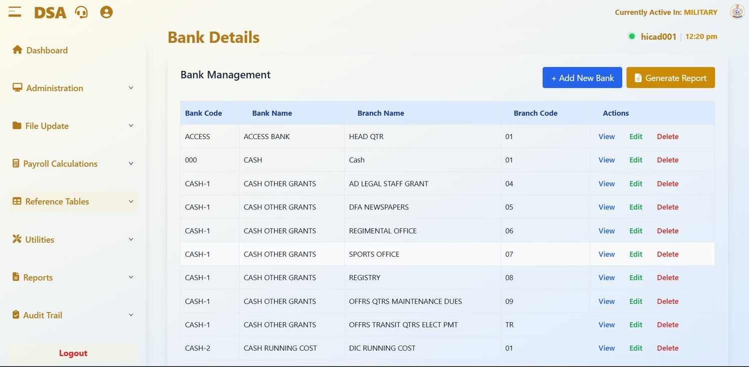
Figure 37.1 Bank Management. Alongside the banks proper, CASH codes provide channels for grants and running costs.
Field / control | What it is for
Bank Code | The short code for the bank or channel: ACCESS, 000, CASH-1, CASH-2.
Bank Name | The bank's name: ACCESS BANK, CASH, CASH OTHER GRANTS, CASH RUNNING COST.
Branch Name | The branch: HEAD QTR for Access Bank; for the cash channels, the purpose: AD LEGAL STAFF GRANT, DFA NEWSPAPERS, REGIMENTAL OFFICE, SPORTS OFFICE, REGISTRY, OFFRS QTRS MAINTENANCE DUES, OFFRS TRANSIT QTRS ELECT PMT, DIC RUNNING COST.
Branch Code | The branch code, used on the bank payment schedule.
Actions | View, Edit, Delete.
+ Add New Bank | Adds a bank or branch.
Generate Report | Prints the list.

37.1 Banks and cash channels
The table does two jobs. Bank entries such as ACCESS BANK / HEAD QTR are where salaries are paid. The CASH entries are not banks: each branch under CASH OTHER GRANTS or CASH RUNNING COST is a channel to which a particular grant or running-cost payment is directed, so that those payments can be reported separately from salaries on the bank reports (Chapter 47).
GOOD PRACTICE
Whenever a bank merges or renames, add the new entry rather than editing the old one, move the personnel across, and only then remove the old entry. That way there is always a moment at which you can see how many records are still to be moved.

CAUTION
Do not use a CASH channel as the salary bank on a personnel record unless you have been told to. A salary routed to a cash channel will not be credited to the person's bank account.

38. Department: Locations and Branches
Reference Tables > Department · dashboard.html#department
How staff are grouped for reporting. Two tables on one screen.

38.1 Locations
The Location tab holds the groupings used as Ship/Establishment on Step 3 of the personnel record and as the Location/Branch filter on the Salary Summary (Chapter 55).
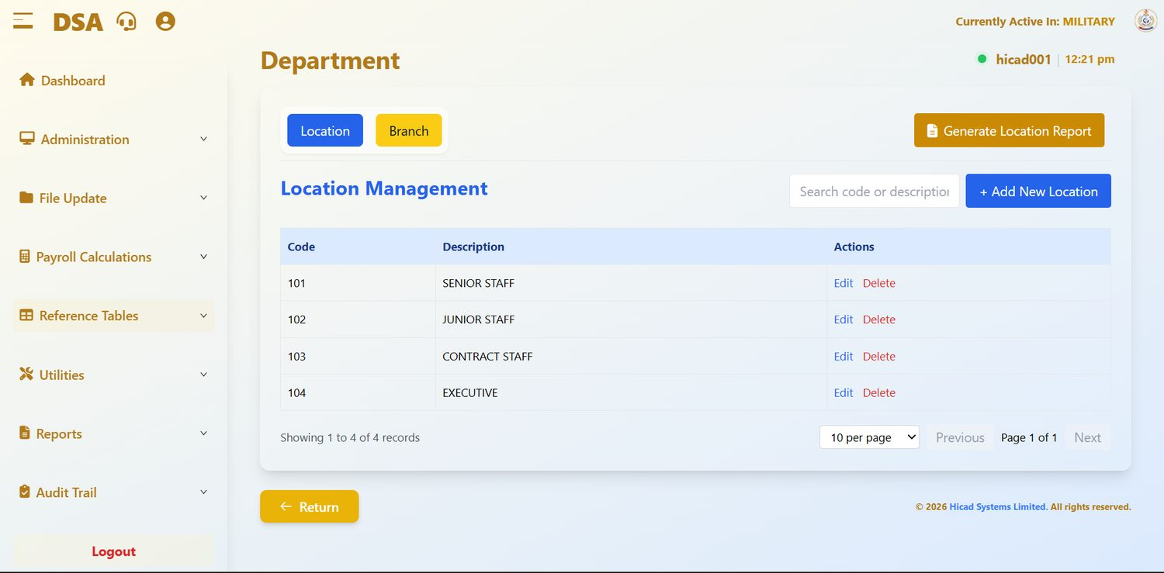
Figure 38.1 Location Management. In this installation the locations are staff categories rather than places.
Field / control | What it is for
Code | The short code: 101, 102, 103, 104.
Description | The name: SENIOR STAFF, JUNIOR STAFF, CONTRACT STAFF, EXECUTIVE.
Actions | Edit and Delete.
Search code or description | Filters the list.
+ Add New Location | Adds a location.
Generate Location Report | Prints the list.

NOTE
Because the four locations are staff categories, every report that groups “by location” (Current Personnel Reports, Salary Summary, the Department Summary calculation report) is in practice a report by staff category. That is a useful view; just read the headings with it in mind.

38.2 Branches
The Branch tab holds the branches used on Step 3 of the personnel record. The controls mirror the Location tab: + Add New Branch, Generate Branch Report, Edit and Delete.

39. State Codes
Reference Tables > State Codes · dashboard.html#state-codes
The states, their capitals and their geopolitical zones.
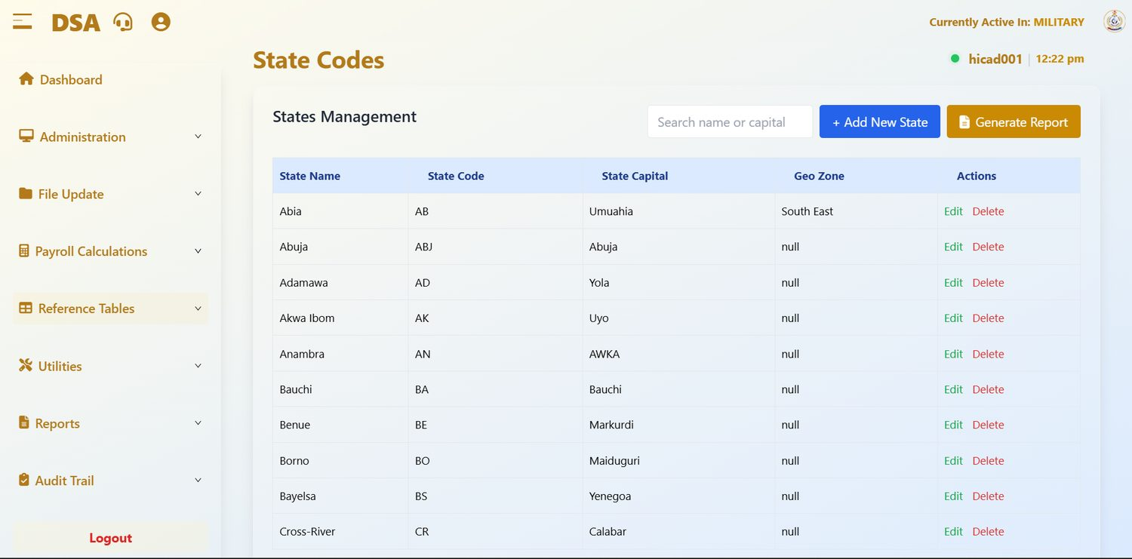
Figure 39.1 States Management, first page.
Field / control | What it is for
State Name | The state: Abia, Abuja, Adamawa, Akwa Ibom, Anambra, Bauchi, Benue, Borno, Bayelsa, Cross-River.
State Code | The short code: AB, ABJ, AD, AK, AN, BA, BE, BO, BS, CR.
State Capital | The capital: Umuahia, Abuja, Yola, Uyo, AWKA, Bauchi, Markurdi, Maiduguri, Yenegoa, Calabar.
Geo Zone | The geopolitical zone. Only Abia is completed (South East); the others read null.
Actions | Edit and Delete.
Search name or capital | Filters the list.
+ Add New State | Adds a state.
Generate Report | Prints the list.

State appears twice on the personnel record, as State Of Origin on Step 1 and as Tax State on Step 2, and they are not the same thing. State of origin is biographical; tax state determines which state internal revenue service receives the PAYE deduction reported in Chapter 51.
NOTE
Two capitals are misspelt, Markurdi for Makurdi and Yenegoa for Yenagoa, one is capitalised inconsistently (AWKA), and Geo Zone is empty for most states. These appear on printed reports. Correcting them is a short job that improves every report the table feeds.

40. Local Government Areas
Reference Tables > Local Government · dashboard.html#local-government
The local government areas within each state.
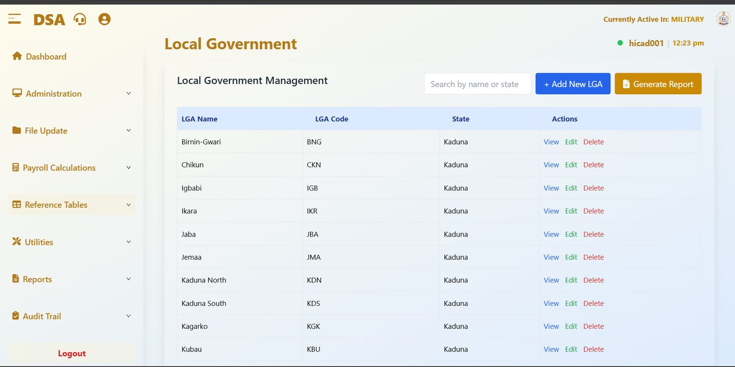
Figure 40.1 Local Government Management, first page. Use the search rather than paging through the list.
Field / control | What it is for
LGA Name | The local government area: Birnin-Gwari, Chikun, Igbabi, Ikara, Jaba, Jemaa, Kaduna North, Kaduna South, Kagarko, Kubau.
LGA Code | The short code: BNG, CKN, IGB, IKR, JBA, JMA, KDN, KDS, KGK, KBU.
State | The state the LGA belongs to.
Actions | View, Edit, Delete.
Search by name or state | Filters the list: the only practical way to navigate it.
+ Add New LGA | Adds an LGA.
Generate Report | Prints the list.

The Local Government field on Step 1 of the personnel record is populated from this table, and it will not offer any options until a state has been chosen: the field reads Select State First until then. That dependency is why the State column here matters: an LGA attached to the wrong state will not appear where the user expects it.

41. Titles
Reference Tables > Title · dashboard.html#title
The rank and title list that the personnel record offers.
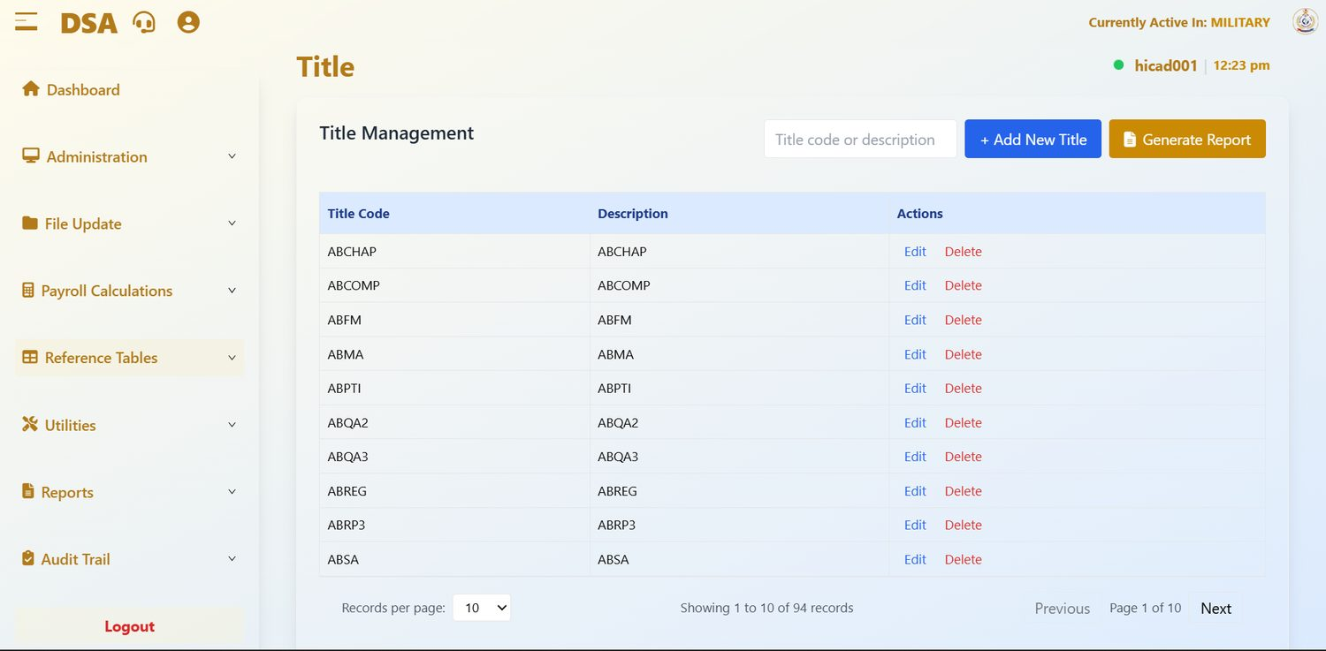
Figure 41.1 Title Management, first page. 94 titles in the installation shown.
Field / control | What it is for
Title Code | The code stored on the personnel record.
Description | The title as printed. In the installation shown it repeats the code.
Actions | Edit and Delete.
Title code or description | Filters the list.
+ Add New Title | Adds a title.
Generate Report | Prints the list.

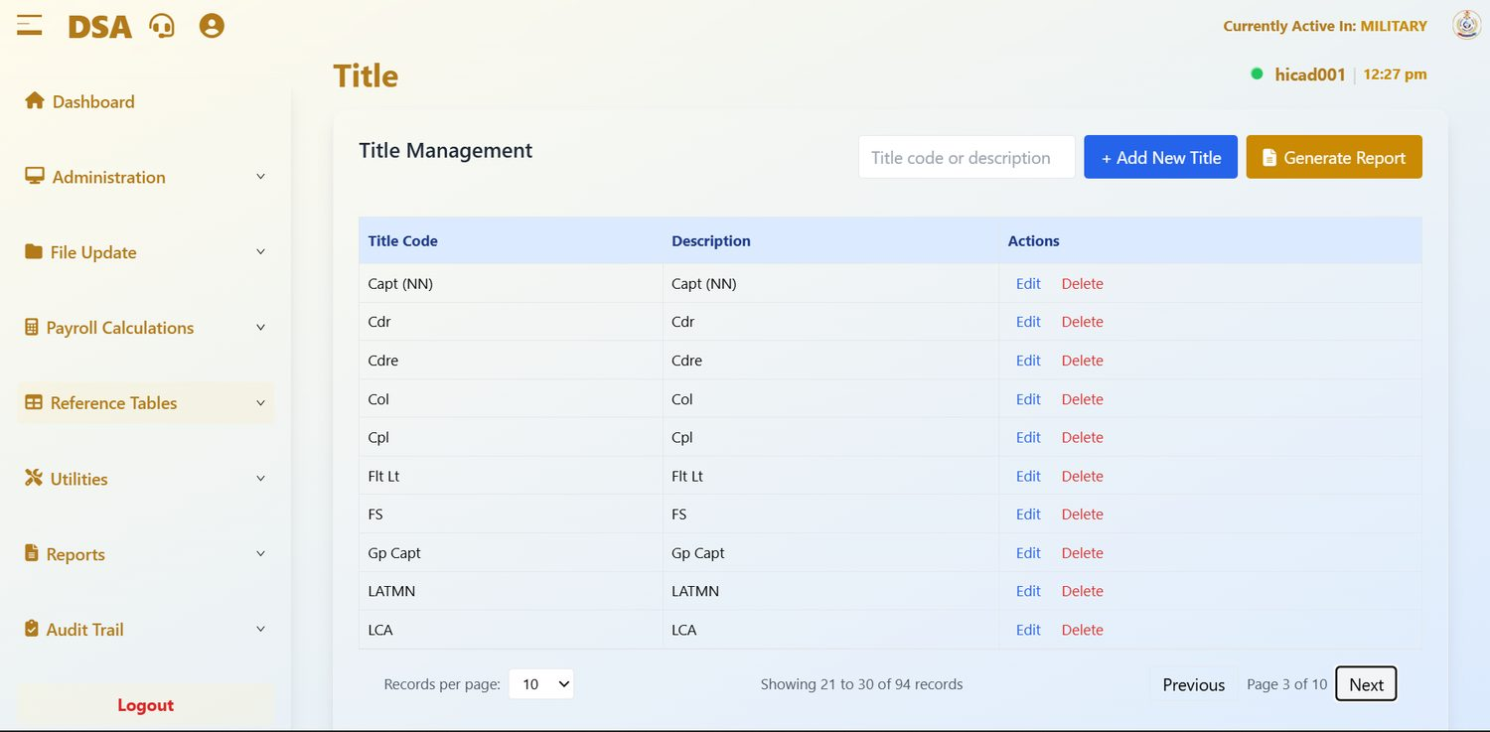
Figure 41.2 Title Management, page 3, showing ranks from more than one Service: Capt (NN), Cdr, Cdre, Col, Cpl, Flt Lt, Gp Capt.
The list covers ranks from more than one Service, because DSA personnel are drawn from more than one. This is the list the Rank field on Step 1 of the personnel record offers (Chapter 14.2), and it is what the By Rank scope on the personnel reports groups by.
GOOD PRACTICE
Before adding a title, search for it. Two spellings of the same rank (Flt Lt and FLT LT, say) split one rank into two groups on every report.

42. Emolument Form Processing and Pull IPPIS Payments
Utilities > Emolument Form Processing; Utilities > Pull IPPIS Payments · dashboard.html#ippis-payments
Two menu items carried over from the platform the system shares with other payrolls. Neither is part of the DSA monthly cycle.

42.1 Emolument Form Processing
This menu item is present but the screen behind it shows This section is under development. Nothing can be processed here. The emolument exercise it refers to is not run through this system for DSA.
The related field on the personnel record, Emolument Form Received? on Step 3 (Chapter 14.4), likewise has no effect on the pay run.

42.2 Pull IPPIS Payments
IPPIS is the Federal Government's central personnel and payroll platform. This screen imports payment data from it, period by period, from a CSV file whose first column is the service number and whose remaining columns are payment type codes. The DSA payroll is not fed from IPPIS, so in normal running this screen is not used.
Field / control | What it is for
Search by Period, Scv No… | Filters the imports.
View Periods / + New Import | Lists the periods imported, or starts an import (Year, Month, Payroll Class and the CSV file, then Validate and Import).
Period, Records, Record Count, Total Amount, Import Date | One row per imported period.

CAUTION
An import replaces any existing data for the period it covers. Do not use this screen unless your administrator has asked you to and has confirmed what the file contains.

NOTE
For the same reason, leave the IPPIS and Use IPPIS options on Salary History (Chapter 58) and the Payroll Register (Chapter 52) unticked, and leave IPPIS NO on the personnel record as it is.

NOTE
No screen capture of either item was taken for this edition.

43. Payroll Class Backup
Utilities > Payroll Class Backup · dashboard.html#database-backup
Taking a copy of a payroll class. The cheapest insurance in the system.
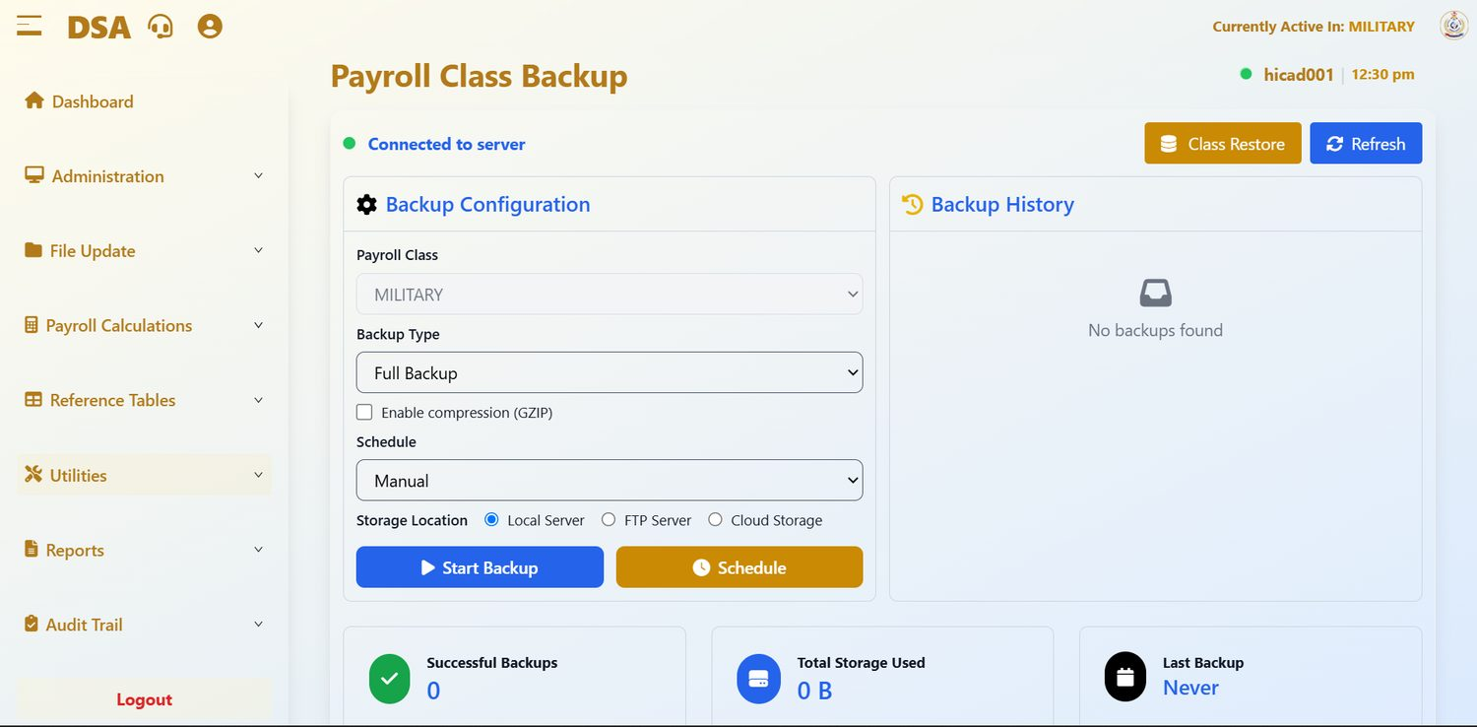
Figure 43.1 Payroll Class Backup. Configuration on the left, history on the right, summary figures beneath. No backup had yet been taken in the installation shown.

43.1 The screen
A green indicator at the top left reads Connected to server when the backup service is reachable. If it does not, no backup can be taken and that is the first thing to resolve.
Field / control | What it is for
Payroll Class | The class being backed up. It follows the active class and cannot be changed here.
Backup Type | Full Backup takes everything. Use it unless you have a specific reason not to.
Enable compression (GZIP) | Compresses the backup file. Slower to produce, smaller to keep.
Schedule | Manual takes a backup when you press the button; other settings run it automatically.
Storage Location | Local Server, FTP Server or Cloud Storage.
Start Backup | Takes the backup now.
Schedule (gold button) | Sets up a recurring backup.
Class Restore | Switches to the restore screen (Chapter 44).
Refresh | Updates the history and the figures.
Backup History | The backups held, each with its name, size and date, and icons to download or delete it. No backups found in the figure.
Successful Backups / Total Storage Used / Last Backup | Summary figures across the foot of the screen: 0, 0 B and Never in the figure.

CAUTION
Last Backup: Never. In the installation shown, September 2026 had been calculated without a class backup having been taken. Take one now, and make it part of every cycle from here on.

43.2 When to take a backup
- Before a bulk payroll class migration (Chapter 9.3).
- Before a batch upload of personnel or of payments and deductions (Chapters 14.7 and 17.3).
- Before running the payroll calculation (Chapter 27).
- Before month-end processing (Chapter 13.1): this one is not optional.
- Before year-end processing (Chapter 13.2).
- On a schedule, so that a routine copy exists even when nobody remembers to take one.
CAUTION
Check the size of every backup you take before relying on it. A backup that shows 0 B has not captured anything: an untested backup is not a backup.

GOOD PRACTICE
Keep at least one backup off the payroll server itself, using the FTP or cloud storage option, or by downloading it. A backup that lives only on the machine it protects will not survive the failure of that machine.

44. Payroll Class Restore
Utilities > Payroll Class Restore · dashboard.html#database-restore
Putting a backup back. Rare, deliberate, and never done in a hurry.
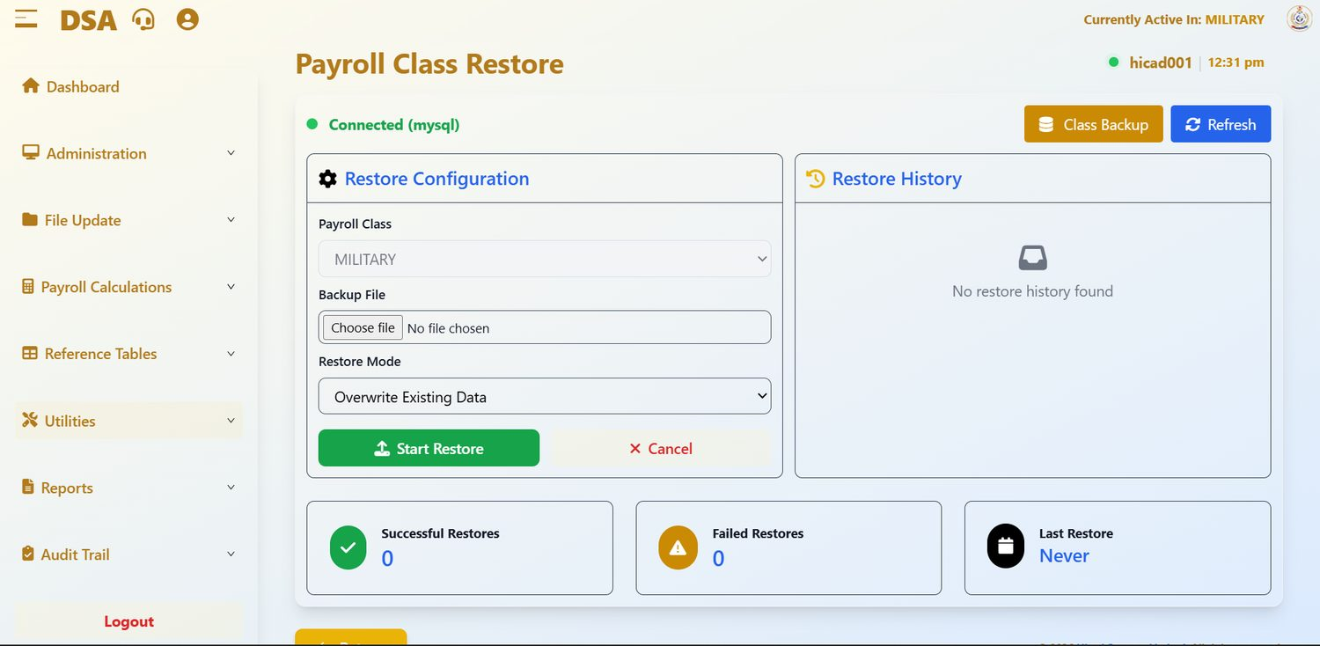
Figure 44.1 Payroll Class Restore. The connection indicator confirms the database; the history panel records every restore.
Field / control | What it is for
Connected (mysql) | Confirms the database the restore will be written to. Read it before you start.
Payroll Class | The class being restored. It follows the active class.
Backup File / Choose file | The backup to restore from.
Restore Mode | Overwrite Existing Data replaces what is there now.
Start Restore | Runs the restore. Cancel abandons.
Restore History | Previous restores.
Successful Restores / Failed Restores / Last Restore | Summary figures.
Class Backup | Switches back to the backup screen.

44.1 Before you restore
- Establish exactly what went wrong and confirm that a restore is the right remedy. Most problems are better fixed by correcting the data.
- Identify the backup that predates the problem, and check its size and date.
- Take a fresh backup of the current state first. However bad the current data is, you may need to refer to it.
- Establish what has happened since the backup was taken. All of it will be lost.
- Get authority. A restore is not a routine operator action.
- Confirm the Payroll Class and the Backup File, then press Start Restore.
- Check the result thoroughly, including the payroll status on Month End Processing, before allowing anybody to resume work.
CAUTION
Overwrite Existing Data does exactly that. Every change made to the class since the backup was taken (every payment captured, every personnel record amended, every calculation run) is discarded. This is the most destructive action available anywhere in this system.

45. Consolidated Payslips
Utilities > Consolidated Payslips · dashboard.html#consolidated-payslip
One payslip document covering a group of staff and a chosen period.
No screen capture of this screen was taken for this edition. Its controls are the same as those on Payslips (Figure 46.1), with a year and month added:
Field / control | What it is for
Select People | All covers the whole class; Specific takes a range of service numbers; Individual takes one person.
Start Service No / End Service No | The range, used with Specific.
Payroll Class, Year, Month | The class and period to report on.
Output Format | PDF to issue or file, Excel to analyse.
Generate | Asks for confirmation, then produces the payslips with a preview and Download PDF. Clear resets the form.

Consolidated payslips are most often needed for a loan or mortgage application, for a pension claim, or in support of a query. For the ordinary monthly payslip, use Chapter 46 instead.
GOOD PRACTICE
Generate consolidated payslips as PDF when they are going to a third party such as a bank. A PDF is a fixed document; a spreadsheet is not, and an institution receiving one may reasonably ask for something that cannot be edited.

46. Payslips
Reports > Payslips · dashboard.html#pay-slips
The Reports menu at a glance, and the report everybody recognises.

46.1 The Reports menu
The Reports menu holds the reporting suite. It also provides a second route to the two personnel reports already described in Part III: Current Personnel Reports (Chapter 15.3) and List Of Exited Members (Chapter 16.2). They are there because they are as often wanted by a reporting user as by somebody maintaining records. The last item, Enquiry, is a read-only personnel list (Chapter 59).
The remaining chapters of this Part take the reports in the order the menu presents them. Nearly all of them share the same controls, so they are described once here and not repeated:
Control | Behaviour
Select People: All / Specific / Individual | All covers the whole class. Specific takes a Start Service No and an End Service No and covers the range between them. Individual takes one person.
Processing Month / Processing Year | The period reported on. These default to the current processing period; check them before generating.
Output Format: PDF / Excel | PDF produces a fixed document suitable for issue, signature or filing. Excel produces a workbook suitable for further analysis.
Generate / Clear | Generate produces the report, usually after a confirmation and with a preview; Clear resets the choices without producing anything.
Summary Report | Where offered, produces totals only instead of the full detail. Run the summary first to check the figures, then the detail.
Generate for All Classes | Where offered, covers MILITARY and CIVILIAN together instead of the active class only.

46.2 Payslips
Open Reports > Payslips to produce individual payslips for the period. They carry the Defence Space Administration heading.
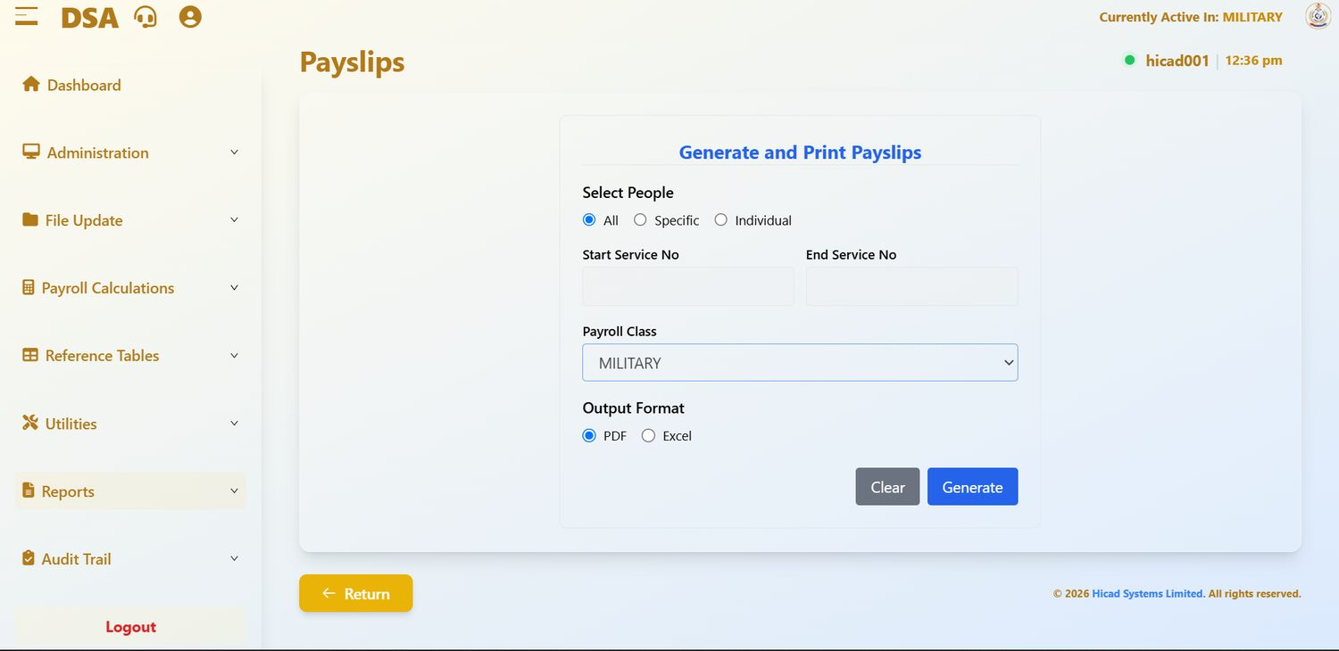
Figure 46.1 Generate and Print Payslips.
- Choose All, Specific or Individual under Select People.
- Where you chose Specific, enter the Start Service No and End Service No.
- Confirm the Payroll Class.
- Choose PDF or Excel.
- Press Generate.
CAUTION
Payslips carry personal financial data. Produce them for the narrowest population that meets the need, and handle the resulting file accordingly: a full-class PDF is a document containing hundreds of people's pay.

GOOD PRACTICE
For a single query, use Individual rather than generating the whole class and searching within it. It is faster, and it produces a document you can send to the person who asked. Staff can also view their own payslips through the staff portal (Chapter 3.7).

47. Payments by Bank (Branch)
Reports > Payments by Bank(Branch) · dashboard.html#payments-by-bank
The schedule that tells each bank what to pay into which account. Handle it with care.
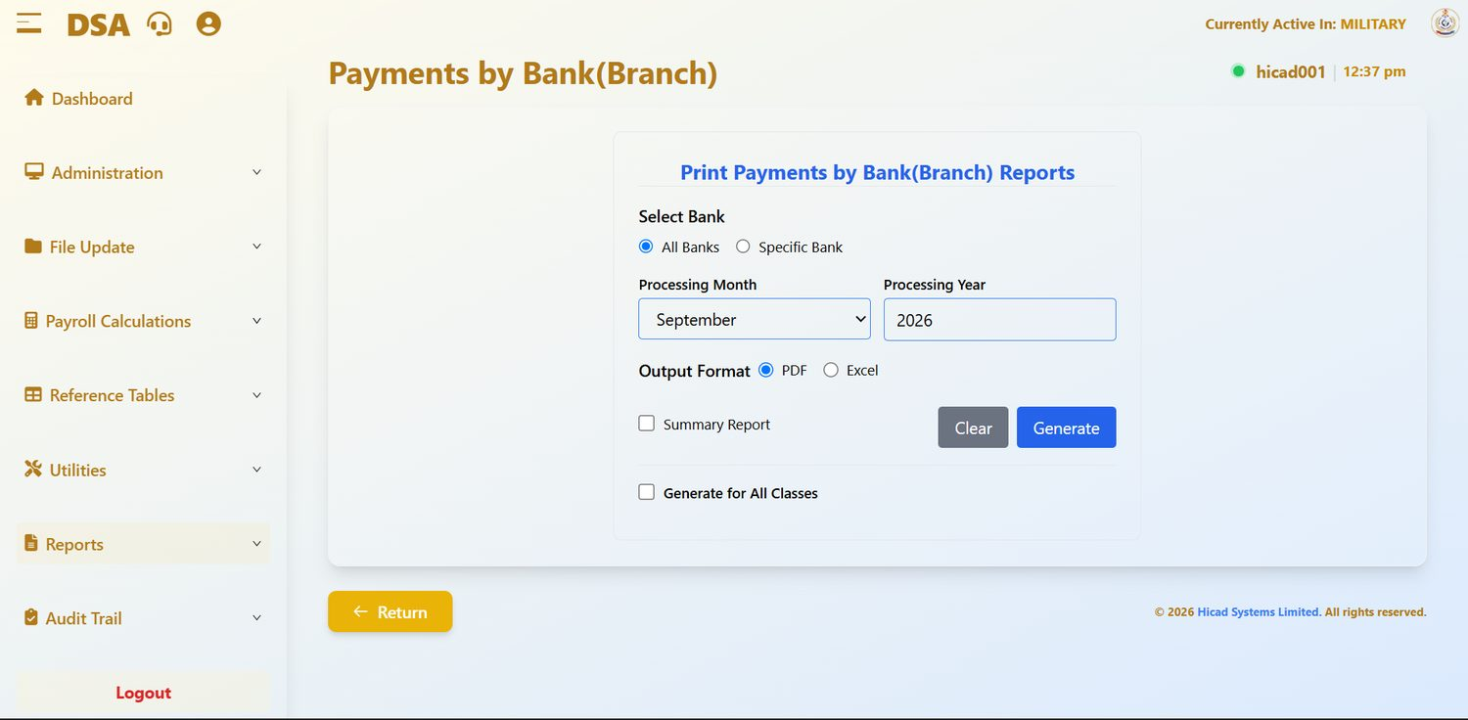
Figure 47.1 Print Payments by Bank(Branch) Reports.
Field / control | What it is for
Select Bank: All Banks / Specific Bank | Produce one schedule covering every bank, or a schedule for a single bank or cash channel (Chapter 37).
Processing Month / Processing Year | The period.
Output Format | PDF or Excel. Banks normally require a fixed document; check what yours accepts.
Summary Report | Totals by bank rather than the full account-level detail. Use it to check before producing the detail.
Generate for All Classes | Covers every payroll class in one schedule instead of the active class only.

- Produce the Summary Report first and agree the total against the payroll register (Chapter 52).
- When the totals agree, produce the detailed schedule.
- Check that every bank in the schedule is a real bank and branch, and that cash channels appear only for the grants and running costs they exist for.
- Have the schedule authorised before it is transmitted.
CAUTION
This report initiates the movement of money. It should never be produced, and certainly never transmitted, by one person acting alone.

48. Analysis of Earnings and Deductions
Reports > Analysis of Earnings/Deductions · dashboard.html#analysis-of-earnings
What was paid and deducted, broken down by payment type.
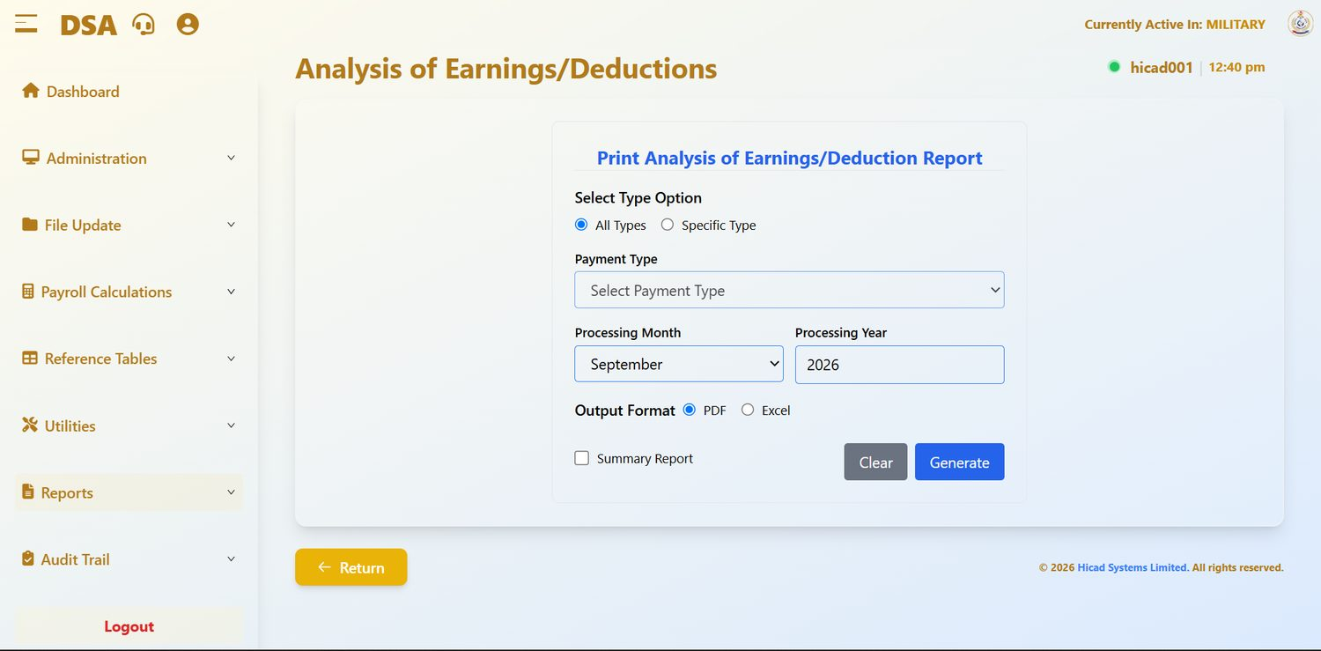
Figure 48.1 Print Analysis of Earnings/Deduction Report.
Field / control | What it is for
Select Type Option: All Types / Specific Type | Report on every pay element, or on one.
Payment Type | The element, used with Specific Type. Drawn from the list in Chapter 34.
Processing Month / Processing Year | The period.
Output Format | PDF or Excel.
Summary Report | Totals by element rather than person-by-person detail.

This is the natural report for answering “how much did we pay in responsibility allowance last month?” or “what did running cost come to across the year?”. Run it with All Types and Summary Report ticked and you have a one-page picture of the whole payroll by element.
GOOD PRACTICE
Produce this summary every month and keep the series. A single month tells you what was paid; twelve months side by side tell you what is changing, which is a far more useful thing to know.

49. Loan Analysis
Reports > Loan Analysis · dashboard.html#loan-analysis
Outstanding loans and recoveries.
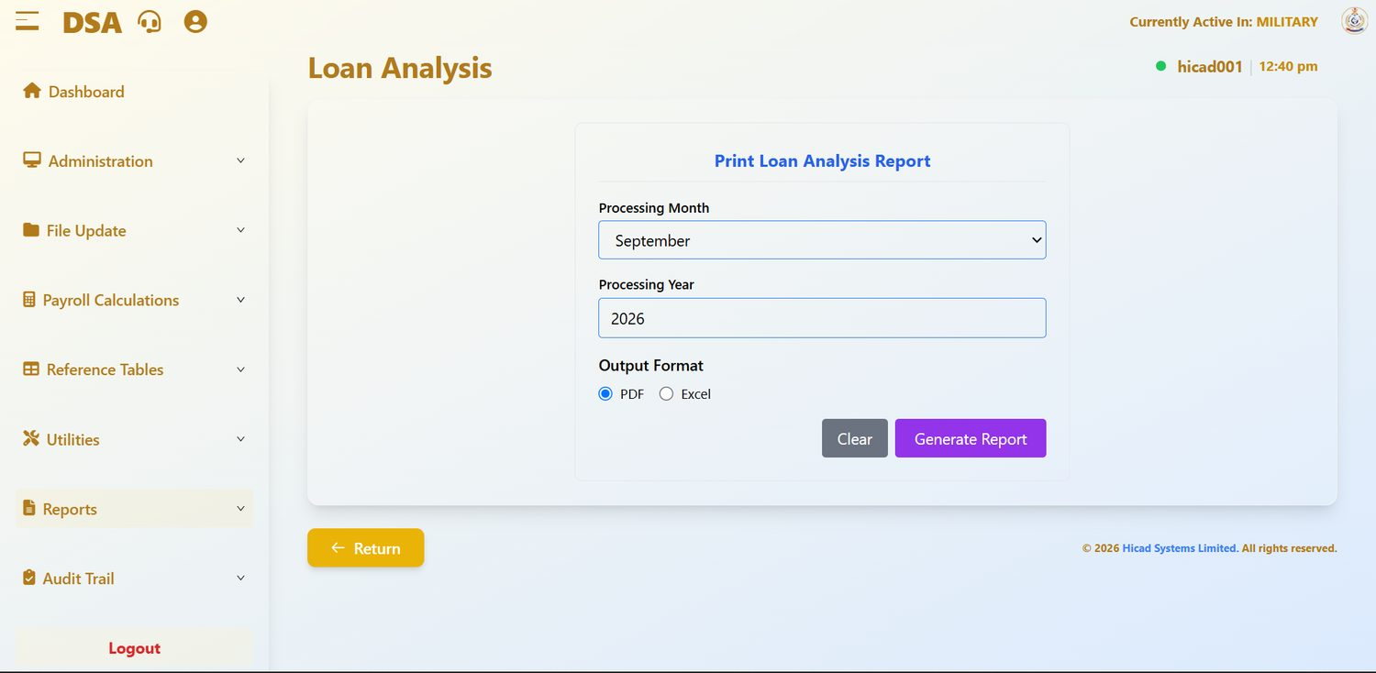
Figure 49.1 Print Loan Analysis Report. The simplest report screen in the system: period, format, generate.
Field / control | What it is for
Processing Month / Processing Year | The period.
Output Format | PDF or Excel.
Generate Report | Produces the report; Clear resets.

The report shows loans and recoveries in force, what has been deducted and what remains outstanding. Those balances come from the Amount To Date field on the payment and deduction records described in Chapter 17.1.
- Check that no loan has a remaining balance below zero: that indicates over-recovery, which must be refunded.
- Check that recoveries scheduled to end have ended. A deduction that continues past its term is money taken without authority.
- Reconcile the total outstanding against the lending body's own records.
NOTE
With no deduction elements defined (Chapter 34.2), this report has nothing to show in the installation pictured. It becomes useful once loan recoveries are set up.

50. Analysis of Payments and Deductions by Bank
Reports > Analysis of Payments/Deductions by Bank · dashboard.html#analysis-of-payments
Payment types crossed with banks.
Field / control | What it is for
Select Bank: All Banks / Specific Bank | Which bank or banks to cover; with Specific Bank, choose it from Select Bank.
Select Type: All Types / Specific Type | Which pay elements to cover; with Specific Type, choose it from Select Payment Type.
Processing Month / Processing Year | The period.
Output Format | PDF or Excel.
Summary Report | Totals only.

Use this report when a bank raises a query about a particular payment, or when a payment type needs to be traced through to the accounts it was paid into. It is the intersection of Chapters 47 and 48.
NOTE
No screen capture of this report was taken for this edition. Its layout follows Figure 47.1 with a payment type selector added.

51. Tax Payments by State
Reports > Tax Payments By State · dashboard.html#tax-payments-by-state
The PAYE return, broken down by the state each deduction is remitted to.
Field / control | What it is for
Select State: All States / Specific State | Every state, or one chosen from Select State.
Processing Month | The period.
Output Format | PDF or Excel.
Summary Report | Totals by state rather than the person-by-person detail.

Each person's Tax State is set on Step 2 of their personnel record (Chapter 14.3), and it is that field, not their state of origin, which determines where their PAYE is remitted.
- Produce the Summary Report for All States and agree the total to the PAYE deduction total on the payroll register (Chapter 52).
- Produce the detail for each state that is to receive a return.
- Check for personnel with no tax state recorded; their deductions will not appear against any state.
- Remit and file.
CAUTION
A wrong Tax State sends a person's PAYE to the wrong state internal revenue service. Correcting it afterwards means recovering money from one state and paying it to another, which is slow. Check new personnel records at the point of entry.

NOTE
No screen capture of this report was taken for this edition.

52. Payroll Register
Reports > Payroll Register · dashboard.html#payroll-register
The definitive record of a pay run.
Field / control | What it is for
Select People: All / Specific / Individual | The population, with Start and End Service No for Specific.
Processing Month / Processing Year | The period.
Header Type | Whether the columns are headed by element Code or Description.
Report Type | Both, Earnings or Deductions.
Output Format | PDF or Excel.
Summary Report | Totals only.
Use IPPIS | Produces the register on the IPPIS basis. Not used for DSA: leave unticked (Chapter 42.2).

The payroll register is the report against which everything else is reconciled. Its totals should agree with the bank payment schedule (Chapter 47), with the analysis of earnings and deductions (Chapter 48), and with the Total Net Pay on the Payroll Calculations screen (Chapter 27.2).
- Produce the register for the whole class with Report Type set to Both.
- Agree its total to the bank payment schedule.
- Agree its total to the analysis of earnings and deductions.
- File it. This is the report an auditor will ask for.
NOTE
No screen capture of this report was taken for this edition.

53. National Housing Fund
Reports > National Housing Funds · dashboard.html#national-housing-funds
The NHF return.
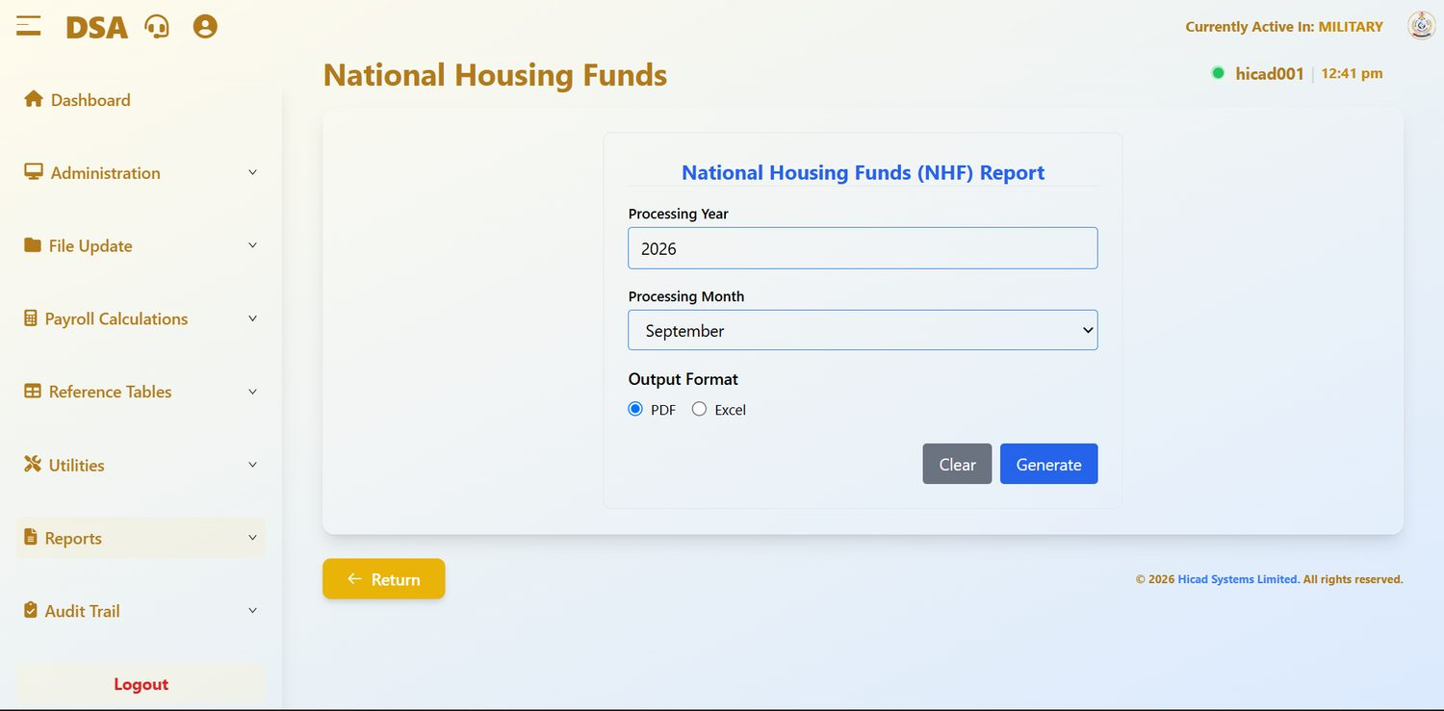
Figure 53.1 National Housing Funds (NHF) Report.
Field / control | What it is for
Processing Year / Processing Month | The period.
Output Format | PDF or Excel.
Generate | Produces the return; Clear resets.

The return lists NHF contributions for the period. It draws on the NHF Code held on Step 3 of each personnel record (Chapter 14.4); a person without an NHF code will not appear on it.
GOOD PRACTICE
Before producing the return, run the current personnel report in Excel and check for blank NHF codes among those who should be contributing. A missing code is the usual reason a contribution fails to reach the Fund.

54. Pension Fund Scheme
Reports > Pension Fund Scheme · dashboard.html#nsitf
The pension return, by administrator.
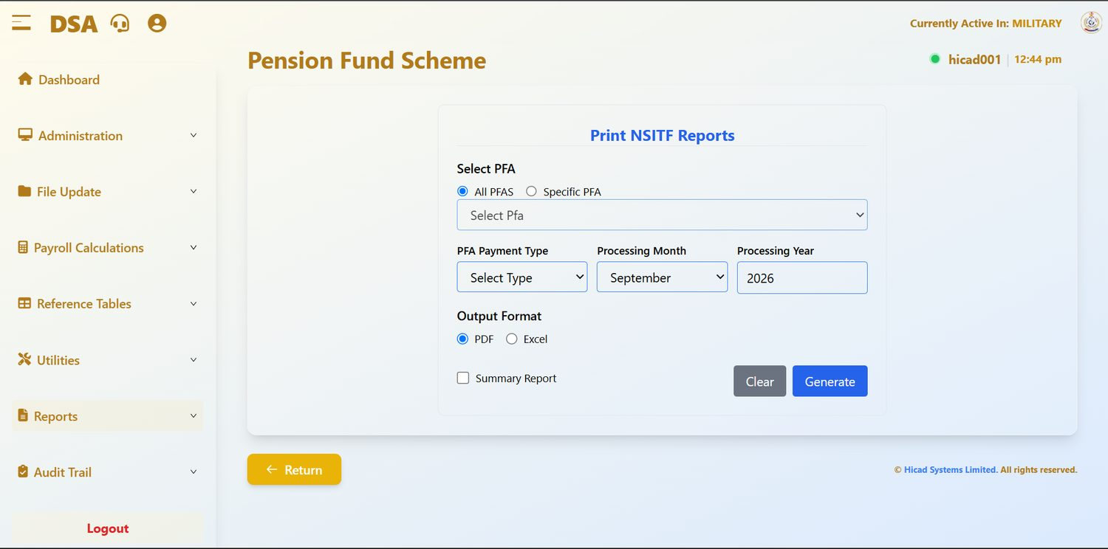
Figure 54.1 Print NSITF Reports. Filter by PFA and by PFA payment type.
Field / control | What it is for
Select PFA: All PFAS / Specific PFA | Every administrator, or one.
Select Pfa | The administrator, used with Specific PFA. Drawn from the list in Chapter 36.
PFA Payment Type | Which pension element to report on.
Processing Month / Processing Year | The period.
Output Format | PDF or Excel.
Summary Report | Totals by administrator.

- Produce the Summary Report for All PFAS and agree the total to the pension deduction total on the payroll register.
- Produce a detailed return for each administrator.
- Check that every administrator on the return has a pension fund custodian recorded (Chapter 36): a missing custodian produces an incomplete remittance schedule.
- Remit and file.

55. Salary Summary
Reports > Salary Summary · dashboard.html#salary-summary
The one-page management view of the payroll.
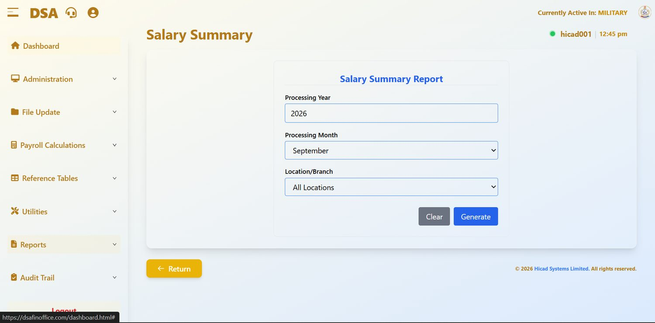
Figure 55.1 Salary Summary Report. Period, location and generate.
Field / control | What it is for
Processing Year / Processing Month | The period.
Location/Branch: All Locations | Covers the whole payroll, or narrows to a single location or branch from the tables in Chapter 38: in this installation, a staff category such as SENIOR STAFF.
Generate | Produces the summary; Clear resets.

This is the report to take to a meeting. It gives the totals without the detail, and narrowing it by location answers the question a manager is most likely to ask: what does this group of staff cost?

56. Control Sheet / Journal
Reports > Control Sheet/Journal · dashboard.html#control-sheet
The accounting summary of the pay run, for posting to the ledger.
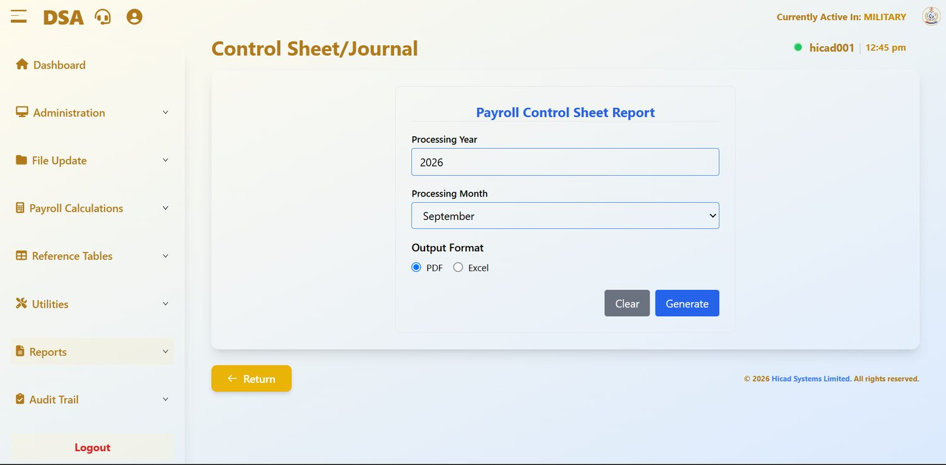
Figure 56.1 Payroll Control Sheet Report.
Field / control | What it is for
Processing Year / Processing Month | The period.
Output Format | PDF or Excel.
Generate | Produces the control sheet; Clear resets.

The control sheet summarises the pay run in accounting terms: the totals to be posted, by category. It is the document that passes from the pay office to the accounts branch, and it should be produced and agreed before month-end processing runs. The Control Sheet card on Calculation Reports (Chapter 28) gives the same view straight after the calculation.

57. Salary Reconciliation
Reports > Salary Reconciliation · dashboard.html#salary-reconciliation
The first of the five exception reports. Run it every month.
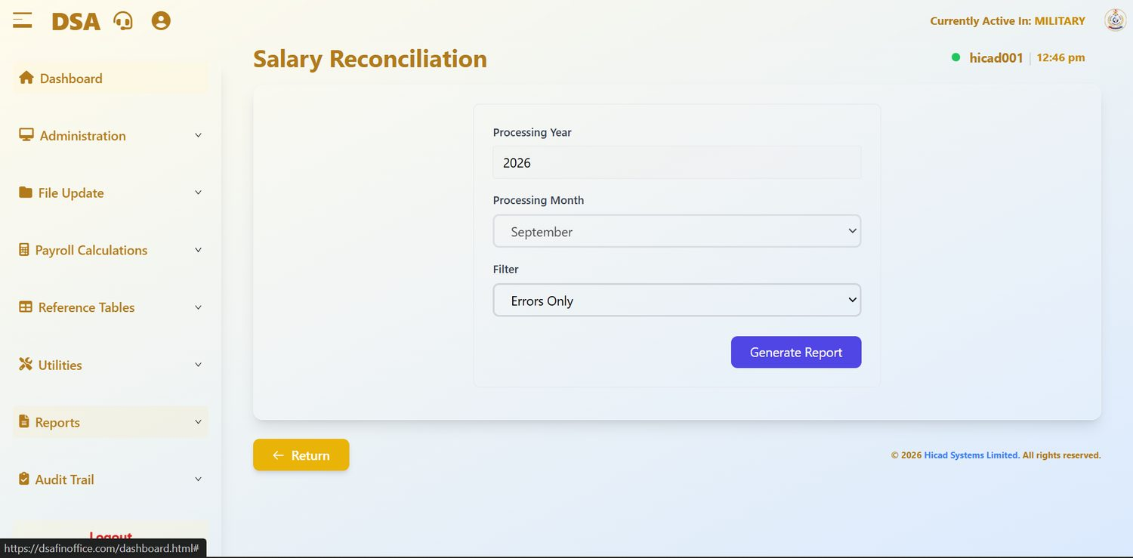
Figure 57.1 Salary Reconciliation with the filter set to Errors Only.
Field / control | What it is for
Processing Year / Processing Month | The period. The year is fixed to the current processing year.
Filter: Errors Only | Restricts the report to records that do not reconcile. Other filter settings widen it.
Generate Report | Produces the report.

The report compares the period's figures and reports records that do not reconcile. With Errors Only selected it should, in a clean month, return nothing, and a nil return is a meaningful result worth filing.
- Run it with Errors Only immediately after the calculation completes.
- Investigate every record it returns. There is no such thing as an acceptable reconciliation error.
- Correct the cause, recall and recalculate (Chapters 26 and 27), and run the report again.
- File the clean report as evidence that the period reconciled.

58. Salary History
Reports > Salary History · dashboard.html#salary-history
Payslips and pay history across periods rather than for the current month.
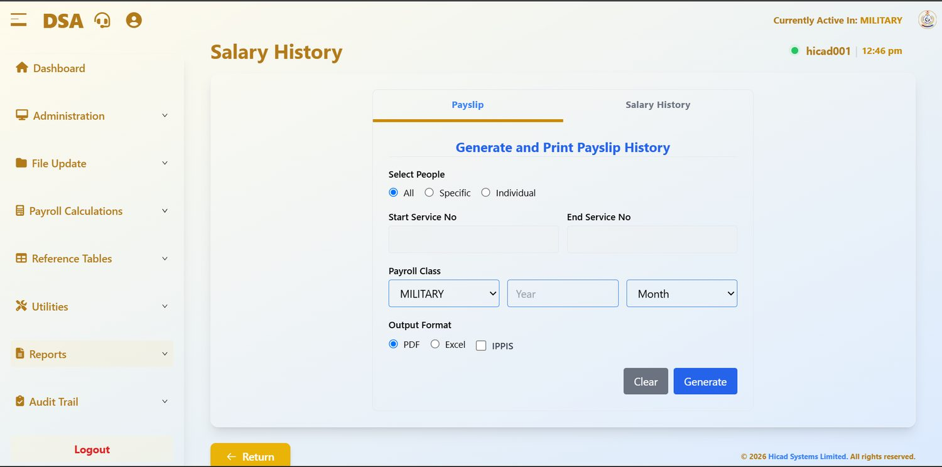
Figure 58.1 Salary History, with the Payslip tab selected. The Salary History tab beside it gives the history view.
Field / control | What it is for
Payslip / Salary History tabs | Switch between reproducing historical payslips and producing a history of pay.
Select People: All / Specific / Individual | The population.
Start Service No / End Service No | The range, with Specific.
Payroll Class, Year, Month | The class and period.
Output Format | PDF or Excel. The IPPIS tick-box beside them is not used for DSA (Chapter 42.2).

This is the report to use when somebody needs a payslip they did not keep, or when a query concerns a period that has already been closed. It reads the history rather than the current period, so it can be run at any time without disturbing the current cycle.

59. Enquiry
Reports > Enquiry · dashboard.html#enquiry
A read-only view of the personnel list, for users who need to look up a person without being able to change them.
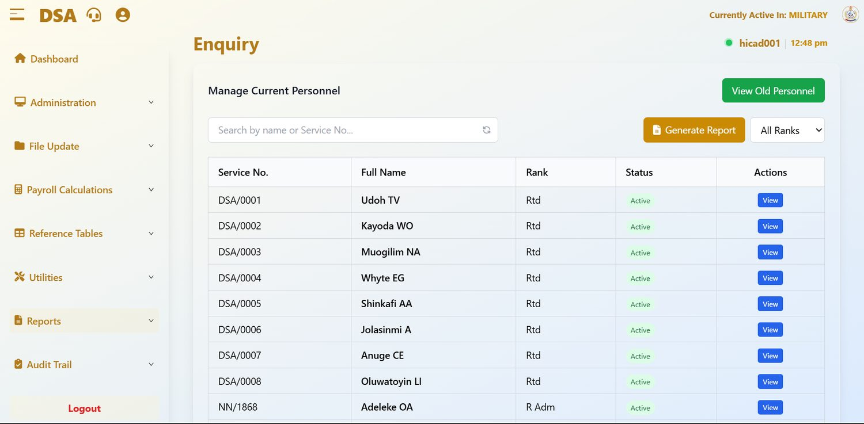
Figure 59.1 Enquiry. The same list as Current Personnel, with View as the only action.
Field / control | What it is for
Search by name or Service No… | Filters the list.
All Ranks | Filters to a single rank.
Generate Report | Opens the personnel reports.
View Old Personnel | Switches to the list of leavers.
Service No., Full Name, Rank, Status | The record.
Actions | View only.

GOOD PRACTICE
Give reporting and enquiry staff this screen instead of Current Personnel. It answers “who is this, and are they on the payroll?” without giving anybody the ability to edit or delete a record (Chapter 7).

60. Salary Variance Analysis
Audit Trail > Salary Variance Analysis · dashboard.html#salary-variance-analysis
Where has pay moved, and why? The first of the six reports on the Audit Trail menu.
The Audit Trail menu holds six control reports. Their purpose is not to get work done but to find mistakes and explain changes, which is why they sit together, and why access to them is worth giving to a supervisor as well as to the people who run the payroll.
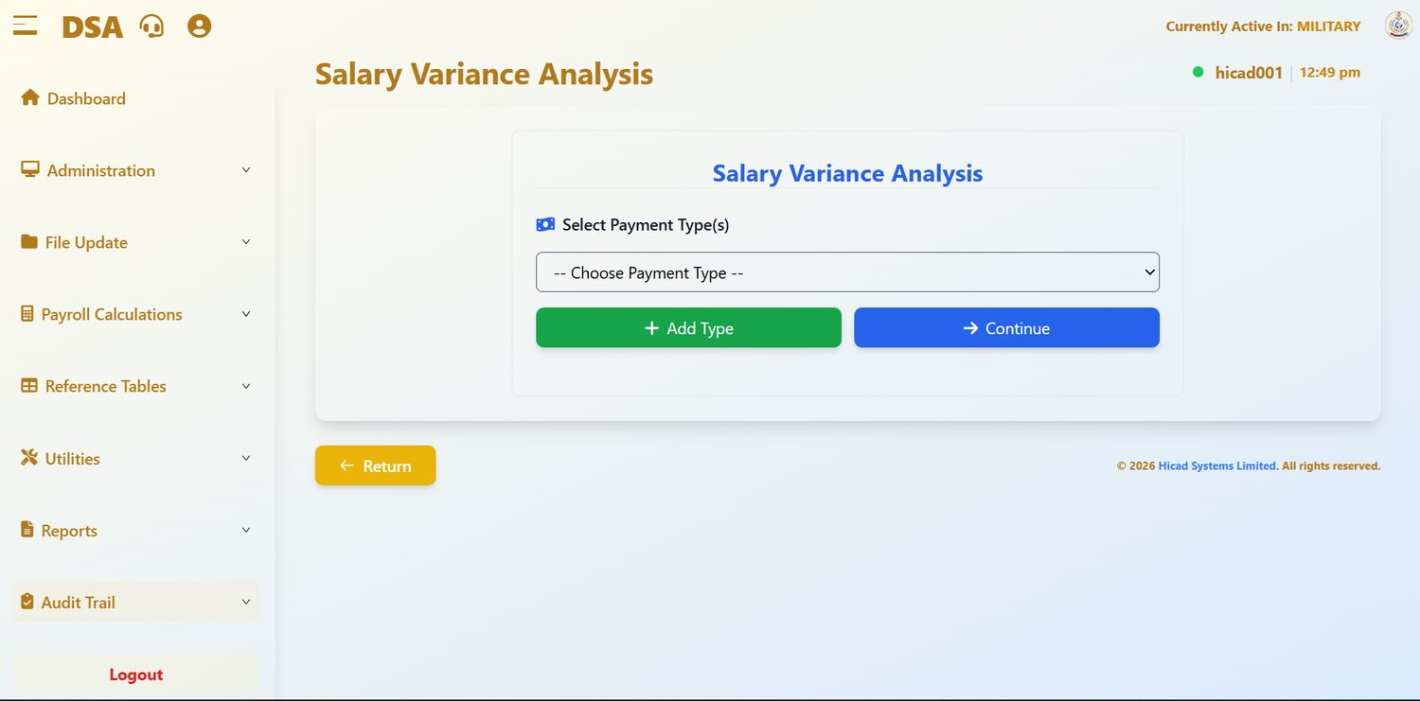
Figure 60.1 Salary Variance Analysis. Choose one or more payment types, then continue.
Field / control | What it is for
Select Payment Type(s) | The elements to analyse, drawn from Chapter 34.
+ Add Type | Adds another element to the analysis. Several can be analysed together.
Continue | Moves to the analysis itself.

Variance analysis compares pay between periods and reports the movements. It is one of the five exception reports, and the one most likely to catch a mistake that is individually plausible: a single person moved to the wrong salary grade, for instance, which no total-level check will find.
- Add the pay elements you want to analyse. Consolidated pay and the larger allowances are the usual starting point.
- Press Continue.
- Read the movements. Anything unexpected should be traceable to a specific authority: a promotion, a posting, a change of entitlement.
- Investigate anything that is not.

61. Changes in Personal Details Record
Audit Trail > Changes in Personal Details Record · dashboard.html#changes-in-personal-details
What changed on personnel records, over a range of periods.
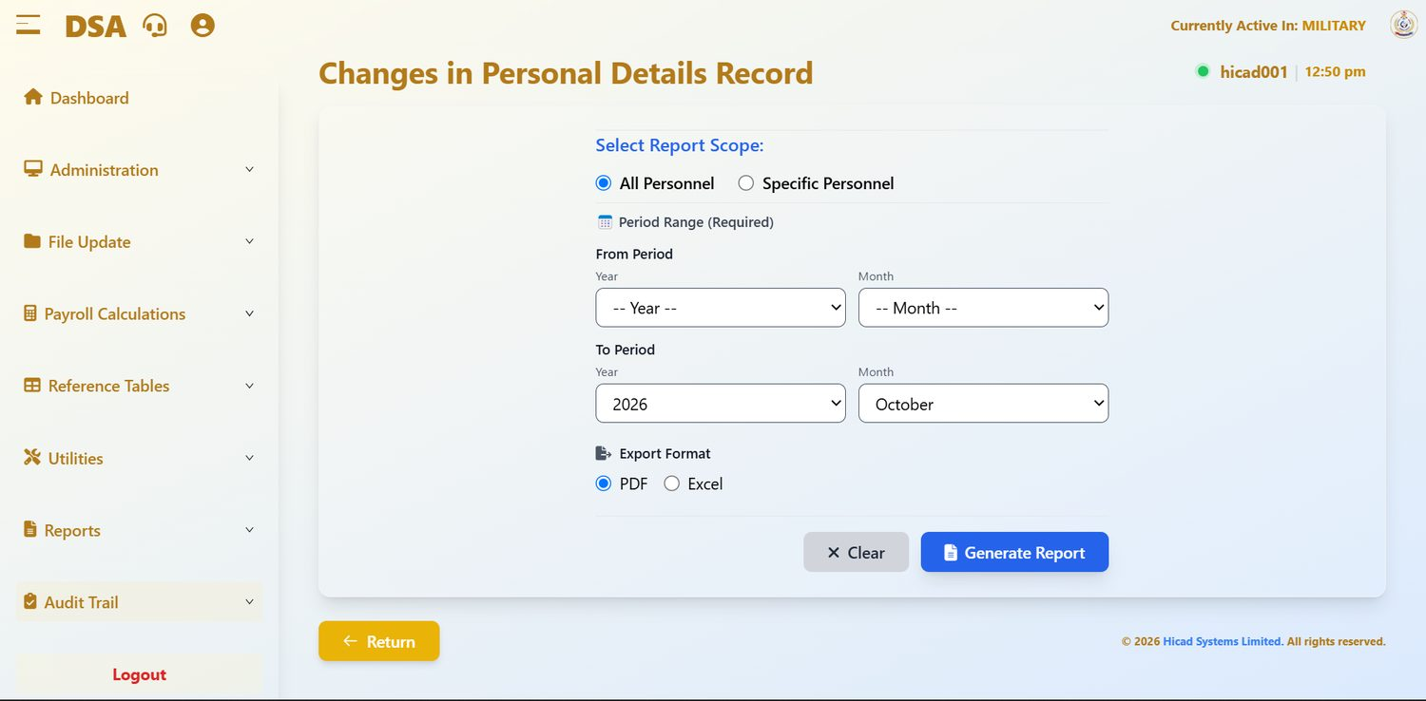
Figure 61.1 Changes in Personal Details Record. The period range is required; both From and To must be set.
Field / control | What it is for
Select Report Scope: All Personnel / Specific Personnel | Everybody, or a named individual.
From Period: Year, Month | The start of the range. Both must be set.
To Period: Year, Month | The end of the range. Both must be set.
Export Format | PDF or Excel.
Generate Report | Produces the report; Clear resets.

This report differs from Changes in Personnel Data in Chapter 23 in one important respect: that one is a control report for a single cycle and is part of the mandatory sequence, while this one looks across a range of periods and can be run at any time. Use this one when investigating a query: “when did this person's bank account change?”
NOTE
The period range is marked (Required). If the report does not generate, the usual reason is that only some of the four year and month fields have been set.

62. Variation Input Listings
Audit Trail > Variation Input Listings · dashboard.html#variation-input-listings
The control report for the variations captured in Chapter 18.
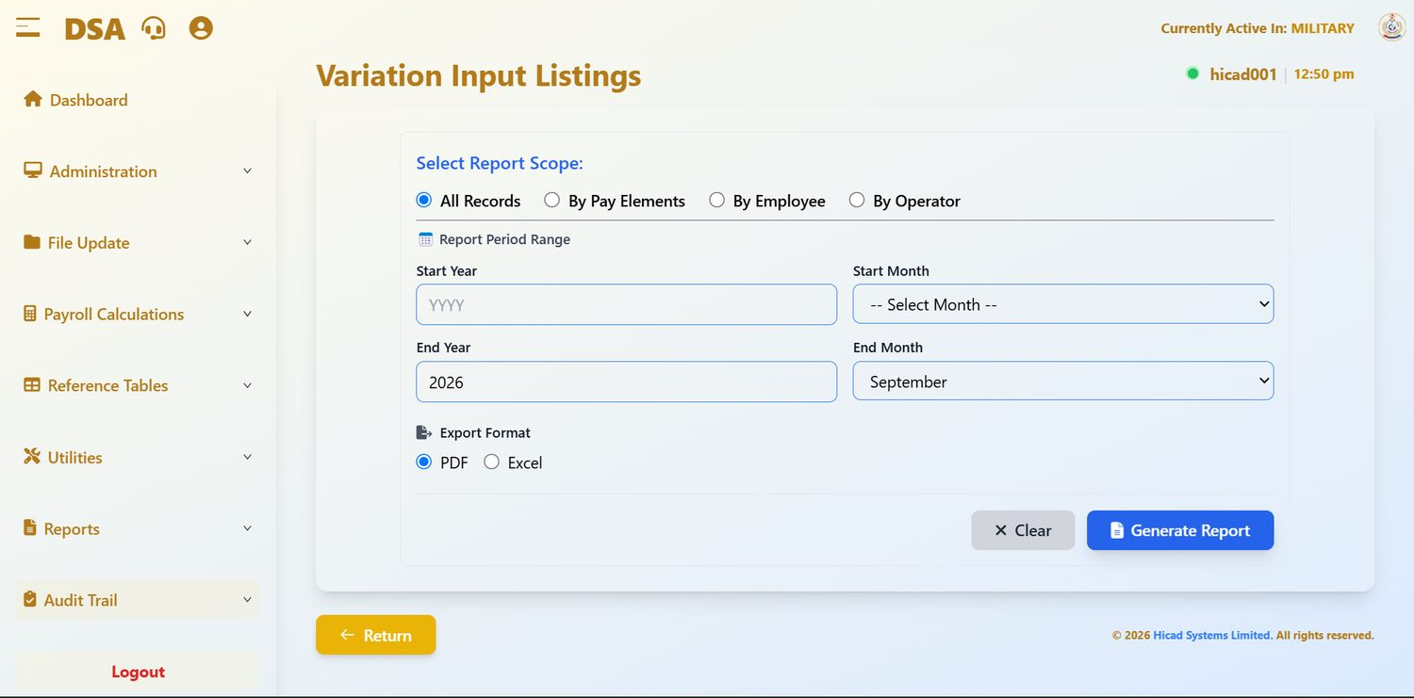
Figure 62.1 Variation Input Listings. Four scopes, including By Operator.
Field / control | What it is for
All Records | Every variation in the period range.
By Pay Elements | Grouped by the element varied.
By Employee | Grouped by the person affected.
By Operator | Grouped by the user who keyed the variation.
Start Year / Start Month / End Year / End Month | The period range.
Export Format | PDF or Excel.

By Operator deserves particular attention. It is the report that shows what each member of staff has changed, presented in a form a supervisor can read and sign.
GOOD PRACTICE
Run By Operator monthly and have each operator's listing initialled by their supervisor. It takes minutes, and it turns the system's record-keeping into an actual control.

63. Overpayment
Audit Trail > Overpayment · dashboard.html#overpayment
Payments that breach the tolerance set in Chapter 31.
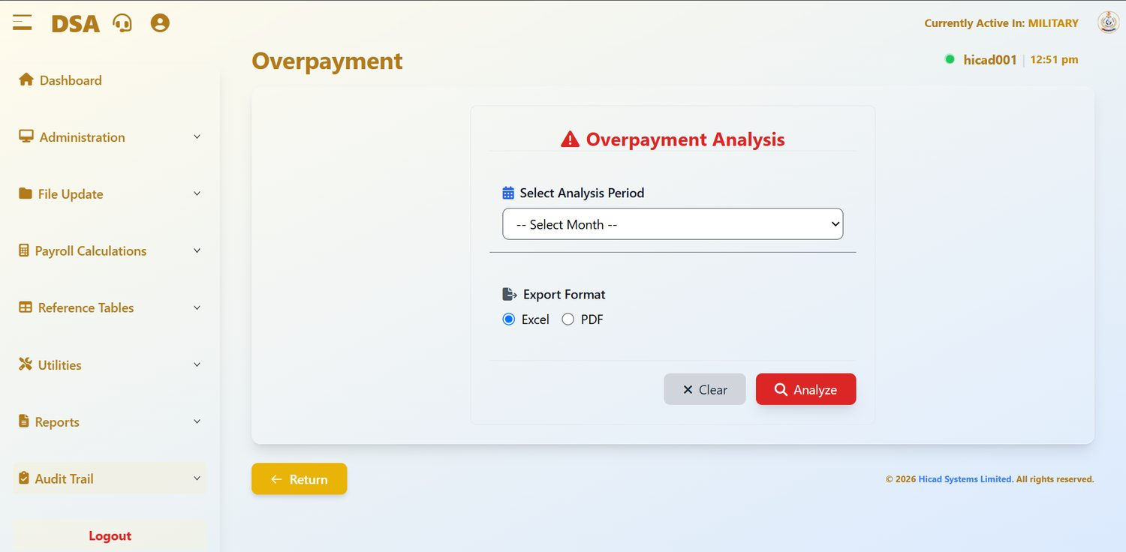
Figure 63.1 Overpayment Analysis. Select a period, choose a format, and analyse.
Field / control | What it is for
Select Analysis Period | The month to analyse.
Export Format | Excel or PDF. Excel is the more useful of the two here, because the output is a working list.
Analyze | Runs the analysis; Clear resets.

The report identifies payments exceeding the overpayment percentage set for the element on the Overpayment Percentage Alarm screen (Chapter 31). With a tolerance of zero, any excess at all is reported; with no tolerance configured, as in the installation shown, there is nothing to measure against.
- Confirm a tolerance is configured for the basic pay element (Chapter 31).
- Run the analysis for the period immediately after the calculation.
- Work through the list and establish the cause of each item.
- Where an overpayment is confirmed, correct the underlying record and set up a recovery through a deduction element (Chapter 34).
- Re-run the analysis after the correction.
CAUTION
An overpayment recovered promptly is an administrative matter. An overpayment discovered a year later is a hardship for the person concerned and a difficult conversation for everybody. Run this report every month.

64. Duplicate Account Number
Audit Trail > Duplicate Account Number · dashboard.html#duplicate-account-number
Two people, one bank account. Almost always an error, occasionally something worse.
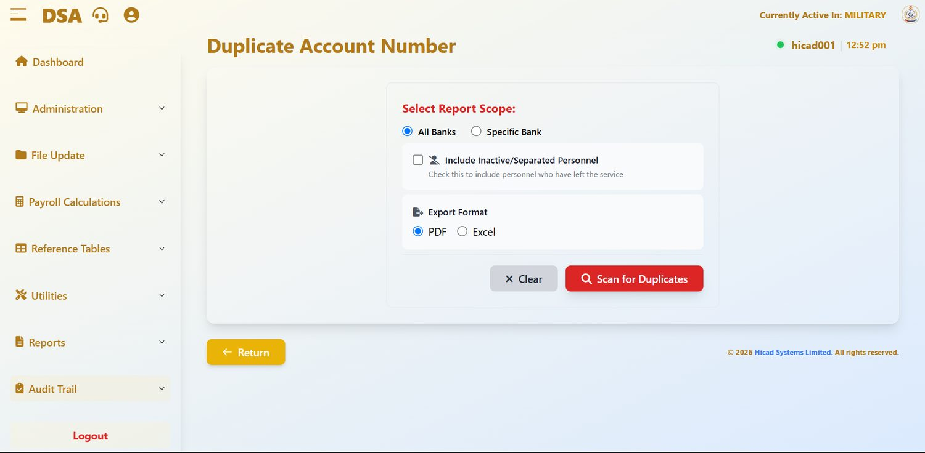
Figure 64.1 Duplicate Account Number. The scan can be restricted to one bank and can optionally include personnel who have left.
Field / control | What it is for
Select Report Scope: All Banks / Specific Bank | Scan every bank, or one.
Include Inactive/Separated Personnel | Extends the scan to personnel who have left the service. Worth ticking periodically: a live account sharing a number with a departed member is exactly the pattern worth understanding.
Export Format | PDF or Excel.
Scan for Duplicates | Runs the scan; Clear resets.

- Run the scan across All Banks each month.
- For every pair returned, obtain the bank documentation for both individuals.
- Correct whichever record is wrong.
- Where the duplication cannot be explained by a keying error, report it through the appropriate channel rather than simply correcting it.
CAUTION
Most duplicates are transcription errors. Some are not. Do not quietly correct a duplicate that you cannot explain: record what you found and refer it.

65. Out-of-Range Payments
Audit Trail > OutOf Range Payments · dashboard.html#outof-range-payments
Payments outside the limits you would expect. The last of the exception reports.
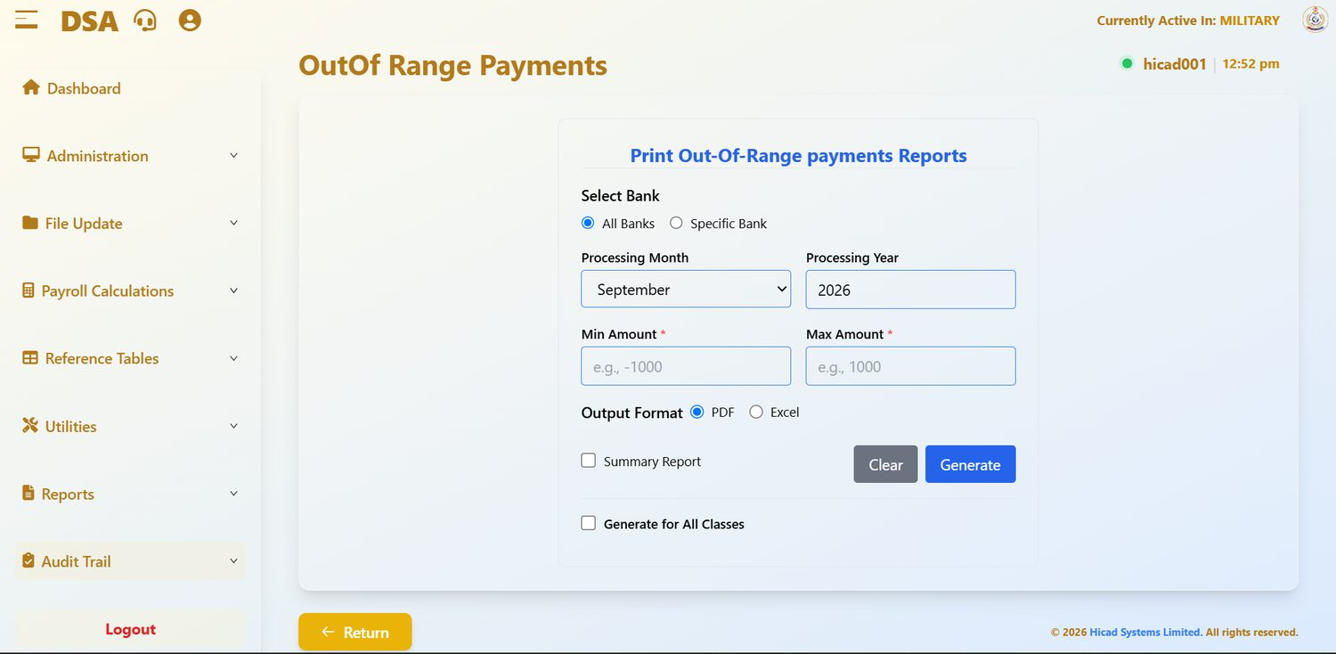
Figure 65.1 Print Out-Of-Range payments Reports. Both Min Amount and Max Amount are required.
Field / control | What it is for
Select Bank: All Banks / Specific Bank | The scope of the scan.
Processing Month / Processing Year | The period.
Min Amount * | The lower limit. The example on screen is -1000: a negative minimum catches negative net pay, which should never occur.
Max Amount * | The upper limit. Set it above the highest legitimate net pay in the class and anything above it is by definition worth looking at.
Output Format | PDF or Excel.
Summary Report | Totals only.
Generate for All Classes | Scans every payroll class rather than the active one.

- Set Min Amount to a small negative figure to catch negative and zero net pay.
- Set Max Amount just above the highest net pay you would expect in the class.
- Tick Generate for All Classes to cover the whole payroll in one pass.
- Run it, and investigate everything it returns.
GOOD PRACTICE
Zero and negative net pay is the single most important thing this report finds. A person whose deductions exceed their gross pay will receive nothing at all that month, and they will find out on pay day unless you find out first.

Appendix A · Payroll Class Reference
The classes configured in the system, as shown on Administration > Payroll Class Setup (Chapter 9.1).
Code | Class | Covers | Notes
1 | MILITARY | Service personnel on the DSA payroll | The primary class. 423 personnel in the installation shown in this manual.
2 | CIVILIAN | Civilian staff | 768 personnel in the installation shown.

NOTE
The population figures are those shown in the figures in this manual and are illustrative. Use the live Payroll Class Statistics panel (Chapter 9.4) for current numbers.

A.1 Class-by-class checklist for a monthly cycle
Every step of the cycle in Chapter 5 is run per class. Use this grid to keep track.
Step | MILITARY | CIVILIAN
Class backup taken
Personnel records updated
Input captured and reconciled
Payroll files saved
Personnel changes printed
Input variable report printed
Master file updated
Calculated: BALANCED
Exception reports run
Register reconciled
Backup taken before close
Month-end processed

Appendix B · Pay Element Code Reference
Pay elements are defined on Reference Tables > Pay Element Description (Chapter 34). The prefix of the code tells you what kind of element it is.

B.1 Prefixes
Prefix | Kind of element
BP / BT | Basic pay: the salary elements from which everything else is derived. Reported as Gross Pay (BP & BT).
PT | Payments: allowances, grants, running costs and other credits. Reported as Allowances (PT).
PR / PL | Deductions and recoveries. Reported as Other Deductions (PR & PL).
PY | Pay totals.

B.2 Elements in the installation shown
Code | Description | Function type | Status
BP302 | Non Regular Allowance | Fixed amount by rank (Chapter 35.1) | Active
BP303 | Consolidated Pay | Input | Active
PT312 | Running Cost | Input | Active
PT314 | MEOO | Input | Active
PT317 | Responsibility Allowance | Input | Active
PT319 | RCA / Armed Guards Allowance | Input | Active
PT320 | Former CDSA Payment | Input | Active
PT321 | NYSC / IT Allowance | Input | Active
PY01 | N E T PAY | Input | Inactive

NOTE
This is the full list as captured. Use the search box on the Pay Element Description screen to find any element added since.

Appendix C · Troubleshooting
The messages and situations most likely to bring work to a halt, and what to do about each.

C.1 Screens that refuse to open
What you see | What it means | What to do
Personnel Profile or Data Input is missing from the menu | The payroll files have been saved for the period, so data entry is closed. | Finish the cycle and run month-end, or, if a correction is essential, Recall Payment Files. Chapters 5.3 and 26.
You have already saved Payroll Files for this period | Save Payroll Files has already run. | Carry on to Changes in Personnel Data, or recall to make changes. Chapters 22 and 26.
Personnel Details Report Not Available Yet | The payroll files have not been saved. | Press Save Payroll Files and complete Chapter 22.
Input Variable Report Not Available Yet | The personnel data changes have not been printed. | Complete Chapter 23.
Waiting for Input Variable Report | The input variable report has not been printed. | Complete Chapter 24.
Ensure Master File Update is completed before calculating | The master file update has not been run. | Complete Chapter 25.
Calculations already completed | The period has already been calculated. | Read the results. To recalculate, recall the files and repeat Chapters 22 to 27.
Payroll Calculations Not Complete | The calculation has not been run. | Complete Chapter 27.
Month-end processing blocked | The status is not Calculation Completed. | Finish the File Update sequence and the calculation. Chapter 5.3.
This section is under development | The feature is not part of this system for DSA. | Nothing to do. Chapter 42.

C.2 Things that look wrong but are not
Situation | Explanation
Total Net Pay is higher than Total Gross Pay on Payroll Calculations. | The gross tile shows basic pay only; allowances are added in the Income Breakdown. Chapter 27.2.
Showing 0 to 0 of 0 records on a data input screen. | Normal at the start of a period, before capture begins. Chapter 17.2.
Showing 0--1 of 0 records on Old Personnel. | A display quirk of an empty list. Chapter 16.1.
Process Year-End is greyed. | The year's final month has not yet been closed. Chapter 13.2.
An allowance on the input does not appear on the payslip. | A mutual exclusion may be suppressing it. Chapter 35.2.
A row is missing after a batch upload. | Duplicates are rejected by design: either a duplicate service number, or a duplicate service number and pay element pair. Chapters 14.7 and 17.3.
Local Government shows Select State First. | The field is dependent on the state. Choose a state and it populates. Chapter 40.
A menu described in this manual is not on your screen. | Your role does not have access to it (Chapter 7), or the payroll status has hidden it (Chapter 5.3).

C.3 Things that are wrong
Situation | What to do
The green status dot is missing or the clock has stopped. | Your session has dropped. Sign in again before entering anything further. Chapter 3.4.
Last Backup reads Never, or a backup shows 0 B. | No usable backup exists. Take one and check its size before doing anything that needs one. Chapter 43.
A command or location record has no code and no description. | A blank record collecting personnel saved without a value. Identify and reassign them, then remove it. Chapter 30.
A PFA has no pension fund custodian. | The remittance schedule will be incomplete. Complete the record before the next return. Chapter 36.
The Overpayment analysis returns nothing at all. | Check that a tolerance has been configured. Chapter 31.
Net pay is zero or negative for a person. | Deductions exceed gross pay. Find these with the out-of-range report before pay day. Chapter 65.
The calculation does not show BALANCED, or a reconciliation error is reported. | There is no acceptable reconciliation error. Investigate, correct, recall, recalculate, re-run. Chapters 27 and 57.

C.4 For IT staff: the payroll status
The status described in Chapter 5.3 is held per payroll class on the BT05 row of py_stdrate, column sun: 0 Data Entry Open, 666 Data Entry Closed, 775 First Report Generated, 777 Two Reports Generated, 888 Update Completed, 999 Calculation Completed. Month-end sets it back to 0 and advances the period; Recall Payment Files sets it to 0 without advancing.
CAUTION
Do not change the status by hand to get past a lock. Each lock exists because the step before it has not happened, and moving the status forward without the step leaves the class in a state no screen can explain. If a class is genuinely stuck, recall the payment files and work through the sequence.

C.5 Escalation
- Data question: a figure looks wrong. Start with Input Documentation (Chapter 20) and the Audit Trail reports (Part X).
- Access question: a menu is missing or a user cannot sign in. Your system administrator, Chapters 7 and 8.
- System question: a screen errors, a backup fails, the connection indicator is missing. Support, using the headset icon in the header.
- Policy question: a rate, a band or an entitlement is in doubt. This is not a system question. Obtain the authority before changing anything.

Appendix D · Glossary
Term | Meaning
Active class | The payroll class every screen currently reads and writes, shown as Currently Active In in the header. Chapter 4.
Amount To Date | The cumulative amount paid or deducted against a payment or deduction record. What makes it possible to see how much of a loan remains. Chapter 17.1.
Arrears | Back pay owed when a change of grade or rate is applied retrospectively. Chapter 21.
Batch upload | Loading many records at once from a spreadsheet instead of keying them. Chapters 14.7 and 17.3.
BALANCED | The result of the calculation's own check that net pay worked out two ways agrees. Chapter 27.2.
Cash channel | An entry on the bank table used to route a grant or running-cost payment rather than a salary. Chapter 37.1.
Cumulative | A year-to-date figure: taxable, tax, gross or net. Maintained by the system; entered manually only on transfer in. Chapter 19.
Data entry open / closed | Whether input may be captured for the period. Closed by Save Payroll Files, reopened by month-end or recall. Chapter 5.3.
Function type | How a pay element's amount is arrived at: captured as INPUT or taken from a rank table as FIXED AMOUNT BY RANK. Chapter 34.
HICAD | Hicad Systems Limited, the supplier of the system; also the name of the full-access role. Chapters 2.2 and 6.
IPPIS | Integrated Personnel and Payroll Information System: the Federal Government platform. Not used for the DSA payroll. Chapter 42.2.
Master file update | Writing the input into the master records, after which the data for the calculation is fixed. Chapter 25.
Month-end processing | Finalising a period and rolling forward. Cannot be undone. Chapter 13.1.
Mutually exclusive elements | Two pay elements that cannot both be paid; the higher-priority one suppresses the other. Chapter 35.2.
NHF | National Housing Fund. Chapter 53.
NSITF | The label on the pension return screen. Chapter 54.
Pay element | Any payment or deduction the system recognises, identified by a code such as PT317. Chapter 34 and Appendix B.
Pay indicator | A setting on a payment or deduction record governing how it recurs and how the calculation treats it. Chapter 17.1.
Payroll class | A group of personnel processed as a separate pay run: MILITARY or CIVILIAN. Chapter 4 and Appendix A.
Payroll status | The single stage marker each class carries through the cycle. Chapter 5.3.
PFA / PFC | Pension Fund Administrator, which manages the retirement savings account; Pension Fund Custodian, which holds the assets. Chapter 36.
Registration number / Service No | The identifier that ties a person to every record in the system. Chapter 10.
Role | A named bundle of menu permissions assigned to a user account. Chapters 6 and 7.
RSA | Retirement Savings Account. Recorded on Step 2 of the personnel record. Chapter 14.3.
Salary group / salary grade | The scale a person is paid on, and their position within it. Chapters 14.3 and 33.
Tax state | The state to which a person's PAYE is remitted. Distinct from state of origin. Chapters 14.3 and 51.
User ID | The identifier a user signs in with, normally their service number. Chapters 3 and 8.
Variation | A recorded change to a payment or deduction already running. Chapter 18.
Year-end processing | Closing the payroll year and resetting annual cumulatives. Chapter 13.2.

Appendix E · Training Exercises
These exercises follow the order of the manual. Work them in a training or test installation only: never against live data.
CAUTION
Do not use live personnel records for training. Service numbers, bank account numbers and pay data are restricted, and a trainee working in a live system can save a period, close a month or migrate a class by accident.

E.1 Exercise 1: Orientation (Chapters 3 – 5)
- Sign in and identify, without scrolling: the active payroll class, the current payroll period, and the number of active personnel.
- Collapse and expand the left-hand menu.
- Name the ten menu groups and say, for each, one thing it is used for.
- Switch the active payroll class to CIVILIAN and back to MILITARY. Confirm the header changes both times.
- Open Month End Processing and read the Current Status. Say which menus should be visible at that status.

E.2 Exercise 2: Access (Chapters 6 – 8)
- Create a role called TRAINEE_CLERK with an appropriate description.
- Grant it access to Data Input and Reports only.
- Create a user account with that role and an expiry date one week from today.
- Sign in as that account and confirm which menus appear.
- Explain why the account cannot reach Administration.

E.3 Exercise 3: A personnel record (Chapter 14)
- Add a new person, completing all three steps.
- Add one next of kin and one child.
- Find the record again through Current Personnel and through Enquiry.
- Say which field on the record determines where their PAYE is remitted, and which two fields a member of staff needs to be right before they can use the staff portal.

E.4 Exercise 4: A cycle (Chapters 17 – 28)
- Capture three payment or deduction records.
- Save the payroll files, and note which menus disappear.
- Work down the File Update menu in order, and note at each screen what the previous step released.
- Run the calculation and confirm it shows BALANCED.
- Open the calculation reports and state the number of employees processed.
- Recall the payment files, and say what status the class is now in.

E.5 Exercise 5: Exceptions (Chapters 57, 60, 63 – 65)
- Run the salary reconciliation with Errors Only.
- Run the out-of-range report with a minimum of -1000.
- Run the duplicate account number scan across all banks.
- Run the overpayment analysis, and say what must be configured first for it to mean anything.
- For any item returned, describe how you would establish its cause.

E.6 Exercise 6: An investigation (Chapters 20, 35, 61, 62)
A member of staff reports that an allowance they expected is missing from their payslip. Using the system only, establish:
- What was captured for them this period (Input Documentation).
- Whether the allowance was varied or removed (Variation Input Listings, Changes in Personal Details Record).
- Whether another allowance is suppressing it (Mutually Exclusive Pay Elements).
- Who keyed the last variation against them (Variation Input Listings, By Operator).
- Write two sentences you would send in reply.

E.7 Assessment
A trainee is ready to work unsupervised on live data when they can, without reference to this manual:
- State the active class and period before doing anything else.
- Recite the ten steps of the monthly cycle in order, and the status each one leaves the class in.
- Explain what each of the five exception reports finds.
- Name the actions in the system that cannot be undone.
- Say what they would do before running any of them.

Appendix F · Figure and Capture Index
Every figure in this manual, with the original screen capture it was taken from. The captures are held in the folder dsa-screens.

F.1 Figures
Figure | Screen | Capture file
Figure 3.1 | The dashboard, showing the greeting, the three headline figures, Quick Access and Notifications. The… | Screenshot 2026-10-26 113856.png
Figure 6.1 | Role Management with the five roles supplied as standard. Each row can be edited or deleted; the buttons… | Screenshot 2026-10-26 113944.png
Figure 8.1 | Create Payroll User. Fields marked with an asterisk are required. The Full Name field fills itself from… | Screenshot 2026-10-26 114614.png
Figure 8.2 | Control Payroll Users. Each account shows its User ID, name, role and status, with View, Edit and Delete… | Screenshot 2026-10-26 114818.png
Figure 9.1 | Payroll Class Setup. The Add New Record strip creates a class; the table below lists those that exist,… | Screenshot 2026-10-26 114918.png
Figure 9.2 | Switch Active Payroll Class. MILITARY is active (shown by the green highlight, the tick and the Active… | Screenshot 2026-10-26 115025.png
Figure 9.3 | Change Personnel Payroll Class with Individual Personnel selected. The Payroll Class Statistics panel… | Screenshot 2026-10-26 115153.png
Figure 10.1 | Change Registration Number. Find the person, enter the new number, save. | Screenshot 2026-10-26 115357.png
Figure 11.1 | One-Off Requirement Setup, before any one-off type has been defined. | Screenshot 2026-10-26 115524.png
Figure 11.2 | One-Off Fixed Amount By Rank Management. Each code is opened with View or Edit to reach the rank-by-rank… | Screenshot 2026-10-26 115630.png
Figure 11.3 | Individual One-Off Payment Input with no records. The search box, Add Payment and the paging controls are… | Screenshot 2026-10-26 115805.png
Figure 11.4 | One-Off Calculations. Choose the payroll class, decide whether to calculate for everybody or for named… | Screenshot 2026-10-26 115847.png
Figure 11.5 | One-Off Reports. Four report types, a payroll class, an output format, and an option to cover all classes… | Screenshot 2026-10-26 120053.png
Figure 12.1 | Company Profile. The Edit button at the top right opens every field for amendment. | Screenshot 2026-10-26 120327.png
Figure 13.1 | Month End Processing. The current status, the period to be processed, an explicit warning, and, on the… | Screenshot 2026-10-26 120406.png
Figure 13.2 | Year End Processing. The panel confirms the current and previous periods; Process Year-End is greyed… | Screenshot 2026-10-26 120433.png
Figure 14.1 | Add New Personnel, Step 1. The three step buttons run across the top; the record tabs and Batch Upload sit… | Screenshot 2026-10-26 213354.png
Figure 15.1 | Current Personnel. The list is filtered to the active payroll class; each row carries View, Edit and Delete. | Screenshot 2026-10-26 213413.png
Figure 15.2 | Current Personnel Reports. Choose a scope, choose PDF or Excel, and generate. | Screenshot 2026-10-26 124815.png
Figure 16.1 | Old Personnel, empty in the installation shown: nobody had yet been recorded as having left. | Screenshot 2026-10-26 213425.png
Figure 16.2 | List Of Exited Members. The scopes mirror the current personnel report, with By Exit Type added. | Screenshot 2026-10-26 124837.png
Figure 17.1 | Payments/Deductions at the start of a period, before any records have been captured. This capture includes… | Screenshot 2026-10-26 213436.png
Figure 17.2 | Payments/Deductions (Batch Upload). The Batch List button keeps a record of previous uploads. | Screenshot 2026-10-26 213445.png
Figure 18.1 | Variation to Payments/Deductions, before any variation has been recorded. | Screenshot 2026-10-26 213454.png
Figure 19.1 | Cumulative Payroll Transfer, showing the four year-to-date figures the system holds. | Screenshot 2026-10-26 213502.png
Figure 20.1 | Input Documentation. Search for a person to see and print their input form. | Screenshot 2026-10-26 213513.png
Figure 21.1 | Arrears Calculations. The REGULAR block handles grade changes; the OTHERS block handles any other… | Screenshot 2026-10-26 213522.png
Figure 22.1 | Save Payroll Files. A single action, with its purpose stated on the screen. | Screenshot 2026-10-26 120605.png
Figure 23.1 | Changes in Personnel Data after the report has been produced. The green panel confirms the download and… | Screenshot 2026-10-26 120647.png
Figure 24.1 | Input Variable Report after the report has been produced. Print Again reproduces it; Master File Update… | Screenshot 2026-10-26 120823.png
Figure 25.1 | Master File Update, completed. The confirmation offers the way on to Payroll Calculations. | Screenshot 2026-10-26 120849.png
Figure 26.1 | Recall Payment Files. A single action, described plainly on the screen. | Screenshot 2026-10-26 120912.png
Figure 27.1 | Payroll Calculations after a successful run for September 2026. The BALANCED banner confirms that the two… | Screenshot 2026-10-26 121006.png
Figure 28.1 | Calculation Reports Generated For September 2026. Each card can be viewed on screen or downloaded; all are… | Screenshot 2026-10-26 121038.png
Figure 29.1 | Overtime Information. Six settings, one Save button. | Screenshot 2026-10-26 121115.png
Figure 30.1 | Command Management. The first row has neither a code nor a name; the rest carry the commands loaded at… | Screenshot 2026-10-26 121150.png
Figure 31.1 | Overpayment Percentage Alarm, with no tolerance yet configured. | Screenshot 2026-10-26 121247.png
Figure 32.1 | Tax Table Configuration. Each row is one band; the buttons above add bands, configure minimum free pay and… | Screenshot 2026-10-26 121325.png
Figure 33.1 | Salary Scale Information with the Salary Groups tab selected. The Salary Scale tab beside it holds the… | Screenshot 2026-10-26 121420.png
Figure 34.1 | Pay Element Description. Nine elements in the installation shown, on a single page. | Screenshot 2026-10-26 121452.png
Figure 35.1 | Fixed Amount By Rank Management, holding one element: BP302 Non Regular Allowance. | Screenshot 2026-10-26 121605.png
Figure 35.2 | Mutually Exclusive Pay Elements, with no pairs configured. | Screenshot 2026-10-26 121744.png
Figure 36.1 | PFA Management, first page. Eighteen administrators in the installation shown, each with its pension fund… | Screenshot 2026-10-26 121810.png
Figure 36.2 | PFA Management, second page, reached with Next. | Screenshot 2026-10-26 121936.png
Figure 37.1 | Bank Management. Alongside the banks proper, CASH codes provide channels for grants and running costs. | Screenshot 2026-10-26 122109.png
Figure 38.1 | Location Management. In this installation the locations are staff categories rather than places. | Screenshot 2026-10-26 122205.png
Figure 39.1 | States Management, first page. | Screenshot 2026-10-26 122234.png
Figure 40.1 | Local Government Management, first page. Use the search rather than paging through the list. | Screenshot 2026-10-26 122320.png
Figure 41.1 | Title Management, first page. 94 titles in the installation shown. | Screenshot 2026-10-26 122357.png
Figure 41.2 | Title Management, page 3, showing ranks from more than one Service: Capt (NN), Cdr, Cdre, Col, Cpl, Flt… | Screenshot 2026-10-26 122809.png
Figure 43.1 | Payroll Class Backup. Configuration on the left, history on the right, summary figures beneath. No backup… | Screenshot 2026-10-26 123018.png
Figure 44.1 | Payroll Class Restore. The connection indicator confirms the database; the history panel records every… | Screenshot 2026-10-26 123144.png
Figure 46.1 | Generate and Print Payslips. | Screenshot 2026-10-26 123626.png
Figure 47.1 | Print Payments by Bank(Branch) Reports. | Screenshot 2026-10-26 123741.png
Figure 48.1 | Print Analysis of Earnings/Deduction Report. | Screenshot 2026-10-26 124023.png
Figure 49.1 | Print Loan Analysis Report. The simplest report screen in the system: period, format, generate. | Screenshot 2026-10-26 124051.png
Figure 53.1 | National Housing Funds (NHF) Report. | Screenshot 2026-10-26 124226.png
Figure 54.1 | Print NSITF Reports. Filter by PFA and by PFA payment type. | Screenshot 2026-10-26 124510.png
Figure 55.1 | Salary Summary Report. Period, location and generate. | Screenshot 2026-10-26 124544.png
Figure 56.1 | Payroll Control Sheet Report. | Screenshot 2026-10-26 124611.png
Figure 57.1 | Salary Reconciliation with the filter set to Errors Only. | Screenshot 2026-10-26 124647.png
Figure 58.1 | Salary History, with the Payslip tab selected. The Salary History tab beside it gives the history view. | Screenshot 2026-10-26 124712.png
Figure 59.1 | Enquiry. The same list as Current Personnel, with View as the only action. | Screenshot 2026-10-26 124907.png
Figure 60.1 | Salary Variance Analysis. Choose one or more payment types, then continue. | Screenshot 2026-10-26 125000.png
Figure 61.1 | Changes in Personal Details Record. The period range is required; both From and To must be set. | Screenshot 2026-10-26 125027.png
Figure 62.1 | Variation Input Listings. Four scopes, including By Operator. | Screenshot 2026-10-26 125059.png
Figure 63.1 | Overpayment Analysis. Select a period, choose a format, and analyse. | Screenshot 2026-10-26 125139.png
Figure 64.1 | Duplicate Account Number. The scan can be restricted to one bank and can optionally include personnel who… | Screenshot 2026-10-26 125225.png
Figure 65.1 | Print Out-Of-Range payments Reports. Both Min Amount and Max Amount are required. | Screenshot 2026-10-26 125247.png

NOTE
Three further captures in the folder are not used because they repeat another figure: Screenshot 2026-10-26 114704.png (Role Management with text highlighted, as Figure 6.1), Screenshot 2026-10-26 115053.png (Payroll Class Setup, as Figure 9.1) and Screenshot 2026-10-26 123431.png (Payroll Class Restore, as Figure 44.1).

F.2 Screens without a figure
The following screens are described from the application itself, without a screen capture: Role Permissions (Chapter 7), Add New Personnel Steps 2 and 3, NOK and Children (Chapter 14), Emolument Form Processing and Pull IPPIS Payments (Chapter 42), Consolidated Payslips (Chapter 45), Analysis of Payments/Deductions by Bank (Chapter 50), Tax Payments by State (Chapter 51) and Payroll Register (Chapter 52). Captures of these can be added in the next edition.

